
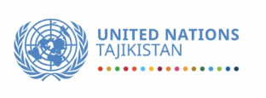

Evaluation Report for the
Final Evaluation of the
United Nations Sustainable Development Cooperation Framework (UNSDCF) for Tajikistan 2023–2026

Second draft

Evaluation Team:
Mr. Tomislav Novovic, Team Leader- Evaluation Expert
Ms. Zulfiya Bakhtibekova, Evaluation Expert

Dushanbe, August 2025

Table of contents

List of abbreviations 4
Executive summary 7
1 Background 13
1.1 Country background 13
1.2 UNSDCF for Tajikistan 2023-2026 16
2 The purpose and objectives of the final evaluation 20
2.1 Purpose of the evaluation 20
2.2 Objectives of the evaluation 21
2.3 Scope of the evaluation 21
3 Evaluation Methodology, Criteria and Approach 22
3.1 Evaluation framework 22
3.2 Defining evaluation questions 23
3.3 The data collection approach 24
3.3.1 Desk analysis (Phase 1) 24
3.3.2 Sampling and primary data collection (Phase 2) 24
3.3.3 Synthesis & reporting (Phase 3) 26
3.3.4 Review and validation (Phase 4) 26
3.4 Participatory approach within the evaluation 27
3.5 Quality assurance during the evaluation 27
3.6 Management arrangements and roles in evaluations 27
3.6.1 Management Arrangements for the Evaluation 27
3.6.2 Evaluation Team Composition, Roles and Responsibilities 28
3.7 Ethical Considerations 28
4 Findings 30
4.1 Relevance 30
4.2 Coherence 37
4.3 Effectiveness 44
4.3.1 Outcome 1: Inclusive Human Development 45
4.3.2 Outcome 2: Sustainable, Inclusive, and Green Economic Growth 46
4.3.3 Outcome 3: Integrated Management of Climate and Environmental Risk 46
4.3.4 Outcome 4: People-Centered Governance and Rule of Law 46
4.4 Efficiency 51
4.5 Progress towards impact 61
4.6 Sustainability 67
5 Conclusions 72
5.1 Conclusions on relevance 72
5.2 Conclusions on coherence 73
5.3 Conclusions on effectiveness 74
5.4 Conclusions on efficiency 74
5.5 Conclusions on progress towards impact 75
5.6 Conclusions on sustainability 76
6 Lessons learned 77
7 Recommendation 78
8 Annexes 82
Annex 1: List of consulted documents 82
Annex 2: Interview Guides 84
Interview Guide: UN Resident Coordinator- UN Coordinator’s Office/ UN Agencies and UN Results groups 85
Interview Guide: Chair of the UN Monitoring Group 88
Interview Guide: Chair of the UN Communication Group 89
Interview Guide: International development partners 90
Interview Guide: Bilateral and multilateral donors 91
Interview Guide: Institutional partners 92
Interview Guide: Beneficiaries (if appropriate) 93
ONLINE questionnaires 94
ONLINE questionnaire for UN management and programme/ project staff 94
ONLINE questionnaire for UN operations staff 100
Annex 3: Progress under UNSDCF outcomes 104
Annex 4 Evaluation matrix 108

List of abbreviations
APR | Annual Performance Review
ARR | Annual Results Reports
BOS | Business Operations Strategy
CA | Contribution Analysis
CCA | Common Country Analysis
CEDAW | Convention on the Elimination of All Forms of Discrimination Against Women
CF | Cooperation Framework
CPDs | Country Programme Documents
CRC | Convention on the Rights of the Child
CRPD | Convention on the Rights of Persons with Disabilities
CSOs | Civil Society Organizations
DAC | Development Assistance Committee of the OECD
DaO | Delivering as One
DCC | Development Coordination Council
DCO | Development Coordination Office (UN)
DRR | Disaster Risk Reduction
DRS | District of Republican Subordination (Tajikistan)
ECE | Early Childhood Education
EM | Evaluation Manager
EMIS | Education Management Information Systems
EMT | Evaluation Management Team
ESC | Evaluation Steering Committee
ET | Evaluation Team
ETMT | Evaluation Technical Management Team
FAO | Food and Agriculture Organization of the United Nations
FE | Final Evaluation
FLA | Free Legal Aid
GBAO | Gorno-Badakhshan Autonomous Oblast
GCF | Green Climate Fund
GDP | Gross Domestic Product
GEM | Gender Equality Marker
GEWE | Gender Equality and Women’s Empowerment
GFATM | The Global Fund to Fight AIDS, Tuberculosis and Malaria
GoT | Government of Tajikistan
HDI | Human Development Index
HR | Human Rights
HRBA | Human Rights-Based Approach
ICT | Information and Communication Technology
IDB | Islamic Development Bank
IFF | Integrated Funding Framework
ILO | International Labour Organization
INFF | Integrated National Financing Framework
IOM | International Organization for Migration
IR | Inception report
ITF | Interagency Task Forces
JSC | Joint Steering Committee
JWPs | Joint Work Plans
KII | Key Informants Interviews
LNOB | Leave No One Behind
M&E | Monitoring and Evaluation
MAF | Management and Accountability Framework
MAXQDA | Qualitative and Mixed Methods Data Analysis Software
MEDT | Ministy of Economic Development and Trade
MEL | Monitoring, Evaluation and Learning
MFA | Ministry of Foreign Affairs
MoA | Ministry of Agriculture
MoES | Ministry of Education and Science
MoF | Ministry of Finance
MoHSPP | Ministry of Health and Social Protection of the Population
MoJ | Ministry of Justice
MoLMEP | Ministry of Labor, Migration, and Employment of the Population
MTDP | Mid-Term Development Programme
MTEFs | Medium-Term Expenditure Frameworks
MTM | Mobility Tracking Matrix
NDCs | Nationally Determined Contributions
NDPs | National Development Programmes
NDS | National Development Strategy
NEET | Not in Education not in Employment
NGO | Non-governmental Organization
OECD | Organization for Economic Cooperation and Development
OHCHR | Office of the United Nations High Commissioner for Human Rights
OMT | Operations Management Team
OVI | Objectively Verifiable Indicator
P&RM | Partnership and Resource Mobilization Strategy
PMT | Programme Management Team
PPP | Public-Private Partnership
PRM | Partnership and Resource Mobilization
RBM | Results-Based Management
RC | Resident Coordinator
RCO | Resident Coordinator’s Office
RG | Results Group/ Outcome Results Groups
SDGs | Sustainable Development Goals
SMART | Specific, Measurable, Achievable, Relevant, Time-bound
SMEs | Small and Medium Size Enterprises
SOPs | Standard Operating Procedures
SoV | Sources of Verification
SPW | Strategic Prioritization Workshop
SRHR | Sexual and Reproductive Health and Rights
TGs | Thematic Groups
TL | Team Leader
ToC | Theory of Change
ToR | Terms of Reference
UN-DCO/ DCO | United Nations Development Coordination Office
UN Women | United Nations Entity for Gender Equality and the Empowerment of Women
UNCT | United Nations Country Team
UNCT-SWAP | UN System-wide Action Plan Gender Equality Scorecard
UNDP | United Nations Development Programme
UNDRR | United Nations Office for Disaster Risk Reduction
UNEG | United Nations Evaluation Group
UNEG | United Nations Evaluation Group
UNEG | UN Evaluation Group
UNESCAP | United Nations Economic and Social Commission for Asia and the Pacific
UNESCO | United Nations Educational, Scientific and Cultural Organization
UNFPA | United Nations Population Fund
UNHCR | United Nations High Commissioner for Refugees
UNICEF | United Nations Children's Fund
UNIDO | United Nations Industrial Development Organization
UNODC | United Nations Office on Drugs and Crime
UNOPS | United Nations Office for Project Services
UNRC/ RC | United Nations Resident Coordinator
UNRCO/ RCO | United Nations Resident Coordination Office
UNSDCF/ CF | United Nations Sustainable Development Cooperation Framework
VNR | Voluntary National Review
WASH | Water, Sanitation and Hygiene
WFP | World Food Programme
WHO | World Health Organization

Executive summary
The United Nations Sustainable Development Cooperation Framework (UNSDCF) 2023–2026 for Tajikistan was signed in December 2022 between the Government of the Republic of Tajikistan and the United Nations. It aligns with Tajikistan’s National Development Strategy 2030 (NDS-2030), the Mid-Term Development Programme 2021–2025, and the Sustainable Development Goals (SDGs). The Cooperation Framework focuses on four strategic outcomes: inclusive human development and well-being; sustainable, inclusive, and green economic growth; climate and environmental risk management; and people-centred governance, justice, and human rights. The UNSDCF is designed to ensure that vulnerable and marginalised groups are actively included, reinforcing the commitment to the principle of Leaving No One Behind (LNOB) in line with the 2030 Agenda.
The final evaluation assessed the relevance, coherence, effectiveness, efficiency, and sustainability of the CF in Tajikistan. Its objectives were to strengthen accountability, inform adaptive programming, and generate strategic recommendations for accelerating progress toward the SDGs. The evaluation focused on drawing lessons and identifying opportunities for improvement to guide the development of the next Cooperation Framework and support enhanced alignment with national priorities and global commitments.
The Evaluation Team (ET) applied a theory-based approach, using the Theory of Change (ToC) as the analytical foundation to assess how UN activities contributed to intended outcomes. This was complemented by contribution analysis to examine the influence of UN-supported interventions on development outcomes. The evaluation employed a human rights-based and gender-responsive lens to ensure that cross-cutting priorities such as gender equality, social inclusion, and environmental sustainability were systematically examined throughout the process.
The evaluation process consisted of four interlinked phases. During the inception phase, the Evaluation Team conducted a comprehensive desk review of strategic documents, including the UNSDCF, national development plans, Joint Work Plans, and monitoring frameworks. An evaluation matrix was developed to guide the analysis, and a stakeholder mapping exercise ensured inclusivity. In the data collection and analysis phase, the team engaged over 150 stakeholders through interviews, focus group discussions, and an online survey, using purposive sampling to ensure broad representation. Findings were synthesized and validated through systematic triangulation during the synthesis and reporting phase, leading to the development of evidence-based conclusions and recommendations. In the final review and validation phase, a draft report was shared with key stakeholders, followed by a validation workshop to incorporate feedback before the submission of the final report.
The evaluation was conducted in full compliance with the UNSDCF Evaluation Guidelines (2024) and adhered to the principles outlined in the UNEG Norms and Standards for Evaluation and the OECD-DAC criteria. The Evaluation Team applied the ethical principles of independence, impartiality, informed consent, do-no-harm, inclusivity, and confidentiality.
Presentation of findings- During the evaluation, the following key findings have been generated
Relevance
The CF has demonstrated strong strategic alignment with Tajikistan’s national development priorities and SDG commitments, serving as a coherent platform for integrated, rights-based development. Anchored in the National Development Strategy (NDS 2030) and the Mid-Term Development Programme (MTDP) 2021–2025, it effectively translates national ambitions into actionable priorities, while maintaining flexibility to respond to evolving risks and development shocks.
The four CF outcomes align with Tajikistan’s policy architecture. For example, Outcome 1 consolidates inclusive human development through education, health, social protection, and food systems, while Outcome 2 promotes green and inclusive economic growth. Similarly, Outcome 3 supports climate resilience and sustainable natural resource management, and Outcome 4 strengthens governance, legal empowerment, and human rights. This structure, grounded in the Common Country Analysis (CCA) and inclusive stakeholder consultations, has enabled broad coherence with both national strategies and the 2030 Agenda.
The CF has functioned as a strategic framework and a delivery mechanism for national reforms. It contributed to operationalising key instruments, including the sectoral references, such as the National Human Rights Strategy (2023–2038), the National Health Strategy, the Education Mid-Term Action Plan (2024–2026), and the Social Protection Programme. It also provided technical and policy support to gender-sensitive reforms, including the prevention of domestic violence legislation and gender-responsive budgeting across sectors.
Strategic responsiveness has been a strength of the CF. Annual CCA updates allowed the UNCT to recalibrate programming in response to inflationary pressures, food insecurity, migration dynamics, and environmental stress. Targeted interventions—such as nutrition scale-up, digital learning platforms, and job programmes for returnees and informal workers—demonstrate the framework’s capacity for adaptive delivery. However, responsiveness was uneven across outcomes, and subnational targeting mechanisms remain underdeveloped.
The CF has advanced Tajikistan’s global commitments under CEDAW, CRC, UPR, and SDG 5, with notable progress in gender equality and social inclusion. Yet, gaps persist in disaggregated data, participatory monitoring, and integration of the Leave No One Behind (LNOB) principle at the local level. Disability-specific data and accountability structures remain particularly weak. In addition, its Results Framework is broadly aligned with national and global indicators, but its evaluability is constrained by inconsistent disaggregation, insufficient baselines, and proxy indicators that obscure actual institutional or behavioural change. These shortcomings limit the ability to track systemic impact as indicators fail to capture progress beyond administrative outputs.
Coherence
The CF has contributed to improved strategic coherence across the UN system in the country, enabling agencies to align their work plans and programmes with shared outcomes and national priorities. Joint Work Plans (JWPs) have emerged as key instruments for facilitating inter-agency collaboration, embedding cross-cutting principles, and structuring delivery. These efforts, supported by the UN INFO, contributed to transparency and coordination across outcomes, though variations in alignment persist, particularly among non-resident and regionally governed agencies.
While most agencies have derived their programmes from the CF and acknowledged its strategic relevance, operational coherence remains uneven. Fragmented output-level indicators, parallel planning frameworks, and inconsistent M&E systems have limited integrated delivery. Efforts to harmonize planning and reporting—such as aligning with the UN Sustainable Development Group’s indicator menu—are still at early stages, and agencies continue to face dual reporting burdens that constrain efficiency and joint accountability.
The Resident Coordinator Office (RCO) has played a critical role in facilitating strategic alignment and maintaining policy dialogue with government counterparts. Its convening power strengthened visibility and coherence at the strategic level, especially through Results Groups and the Joint Steering Committee. However, operational support to agencies has been less consistent. While smaller and non-resident agencies benefited from inclusive coordination mechanisms, larger agencies expressed reservations about the RCO’s added value, citing limited support in programming, resource mobilisation, and technical integration.
The JWPs have improved planning discipline and transparency, but have yet to evolve into fully operational tools for joint delivery. Activity-level clarity, milestone definition, and cost-sharing modalities remain weak, limiting the traceability of contributions and undermining adaptive management. Recent joint initiatives, e.g., those on HIV/AIDS, food systems, and SDG financing showed progress, but their institutionalisation and sustainability require further consolidation.
National coordination structures under the CF, including Results Groups, Thematic Groups, and the Joint Steering Committee, have laid a foundation for joint planning but suffer from limited government engagement, unclear mandates, and insufficient technical capacity. Linkages with national SDG governance bodies remain fragmented, reducing the utility of the CF’s outputs for informing national SDG planning and reporting.
Effectiveness
The CF has been effective in delivering a wide range of outputs that have contributed to outcome-level progress across all four priority areas. Outputs were largely aligned with national targets and SDG commitments and were implemented through coordinated Joint Work Plans. Progress has been particularly strong in health, education, climate adaptation, and legal and policy reform. Many of these results reflect upstream contributions to national systems, though downstream service delivery remains uneven, particularly in remote areas.
Under Outcome 1, major gains were observed in maternal and child health, nutrition, early childhood education, WASH, and social protection. Interventions such as school feeding, micronutrient supplementation, and expanded reproductive health access reached millions. Policy reforms, digital tools, and improved planning systems supported longer-term systemic change, though gaps in social protection coverage and regional equity remain.
Outcome 2 saw the UNCT support productive employment, SME development, and agricultural innovation, with early signs of progress in women’s economic participation and youth skilling. However, informal employment, limited structural change in the private sector, and financing gaps constrain deeper impact.
Under Outcome 3, the UN contributed to disaster preparedness, local adaptation planning, and climate-resilient livelihoods, benefitting over 67,000 people. Yet, integration into national financing systems and vertical coordination remain weak, limiting long-term sustainability.
Outcome 4 demonstrated strong normative achievements. The adoption of the National Human Rights Strategy, legal reforms on domestic violence and civil registration, and the institutionalisation of legal aid services reflected important legislative and institutional progress. Nonetheless, behavioral change and equitable service access require further investment and capacity at the subnational level.
The UNSDCF has fostered meaningful institutional and legislative changes, particularly in governance, gender equality, digital transformation, and rights-based service delivery. However, systemic change remains constrained by fragmented delivery approaches, weak inter-agency integration, and limited use of disaggregated data.
The framework improved the lives of vulnerable and marginalized groups—including women, returnees, persons with disabilities, and stateless individuals—through tailored services and inclusive reforms. Still, challenges in scaling, sustainability, and mainstreaming cross-cutting issues highlight the need for stronger institutionalisation, domestic financing, and long-term accountability mechanisms.
Efficiency:
The UNSDCF mobilised approximately USD 234 million by mid-2025—58% of the total estimated financial needs—with delivery rates consistently high in 2023 and 2024. However, the efficiency of resource mobilisation and use was undermined by the absence of a functional integrated funding framework and limited application of joint or pooled financing modalities. Most resources continued to flow through agency-specific channels, constraining strategic flexibility, reducing inter-agency coherence, and reinforcing funding imbalances across outcomes. Outcome 1 absorbed the largest share of available funds, while Outcome 2, focused on inclusive and green economic growth, remained significantly underfunded.
Despite adopting elements of an Integrated National Financing Framework (INFF), implementation remained fragmented, and SDG budgeting approaches have yet to be institutionalised in national planning. Financial accountability at the UNCT level is weak, with funding largely tied to bilateral agreements. This has limited the UN system’s ability to respond adaptively to underfunded thematic areas, including governance, DRR, and economic transformation.
Operational efficiency was modestly improved through the Business Operations Strategy (BOS), which generated over USD 1.2 million in cost avoidance since 2019. However, its impact has been limited to transactional services, with little relevance for programme-level integration. Planning and procurement systems remained siloed, with persistent interoperability issues that hinder joint implementation and increase administrative burdens. Delivery rates also varied, with smaller agencies achieving high execution under constrained resources, while larger agencies posted lower delivery despite substantial allocations. Stakeholders widely endorsed the establishment of a CF-specific pooled fund as critical for reducing fragmentation, enabling more equitable resource allocation, and enhancing joint programming and financial accountability.
Progress towards impact
The UNSDCF contributed meaningfully to upstream policy reform, institutional development, and rights-based service delivery across all four outcome areas. It catalysed the elevation of neglected policy issues—including civil registration, gender-based violence (GBV), and child protection—into national dialogues, leading to substantial legal reforms and new programme models. The adoption of the National Human Rights Strategy, amendments to the Domestic Violence Law, and institutionalisation of the free legal aid system illustrate the UN’s catalytic role in promoting governance and legal transformation.
Institutional capacity development was evident in justice, health, education, and employment. Highlights include the digitisation of civil registration and health data systems, the expansion of inclusive education frameworks, and the launch of digital job-matching tools. Climate resilience and environmental governance received substantial support, including adaptation planning, disaster risk reduction (DRR), and watershed management, enhancing Tajikistan’s global advocacy on climate issues.
Despite these achievements, the sustainability and scalability of impact remain constrained by systemic weaknesses on the national side. Key barriers include fragmented planning and budgeting systems, weak inter-ministerial and vertical coordination, high staff turnover, and limited domestic financing. Cross-cutting issues—particularly gender equality, disability inclusion, and environmental sustainability—were addressed but unevenly mainstreamed across sectors. Gender-focused programmes such as the Spotlight Initiative demonstrated progress, yet only 26% of resources were GEM-coded at significant levels, and fewer than 35% of indicators were gender-sensitive.
Human rights integration varied across agencies and was often compliance-driven. Environmental initiatives have shown potential but are not yet fully embedded in sectoral strategies or public investment systems. Progress toward SDG targets—especially in nutrition, school feeding, and legal identity—was observed, but deeper, system-wide impact will require greater national ownership, improved data systems, integrated accountability frameworks, and strategic investment in institutional resilience. Without these structural shifts, many UNSDCF-supported reforms risk remaining dependent on external funding and isolated from national development systems.
Sustainability
The UNSDCF contributed to building institutional and policy foundations in several critical areas, notably legal aid, inclusive education, gender-based violence response, and civil registration. Tangible government uptake is evident in the Ministry of Justice’s stewardship of the Free Legal Aid system, the expansion of child protection services, and integration of health and education information systems. These transitions signal progress toward national ownership but are not yet systemically secured.
Capacity development efforts under the CF—such as civil service training, digitisation, and results-based management—have been extensive, yet retention mechanisms remain weak. Line ministries lack structured workforce development systems, and staff turnover is high, impeding institutional continuity and knowledge transfer. Ministries also face limitations in translating costed policy frameworks into MTEFs, and many reforms remain siloed without strong operational alignment across sectors.
Domestic financing for sustained implementation is emerging in select areas, including SDG data systems and reproductive health protocols. However, the majority of reforms are financed through fragmented, project-based donor mechanisms. The absence of pooled or programmatic funding models limits strategic resource allocation, particularly in sectors such as digital transformation, climate adaptation, and gender equality.
Subnational and civil society actors are insufficiently embedded within sustainability structures. While they are involved in delivery, they rarely influence policy or budgeting decisions. CSOs, particularly those representing marginalised groups, operate with constrained mandates and little financial autonomy, limiting their ability to assume stewardship of results.
Coordination structures like Results Groups and Thematic Groups introduced under the CF have improved cross-agency planning but remain disconnected from national governance mechanisms. They have not been leveraged to institutionalise inclusive, participatory policy cycles, and feedback loops between beneficiaries and decision-makers are weak. Lessons learned from pilots and innovations are often not codified into national guidelines or operational standards.
Environmental sustainability was promoted through support to disaster risk reduction and watershed management. However, climate adaptation has not been sufficiently integrated into sectoral strategies or public investment frameworks. Despite growing interest in green transition, enabling legal, institutional, and budgetary mechanisms are not yet in place.
Conclusions
Conclusions on UNSDCF Relevance: The CF is well-aligned with Tajikistan’s national development agenda, particularly the NDS-2030 and MTDP 2021–2025. Its focus on human capital, inclusive growth, environmental resilience, and governance reflects national and global priorities. The framework has supported the institutionalisation of key normative reforms—such as the adoption of the National Human Rights Strategy, legal aid systems, and gender-responsive planning. The CF also demonstrated adaptive capacity by responding to shocks, including post-COVID vulnerabilities and food insecurity. However, systemic weaknesses in governance structures—especially at the subnational level—have hindered the translation of national commitments into localised action. Strategic gaps in data, disaggregation, and results architecture persist, particularly around DRR, youth, and digitalisation. To enhance its transformational value, the CF must better integrate transition pathways and adopt a more coherent, systems-based design.
Conclusions on Coherence and Coordination: The UNSDCF has laid a solid foundation for coordination across the UN system through mechanisms such as JWPs, Results Groups, and the JSC. The UN RCO has strengthened strategic alignment and facilitated high-level government engagement. However, coherence at the output level remains weak due to fragmented planning systems, unharmonised indicators, and lack of joint performance tracking. While smaller agencies benefited from RCO leadership, larger agencies perceived limited added value, pointing to the need for stronger technical and operational roles for the RCO. Thematic Groups remain underutilised, and their disconnection from SDG governance structures constrains strategic integration. To deliver on its full potential, the coordination architecture must evolve from structural compliance to impact-driven integration, backed by stronger government participation and embedded data systems.
Conclusions on Effectiveness: The UNSDCF has enabled the UNCT to contribute meaningfully to outcome-level results through combined policy, service delivery, and institutional support. Reforms in legal aid, digitalisation, climate resilience, and education demonstrate tangible progress. However, fragmented delivery systems, weak joint programming, and limited subnational capacities constrain implementation. Inclusion has improved in sectors such as reproductive health and education, but data gaps and the absence of standardised vulnerability criteria have limited the realisation of the LNOB principle. Digitalisation has accelerated access and service innovation but remains uneven in rural and underserved communities. Moving forward, effectiveness will depend on scaling pilot initiatives into system-wide reforms, reinforcing government ownership, and strengthening horizontal integration across outcomes.
Conclusions on efficiency: The CF has demonstrated the UN system’s ability to mobilise significant resources and maintain high delivery rates, particularly in human development. However, financing remains highly fragmented, with little use of joint funding instruments. Most resources flow through agency-specific pipelines, limiting strategic alignment and equity across outcomes. Despite some efficiency gains under BOS and UN INFO, the CF lacks a fully functional Integrated Funding Framework that links resource mobilisation to results. Coordination remains hampered by siloed systems, and GEM coding is below benchmark, signalling gaps in gender-responsive budgeting. To enhance efficiency, a shift towards supporting the GoT to diversify funding is needed, along with stronger RCO leadership and joint accountability frameworks.
Conclusions on progress towards impact: The UNSDCF has helped catalyse policy and institutional shifts aligned with SDG priorities—most notably in justice, child protection, employment, and civil registration. The CF elevated neglected issues into national dialogue and supported their operationalisation. Still, scale-up is constrained by limited government absorption capacity, fragmented planning, and weak monitoring systems. Achievements in governance and climate resilience illustrate that sustainable outcomes are possible when reforms are anchored institutionally and financially. Yet cross-cutting priorities—particularly gender equality and disability inclusion—remain unevenly mainstreamed. Realising impact at scale will require embedding reforms into budget frameworks, strengthening inter-ministerial coordination, and ensuring data-driven decision-making.
Conclusions on Sustainability: The CF established credible foundations for sustainability through institutional development, policy reforms, and capacity-building. However, national systems face structural bottlenecks—including fiscal constraints, fragmented mandates, high staff turnover, and weak subnational capacities—that undermine long-term ownership. While some ministries have demonstrated readiness to assume responsibility, most reforms remain donor-dependent. Civil society and local government engagement is still transactional and lacks strategic embedding. Gender equality, climate, and human rights frameworks require deeper institutionalisation across policy, budgeting, and monitoring systems. Strengthening knowledge management, enabling financial sustainability, and expanding inclusive partnerships will be essential to consolidate achievements and ensure that reforms endure beyond the CF cycle.
Lessons learned
The UNSDCF implementation underscored the critical value of adaptability, national ownership, and evidence-informed planning. The UNCT’s agile responses to emergeincies- COVID-19, natural disasters, and regional spillovers (situation in Afghanistan and the war in Ukraine) highlighted the importance of flexible frameworks capable of addressing urgent needs without losing strategic coherence. Key programming adaptations, including the expansion of school feeding, mobile legal aid, and digital education, were enabled by the dynamic use of the CCAs and reaffirm the necessity of embedding flexible budgeting and prioritisation mechanisms. However, the experience also showed that without structured prioritisation processes, rapid responsiveness risks fragmenting long-term development pathways.
Another core lesson relates to the challenges of joint delivery and inclusion. Although inter-agency coordination platforms improved strategic alignment, most “joint” initiatives lacked co-design, co-financing, and shared accountability frameworks, reducing the potential for transformative, integrated impact. Efforts to mainstream gender equality, disability inclusion, and human rights yielded progress—such as reforms under the Spotlight Initiative and expanded legal identity access—but remained inconsistently applied across sectors. Additionally, improved communication, adaptive knowledge systems, and sustained stakeholder engagement—particularly through digital innovation and accessible reporting—emerged as key enablers for learning and accountability.
Recommendations:
Recommendation 1: Strengthen subnational integration and embed cross-cutting commitments (gender equality, human rights, disability inclusion, and environmental sustainability) into all phases of CF planning, implementation, and monitoring. This requires participatory consultations with local governments and CSOs, robust subnational indicators, and disaggregated data systems aligned with LNOB and SDG frameworks.
Recommendation 2: Strengthen coordination and joint programming by clarifying agency roles, empowering Results Groups and Thematic Groups, and harmonising monitoring frameworks. The RCO should provide technical guidance, facilitate joint resource mobilisation, and oversee coherence and performance through structured annual reviews and the JSC.
Recommendation 3: Reinforce national institutional capacities and strengthen ownership by embedding flagship reforms (legal aid, inclusive education, digital civil registration, GBV prevention, climate adaptation) into legislation, policies, and budget systems, including MTEFs. Public administration reform and retention strategies should be prioritised to address staff turnover and institutional fragility, particularly at subnational levels.
Recommendation 4: Support the Government of Tajikistan in diversifying development financing opportunities by expanding engagement with IFIs, regional banks, private sector actors, and innovative financing mechanisms. The UNCT should provide technical support to align diversified financing flows with UNSDCF outcomes and national priorities, ensuring resources address underfunded sectors such as governance, climate resilience, and human rights.
Recommendation 5: Increase operational efficiency in programme delivery by further harmonising procurement, ICT, and financial management systems under BOS. Establish clear operational guidelines, benchmarks, and capacity-building for UN staff to adopt unified procedures. Performance reviews should guide adaptive management, streamline processes, and reduce overheads.
Recommendation 6: Strengthen national ownership, sustainability planning, and multi-stakeholder partnerships by embedding costed transition and exit strategies in national frameworks, codifying pilot initiatives into national standards, and ensuring institutional retention mechanisms. CSOs, local governments, and the private sector should play a stronger role in co-design, oversight, and accountability, while diversified financing and domestic resource mobilisation should reinforce continuity.
Recommendation 7: Promote systemic integration and scale-up of successful reforms by embedding them into national strategies, legal frameworks, and budget cycles (including MTEFs). Develop structured mechanisms to codify and replicate innovations in governance, justice, education, social protection, and climate resilience, ensuring a shift from donor-driven pilots to nationally owned, transformative reforms.

.

Background

Country background
Tajikistan, a mountainous and landlocked country in the heart of Central Asia, navigates a complex development landscape marked by socio-economic fragility, environmental stressors, and a significant dependence on labour migration. Despite these challenges, the country has demonstrated a strong commitment to sustainable development, as outlined in the National Development Strategy (NDS) 2016-2030, and is aligned with the 2030 Agenda for Sustainable Development.
The NDS 2030 serves as Tajikistan’s principal long-term development roadmap. Closely associated with the President’s strategic vision, the NDS outlines four overarching goals: achieving energy independence, overcoming communication and transport isolation, ensuring food security and population access to quality nutrition, and expanding productive employment and intensive industrialisation. These strategic priorities—regularly reiterated in the President’s annual addresses to the Majlisi Oli (Parliament)—are symbolic and programmatically linked to a broader national agenda to transition Tajikistan into a self-sufficient, industrialized, middle-income country by 2030. The annual presidential address acts as a de facto progress review and a high-level directive that guides state institutions in policy prioritization and resource allocation.
To operationalize the NDS, the Government developed successive National Development Programmes (NDPs). Before this period, the Government was implementing Mid-Term Development Programs- the current MTDP 2021–2025 emphasizes economic recovery following COVID-19, public administration reform, digitalization of services, fiscal sustainability, and climate resilience. These efforts are increasingly aligned with SDG targets and Tajikistan’s national SDG indicator framework, which is monitored by the Agency on Statistics under the President and coordinated through the Strategic Planning and Reforms Department, which plays a key role in monitoring and overseeing the implementation of strategic documents and national development programmes. In 2025, the government initiated a review of the above and the development of a new MTDP for 2026-2030, engaging the UN and development partners. Despite the strategic alignment, capacity and coordination challenges remain, particularly in aligning sectoral strategies and budgets with NDS priorities. One of the flagship initiatives under the NDS is the Rogun Hydropower Plant, a megaproject and a central pillar of the country’s aspiration for energy sovereignty. Upon full completion, Rogun is expected to double Tajikistan’s electricity generation capacity and facilitate exports to neighboring countries, reinforcing the country’s regional role in the energy-water nexus. The project emulates Tajikistan’s broader economic strategy, which emphasizes infrastructure-led development and strategic independence in vital sectors (SDG 7 and SDG 9).
As already mentioned, the President has also launched a renewed emphasis on industrialization aiming to increase its share in GDP and reduce dependency on agriculture and remittances. This includes expanding free economic zones, strengthening processing capacities in textiles, food, and metallurgy, and incentivizing foreign direct investment. These priorities reflect a clear intention to reposition the national economy toward higher value-added production, job creation, and fiscal self-reliance, core to SDGS 8 (Decent Work), 9 (Industry and Innovation), and 10 (Reduced Inequality).
Tajikistan’s presentation of its first Voluntary National Review (VNR) in 2017, followed by a second in 2023, demonstrates a growing national commitment to the 2030 Agenda and the Sustainable Development Goals (SDGs). The 2023 VNR particularly underscores increased government ownership, with substantive progress highlighted in human capital development, poverty reduction, and alignment with the NDS 2030. It also reflects Tajikistan’s efforts to institutionalize SDG implementation across sectors, identify groups at risk of being left behind, and reinforce inclusive, gender-sensitive, and adequately financed systems for health, education, and social protection. These VNRs serve not only as accountability tools but also as catalysts for refining strategic priorities and mobilizing international cooperation to address enduring structural challenges. The UNSDCF supports national priorities by promoting inclusive human development, effective governance, climate resilience, and sustainable economic transformation. It reinforces a human rights-based approach, emphasizes data disaggregation to support the Leave No One Behind (LNOB) principle, and integrates cross-cutting issues such as gender equality, youth empowerment, and environmental sustainability.
Tajikistan’s economy rebounded strongly in 2021 with a real GDP growth rate of 4.6%, following a contraction of -0.7% in 2020 due to the COVID-19 pandemic. This recovery accelerated in subsequent years, with GDP expanding by 8% in 2022 and 8.3% in 2023. Growth was primarily driven by sustained public investment, robust remittance inflows—reaching over 38% of GDP—and favorable gold export revenues. Inflation declined markedly, from 8% in early 2022 to 4.2% by year-end, and remained relatively subdued through 2023. However, the economic outlook remains vulnerable to external risks, including anticipated slowdowns in partner economies and evolving restrictions affecting Tajik migrant workers in Russia, which may curtail remittance flows. The medium-term growth trajectory is projected to moderate to 6.5% in 2024 and 4.5% thereafter, underscoring the need for stronger domestic drivers of growth and structural transformation.
Figure 1 GDP Growth in Tajikistan, 2021-2023, with projects until 2026
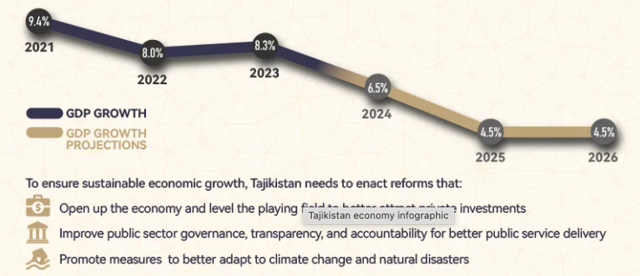
Source: World Bank/Tajikistan
Tajikistan is entering its early demographic dividend phase. The country’s working-age population (15-64 years) is projected to grow from 6.2 million (60% of the total population) in 2024 to 9.8 million (64.4%) in 2050. The dependency ratio declined from 90 dependents per 100 working-age people in 1991 to 67 in 2023 and will continue to decline until 2050. The child dependency ratio is falling, while the old-age ratio is gradually rising, signaling the onset of population ageing. If supported by strategic and timely investments, this demographic shift offers an opportunity for accelerated growth, innovation, and poverty reduction.
In response, the Government of Tajikistan has intensified efforts to diversify the economy in line with the NDS and the MTDP 2021–2025. Economic diversification measures aim to reduce overreliance on remittances and include promoting small and medium-sized enterprises (SMEs), supporting entrepreneurship, and investing in high-potential sectors. Strategic focus areas include value-added agribusiness (e.g., dried fruits and nuts for off-season export), tourism development that leverages the country’s Silk Road heritage, and light manufacturing, such as ready-made garments. Substantial public investments and donor-supported initiatives accompany these priorities, focusing on infrastructure, industrial competitiveness, and workforce skills development. Collectively, these interventions are designed to foster fiscal resilience, create employment, and build a more innovation-driven, self-sufficient economy aligned with Tajikistan’s long-term development goals.
Agriculture remains central to both livelihoods and national food security, employing more than 45 percent of the labour force and contributing roughly a quarter of GDP. However, the sector faces persistent structural, technological, and climatic constraints that undermine productivity and resilience. Tajikistan’s food security is challenged by limited arable land, land degradation, and low yields, compounded by dependence on food imports for key staples. According to national assessments, around 16 percent of households experience food insecurity, with undernutrition and micronutrient deficiencies—particularly among children and women—remaining significant public health concerns. One in ten households faces severe food insecurity, while stunting affects nearly one-fifth of children under five. Seasonal fluctuations, regional disparities, and limited storage and processing capacity exacerbate vulnerability, especially in rural and mountainous areas.
The Government has prioritized land reform, farm consolidation, and investments in climate-resilient rural infrastructure, including irrigation, drainage, and feeder roads. It has also introduced policies to strengthen domestic food production, diversify crops, and improve nutrition through school feeding and fortification programmes. Nevertheless, vulnerability to natural disasters—floods, landslides, droughts, and earthquakes—combined with the growing impacts of climate change, continues to threaten agricultural output and household food access. Tajikistan is in the process of updating its Nationally Determined Contributions (NDCs) and launched climate-focused programmes, but implementation is constrained by financing gaps, institutional capacity limitations, and the need for stronger inter-sectoral coordination to link agricultural growth with sustainable food systems and nutrition outcomes.
Figure 2: Overview of Human Development Index for Tajikistan
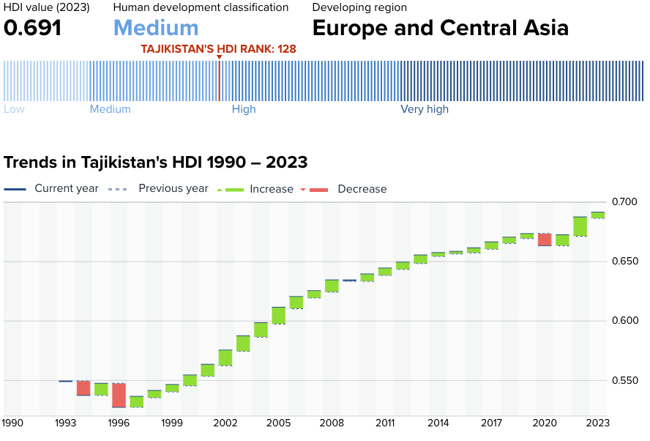
Source: https://hdr.undp.org/data-center/specific-country-data#/countries/TJK
Tajikistan’s human development trajectory has advanced gradually, though progress remains modest and uneven across key dimensions. According to the 2023 Human Development Index (HDI), Tajikistan scored 0,691 (compared to 0.679 in 2022), maintaining its position in the “medium human development” category. This composite score reflects a life expectancy at birth of 71.3 years, expected years of schooling at 13.1, and mean years of schooling at 5.8. While life expectancy has steadily improved and primary enrollment is high, the gap between expected and attained schooling suggests systemic weaknesses in education quality and retention. The infrastructure limitations (access to education facilities) remains major obstacles in providing quality teaching and learning environments, however, the quality of teaching and learning itself still needs further improvement in line with Competency Based Education reform as the MoES priorities
The HDI report reveals a notable gap between Tajikistan’s income-based ranking and its HDI standing—a discrepancy of 18 places—underscoring the lag in translating economic capacity into broader human capital development. Health system performance has seen moderate improvements, particularly in maternal and child health; however, underfunding, staffing shortages, and inequities in access to quality health services in rural areas, where 73% of the population lives remain a hindrance. Social protection programmes, including cash transfers, pensions, and school feeding initiatives—have expanded in scope. Yet, coverage and adequacy remain limited, particularly for children, people with disabilities, and female-headed households. Closing these gaps will require sustained investment, better coordination, and enhanced data systems to align policy implementation with the LNOB principle and national SDG targets.
Tajikistan has made legal progress on gender equality, including the Law on the Prevention of Domestic Violence, but the reports indicate inconsistent implementation. The President has publicly acknowledged the importance of women’s societal roles, yet female participation in politics, leadership, and the economy remains low. Social norms and gender disparities in land ownership, financial access, and employment continue to hinder SDG 5 progress. Within the framework of UNSDCF implementation, national, development and international partners support initiatives to strengthen gender-responsive institutions, service delivery, and community-based empowerment.
Governance reforms are a long-term commitment under the NDS, yet Tajikistan continues to face limitations in transparency, rule of law, and civic participation. Civil society operates under regulatory constraints, and press freedoms are limited. Efforts to improve public administration, enhance digital governance, and combat corruption have gained momentum, but progress is uneven. The UNCT and development partners support institutional accountability and justice sector reform to advance SDG 16 and build trust in public institutions.
Emerging sectors such as tourism and aviation offer promising avenues for diversification. Tajikistan possesses significant untapped potential for eco-tourism and cultural tourism, capitalizing on its Silk Road heritage and stunning natural landscapes. Strategic investments in hospitality, service standards, and international marketing, combined with air transport modernization, could position Tajikistan as a growing destination in Central Asia. These sectors align with national priorities to enhance employment, particularly for young people and rural communities.

UNSDCF for Tajikistan 2023-2026
The United Nations Sustainable Development Cooperation Framework (UNSDCF) for Tajikistan (2023–2026) serves as the central strategic document guiding the collaboration between the UN system and the Government of the Republic of Tajikistan. Developed through extensive consultations with national authorities, civil society, development partners, and private sector stakeholders, the UNSDCF aligns closely with the NDS 2030, the MTDP 2021-2025, the SDGs and Tajikistan’s human rights and international treaty commitments. It succeeds the UNDAF 2016–2022 and builds upon its lessons, responding to the evolving development context, the post-COVID-19 recovery agenda, and the imperative to reach vulnerable populations in line with the LNOB principle.
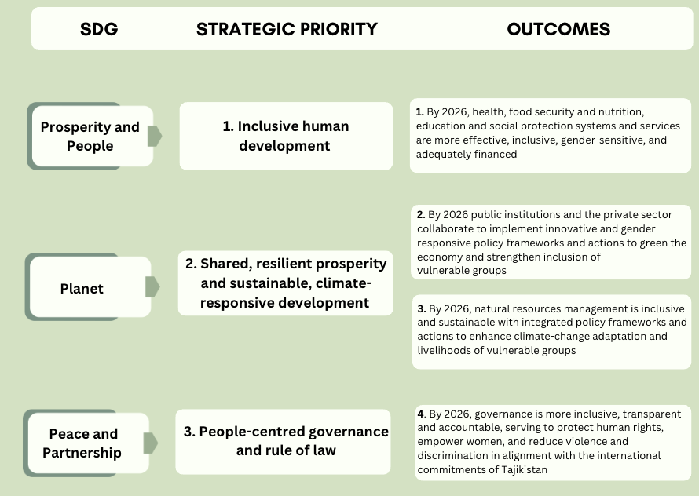
Figure 3: The UNSDCF results structure
The UNSDCF is structured around three strategic priorities and four outcomes, interconnected across thematic areas and organized along the dimensions of People, Prosperity, Planet, Peace, and Partnerships.
The UNSDCF is organized around the following outputs:
Table 2 Overview of the UNSDCF outputs (under each outcome and priority area)
PROSPERITY and PEOPLE | PLANET | PEACE and PARTNERSHIP
OUTCOME 1. | OUTCOME 2 | OUTCOME 4.
Output 1.1. Institutional capacities strengthened to provide vulnerable groups with improved access to diversified, adequately financed, inclusive, quality social protection services  Output 1.2. National education systems strengthened to ensure access to quality and inclusive life-long-learning and skills opportunities for personal empowerment, employability, social cohesion and community resilience  Output 1.3. Health system capacitated to provide universal access to quality, affordable, risk-informed and integrated health (including HIV/TB) and ECD services  Output 1.4. Strengthened institutional capacity for effective governance, planning, delivery and monitoring of equitable, safe, affordable and risk-informed water and sanitation services, (prioritizing the most vulnerable)  Output 1.5. Stronger institutional capacities to ensure food security of vulnerable groups and households, provide access to nutrition services and to adopt appropriate behaviors. | Output 2.1. Effective institutions and policy making mechanisms accelerate people centered and risk-informed economic transformation;  Output 2.2. Innovative solutions scaled up for green and inclusive value chains and food systems to promote decent employment and sustainable standards and practices  Output 2.3. People especially women, youth and other vulnerable groups have access to knowledge, skills and assets for decent employment; | Output 4.1. Institutional capacities are strengthened to develop, implement and monitor governance, rule of law and justice policies and legislation, including independent monitoring and oversight  Output 4.2. National and local capacities are strengthened to develop, implement and monitor security, social cohesion and peacebuilding policies and legislation  Output 4.3. Communities, media and vulnerable groups enjoy new capacities and opportunities to monitor and participate in decision-making and address harmful social norms.  Output 4.4. Policy frameworks and services are strengthened to prevent and respond to human rights violations, violence against women and children and gender-based violence.
 | OUTCOME 3.
Output 3.1. Policies, strategies and planning approaches are strengthened and gender-responsive solutions identified for more effective climate change adaptation and integrated natural resources management
Output 3.2. National institutions have stronger capacities to implement and monitor environment and climate change policies, manage infrastructure, and reduce the risk of local and transboundary NRM
Output 3.3. Communities, CBOs, and CSOs are engaged in planning, design and delivery of ecosystem-based interventions and models supporting community resilience and climate change adaptation
Output 3.4. Implementation mechanisms and monitoring systems are strengthened for effective emergency and disaster preparedness and response at regional, national and sub-national levels
The UNSDCF supports Tajikistan’s development vision of “a steadily growing, competitive country that provides decent living standards and equal opportunities for each person based on equality, justice and respect for human dignity.” It promotes transformative change through coordinated actions across sectors and stakeholders, including civil society, academia, the private sector, and development partners. Key focus areas include expanding inclusive access to essential services; enabling decent job creation, particularly for women and youth; managing environmental and climate risks; improving legal protection and access to justice; and strengthening institutional capacities for gender-responsive, data-driven policy and budgeting.
Guided by the core principles of human rights, gender equality and women’s empowerment, resilience, sustainability, accountability, and LNOB, the UNSDCF integrates systemic support for statistical capacity, civic engagement, and results-based management. It is operationalized through Joint Work Plans (JWPs) and monitored through Annual Performance Reviews (APR), Annual progress reporting, and evaluations. Strategic direction is provided by a Joint Steering Committee (JSC), co-chaired by the Minister of Economic Development and Trade and the UN Resident Coordinator, supported by a Programme Management Team (PMT) and Results Groups, as well as a Data/ M&E group, ensuring technical oversight and coordination. Ultimately, the UNSDCF for Tajikistan reflects a shared commitment to achieving inclusive, just, and sustainable development outcomes. It leverages the comparative advantages of the UN system to accompany Tajikistan in delivering transformative results, addressing structural bottlenecks, and ensuring that all people, especially the most vulnerable, benefit from national development progress in line with the 2030 Agenda.
Analysis of the Theory of Change (ToC)
The UNSDCF 2023–2026 for Tajikistan is firmly anchored in the guiding principles of the 2030 Agenda, specifically emphasizing the imperative to "leave no one behind," and deeply rooted in human rights, equality, inclusion, and empowerment.
It articulates a shared commitment by the UN and the Government of Tajikistan towards sustainable, inclusive development aimed at poverty reduction, resilience-building, and gender equality. Central to this Cooperation Framework is the vision of a society where all individuals, especially those most vulnerable, can meaningfully participate in development processes, fully enjoy their rights, and live with dignity.
The Cooperation Framework’s Theory of Change (ToC) clearly outlines causal pathways linking national development goals and UN contributions through three strategic priorities and four interrelated outcomes, fully aligned with the NDS 2030, the MTDP, and grounded in evidence from the Common Country Analysis (CCA). The ToC highlights the interdependence of equitable social service provision, human rights-based governance, environmental sustainability, and inclusive, resilient economic growth as prerequisites for sustainable development.
Structured around transformative pathways, the ToC explicitly targets systemic bottlenecks and emphasizes strengthening national capacities, prioritizing good governance, gender equality, and the empowerment of vulnerable populations. The ToC also outlines critical assumptions required for success, such as sustained political commitment, effective inter-agency coordination, donor engagement, and robust national data systems. Additionally, cross-cutting themes, including climate resilience, gender equality, and inclusive participation, are prominently integrated throughout the ToC to ensure holistic development.
Aligned with UNEG evaluation standards, the Evaluation Team (ET) undertook a structured assessment of the ToC across three critical dimensions: (1) conceptual soundness and relevance, (2) realism and measurability of objectives and indicators, and (3) adaptability and responsiveness to evolving contexts.
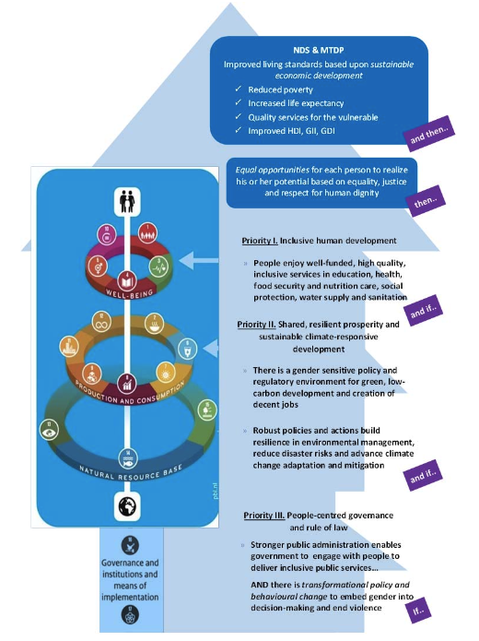
Figure 4: The UNSDCF Theory of Change (from the approved UNSDCF document)
Area 1: Conceptual Soundness and Relevance the ET confirmed that the ToC remains conceptually robust and strategically coherent. It effectively aligns with Tajikistan’s national development priorities, clearly articulated in the NDS 2030 and MTDP, as well as the challenges identified through the CCA. Strategic priorities, outcomes, and outputs reflect an integrated approach to poverty alleviation, resilience-building, and human rights promotion, with clear logical linkages and coherence with the broader SDG framework. Consultations during the inception phase with the RCO, UNCT, and government stakeholders validated the continued relevance of the ToC and its foundational role during UNSDCF implementation.
Area 2: Realism and Measurability of Objectives and Indicators: the objectives and targets defined within the ToC are largely realistic and aligned with Tajikistan’s development context and strategic priorities. However, the ET identified critical limitations in outcome-level indicators regarding their ability to adequately capture the UN’s specific contributions. For instance, the indicator under Outcome 1 – “Proportion of total government spending on essential services (education, health, and social protection)” (SDG 1.a.2) – reflects high-level fiscal policy decisions and is shaped primarily by national budgetary processes. While the UN may support public finance reform, evidence-based advocacy, or capacity development in these sectors, the indicator does not allow for attribution of change to these efforts. It fails to capture UN contributions such as technical advice, gender-responsive budgeting tools, or analytical inputs to sectoral financing strategies. Similarly, under Outcome 2, the indicator “Number of new or amended laws, policies, regulations, and investments approved to promote sustainable and green economy development that incorporate gender equity considerations” (SDGs 12.1, 12.2, 13.2.2) is conceptually relevant but operationally insufficient to reflect the scope and depth of UN engagement. It does not distinguish whether the UN facilitated technical consultations, provided legal drafting support, or developed analytical evidence underpinning these policy decisions. Without complementary process indicators, the measure risks overstating or understating the UN’s contribution.
Similarly, indicators under Outcome 3 on sustainable agriculture coverage, and Outcome 4 on governance reforms lacked granularity and specificity in distinguishing UN contributions, such as technical support, advocacy efforts, or capacity-building initiatives.
Additionally, the lack of sufficient disaggregation by gender, age, disability, and region in many indicators further limits the utility and effectiveness of the ToC’s monitoring framework in measuring inclusivity and assessing adherence to the principle of leaving no one behind. Indicators relying on national administrative data and surveys, without consistent UN support, led to data gaps in quality assurance, availability, and frequency.
Area 3: Adaptability and Responsiveness to Evolving Contexts: The ToC demonstrated considerable resilience and adaptability to significant contextual changes during implementation. The evaluation highlighted its capacity to accommodate external shocks, including the COVID-19 pandemic, the conflict in Ukraine, and related socio-economic pressures (e.g., inflationary challenges), through adaptive programming and strategic resource reallocation. Adjustments were effectively made at operational levels, including reallocation of resources and targeted realignment of interventions to emerging priorities, without undermining the broader strategic coherence. In addition, the ET analysed adaptive management practices and the efficacy of established monitoring protocols, reflecting the need for adjustments to enhance responsiveness and resilience.

The purpose and objectives of the final evaluation

Purpose of the evaluation
The rationale for this UNSDCF evaluation was to assess the extent to which the UNCT in Tajikistan prioritized support and actively contributed to the country’s comprehensive development. As emphasized in the Terms of Reference, the goal was twofold:
- To promote learning and operational improvement by providing key insights to strengthen programming and inform the next CF cycle. The evaluation enabled stakeholders to learn from documented good practices and lessons, with potential benefits for other countries.
- To support accountability by providing objective evidence of results, allowing stakeholders, including national counterparts and donors, to hold the UNCT and other actors accountable for their roles and commitments.
The insights gained from the evaluation and the recommendations derived from its conclusions were intended to facilitate the alignment of UN interventions with the principles of Agenda 2030 and the LNOB approach. This alignment aimed to forge a robust coalition to support Tajikistan in achieving its SDG targets and fulfilling its international and national commitments more effectively.

Objectives of the evaluation
The UNSDCF 2023–2026 final evaluation was conducted as an external, independent, and stand-alone exercise. Its overarching purpose was to facilitate learning by identifying what worked, what did not, and why. The evaluation assessed the performance and achievements of the Result Groups under each of the four outcomes, providing insights to inform the design of the new UNSDCF 2027-2030. It produced an independent assessment of achievements and their significance, while also reflecting on implementation challenges and lessons learned. This helped inform key stakeholders and supported accountability of the UN system.
The objectives of the evaluation were:
- To assess the UNSDCF’s contribution to national development results through evidence-based judgments, incorporating feedback from stakeholders and applying established evaluation criteria.
- To identify factors that affected the UNSDCF’s contributions, explain the reasons behind observed performance, and highlight enabling conditions and bottlenecks to support organizational learning.
- To assess the effectiveness, efficiency, and sustainability of the UNCT Tajikistan’s support, and to provide conclusions on its contributions across the evaluated period, thereby supporting institutional learning and continuity.
- To generate clear and actionable recommendations aimed at improving the UN system’s contribution to national development priorities, particularly for integration into the next UNSDCF programming cycle. This included highlighting the importance of using relevant indicators with available data and verification mechanisms to measure progress toward intended outcomes and outputs.

Scope of the evaluation
Time Scope: The evaluation covered two and a half years of UNSDCF implementation, from January 2023 to March 2025, with the earlier timing deliberately chosen to generate findings that will inform the design of the next UNSDCF cycle and support evidence-based strategic planning.
Thematic Scope: The ET assessed the collective contributions of the entire UN Country Team (UNCT)—including both resident and non-resident UN entities—toward the four outcomes outlined in the UNSDCF 2023–2026. The evaluation did not examine individual projects or agency-level programming. Instead, the ET focused on the added value, coherence, and alignment of joint efforts within the broader Cooperation Framework (CF). Special attention was given to cross-cutting issues and global UN programming principles, particularly the LNOB principle, gender equality, human rights, disability inclusion, youth engagement, and accountability. The analysis also included the UNCT’s normative and advocacy work and the functioning of inter-agency coordination mechanisms.
The evaluation further considered the UNCT’s capacity for adaptation and responsiveness to emerging development challenges, including the lingering socio-economic impacts of the post-COVID-19 recovery, climate shocks, energy insecurity, and external economic pressures. Where relevant, the ET identified thematic or sectoral areas that warranted deeper analysis to inform strategic learning and programmatic adjustment, in consultation with national stakeholders and the Evaluation Steering Committee (ESC).
Geographic Scope: The evaluation covered the national scope of the UNSDCF, with a particular focus on subnational contexts where implementation was most intensive or where disparities in development outcomes were evident. Based on the initial desk review of intervention geography, the ET and the UNCT selected a representative sample of regions—including urban and rural settings—where multiple UN agencies had an operational presence. This allowed for field-based data collection in diverse contexts and helped capture variations in institutional reach, programming intensity, and the inclusion of marginalized populations.
Findings were derived from triangulated primary data and supplemented by documentation and analytical products from agency-level evaluations, where applicable.
Intended Users of Findings: The primary users of the evaluation findings included the UNCT in Tajikistan, the Government of the Republic of Tajikistan—including line ministries and national institutions participating in the UNSDCF Results Groups—and the Office of the UN Resident Coordinator (RCO). Additional users encompassed parliamentary bodies, civil society organizations, national research institutions, development partners, and donor agencies involved in Tajikistan’s development agenda. The evaluation was designed to inform learning, enhance accountability, and support evidence-based decision-making in the development of the next UNSDCF cycle.

Evaluation Methodology, Criteria and Approach

Evaluation framework
The Evaluation Methodological Approach was grounded in the United Nations Development Coordination Office (DCO) and United Nations Evaluation Group (UNEG) Guidelines for Evaluating the United Nations Sustainable Development Cooperation Frameworks (updated 2025). It was explicitly designed to address evaluation criteria set by the OECD-DAC (relevance, coherence, effectiveness, efficiency, sustainability, and orientation toward impact) and aligned with the UNEG Norms and Standards for Evaluation. (2016).
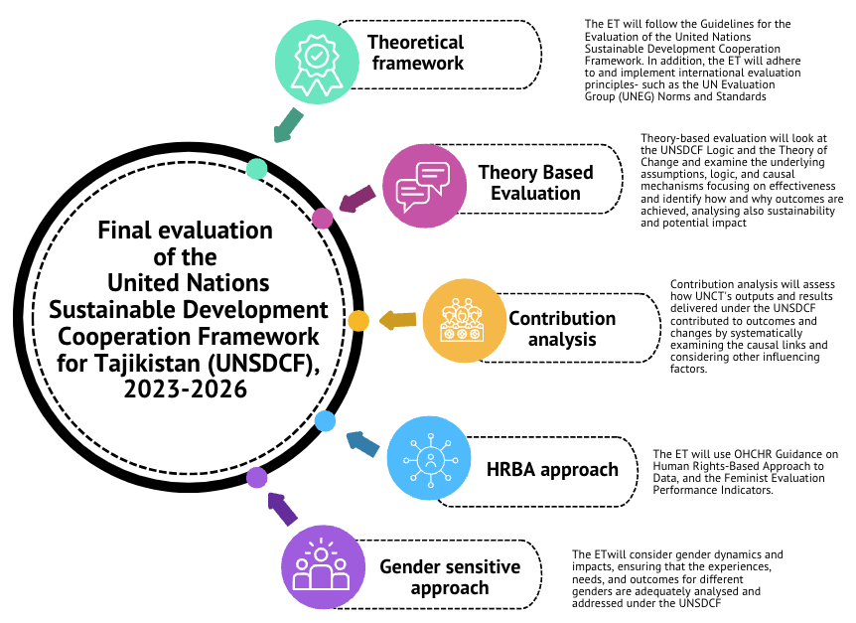
Figure 5 Overview of the evaluation methodology
Throughout all phases, the evaluation strictly adhered to UNEG Norms and Standards and UNEG Ethical Guidelines (2020), which included securing informed consent from participants and ensuring respect for privacy and confidentiality. Specific ethical considerations and mechanisms for maintaining these standards were detailed in the Inception Report. Each ET member reviewed and signed the UNEG Code of Conduct for Evaluators to ensure full ethical compliance.
The evaluation adopted a theory-based approach, using the Theory of Change (ToC) as its principal analytical framework. The ToC offered a comprehensive mechanism explicitly delineating the anticipated sequence of results and causal pathways, linking UNSDCF activities, outputs, and outcomes with broader national development priorities in Tajikistan. By clearly articulating key assumptions and potential risks, the ToC enabled systematic assessment of the organization, implementation, and achievement of the UNSDCF's intended results. This structured approach ensured that the evaluation criteria, such as relevance, coherence, effectiveness, and sustainability, were explicitly addressed through assessing the alignment of interventions with national priorities and the SDGs.
Contribution analysis served as a core analytical tool within this methodology. It systematically examined causal linkages and rigorously tested underlying assumptions, allowing validation of the specific contributions made by the UN system towards observed outcomes. This method ensured that the evaluation addressed not only the effectiveness of results achieved but also critically analyzed processes, enabling conditions, and external factors influencing these outcomes. This facilitated an in-depth understanding of efficiency, sustainability, and orientation toward impact, highlighting the UN system's value-added contributions.
Additionally, the evaluation incorporated a robust gender-responsive lens and a human rights-based approach (HRBA) throughout the entire evaluation process. Special attention was given to examining how UNSDCF interventions addressed structural gender inequalities, promoted women's empowerment, and encouraged transformative gender changes. This entailed a detailed assessment of gender equality mainstreaming within the design, implementation, monitoring, and reporting of UNSDCF initiatives. The HRBA further guided the evaluation in assessing support provided to duty-bearers to fulfill their obligations, and the empowerment of rights-holders to claim their rights. The HRBA emphasised the principles of non-discrimination, participation, accountability, and legal empowerment, thus aligning directly with evaluation criteria focused on coherence, effectiveness, and orientation toward impact.

Defining evaluation questions
The evaluation questions were strategically determined during the Inception Phase, reflecting a thorough participatory approach that involved extensive consultations with key stakeholders, including EMT, ESC, UNRCO, and UNCT. These questions were carefully refined and finalised, ensuring alignment with the evaluation criteria defined by OECD-DAC—namely, relevance, coherence, effectiveness, efficiency, sustainability, and progress towards impact—as well as with the UNSDCF’s intervention logic and the ToC.
Under the criterion of Relevance, the evaluation questions focused on assessing how effectively the UNSDCF addressed national development priorities, emerging needs, and the specific requirements of vulnerable and marginalised populations. These questions aimed to verify the alignment of CF objectives with national plans and international commitments, examining the CF's responsiveness to evolving contextual needs, particularly in relation to human rights, gender equality, and inclusion. The evaluation questions related to Coherence examined the extent to which UN agency programs and work plans were effectively derived from the CF, both in their design and implementation phases. They also assessed the roles and effectiveness of coordination structures, including the post-reform Resident Coordinator’s Office (RCO) and the Results Groups, to determine their contributions to enhancing harmonisation, complementarity, and coordinated delivery of interventions across UN agencies.
Under the criterion of Effectiveness, the evaluation questions were formulated to assess the extent to which outputs envisaged in the UNSDCF had been achieved and their contributions towards intended outcomes. The questions specifically focused on how these outputs advanced key institutional, behavioral, and legislative changes, particularly in priority thematic areas such as gender equality, women’s empowerment, and human rights. They further evaluated the tangible benefits delivered to target populations, including vulnerable and disadvantaged groups. Closely related, the Efficiency criterion questions assessed the appropriateness and effectiveness of the CF’s resource mobilisation and allocation strategies. These questions scrutinised the adequacy of financial and human resources provided by the UN agencies and examined how effectively inter-agency synergies and collaboration contributed to achieving planned outcomes.
Questions concerning Progress Towards Impact sought to determine the extent to which the activities under the UNSDCF supported the broader objectives articulated within the ToC, particularly focusing on institutional capacities and contributions to national SDG targets. These questions emphasized cross-cutting impact areas such as gender equality, human rights, and environmental sustainability, aiming to measure progress against these critical dimensions.
Finally, under the Sustainability criterion, the evaluation questions focused on examining mechanisms established by the UNSDCF to ensure the socio-political, institutional, financial, and environmental sustainability of achieved outcomes. These questions assessed the likelihood of sustained progress towards SDGs, specifically evaluating national stakeholder ownership, integration into national policies and budgets, and the commitment of national partners to maintaining results beyond the lifecycle of the UNSDCF.

The data collection approach
The evaluation integrated summative and formative dimensions. The summative dimension involved a rigorous assessment of the achievement of results at output and outcome levels, identifying best practices, innovations, and lessons learned. The formative dimension analysed implementation experiences and progress towards outcomes, including challenges and areas with more substantive achievements, to inform and enhance the responsiveness of future UN programming.
Throughout the evaluation, the ET followed a mixed-methods design, combining qualitative and quantitative data collection to ensure comprehensive triangulation and robust evidence. Multiple data sources were utilised, including in-depth desk research, secondary data analysis, key informant interviews, group discussions, targeted focus group discussions (FGDs), and online surveys for UN staff. Reflective sessions and validation exercises were systematically integrated into the fieldwork to ensure stakeholder engagement, clarify findings, and explore diverse perspectives.

Desk analysis (Phase 1)
During the inception phase, the ET conducted a comprehensive desk review aligned with the objectives set out in the ToR. This involved a detailed analysis of key strategic and programmatic documents, including the UNSDCF for Tajikistan 2023–2026, Annual Results Reports, Joint Work Plans, UNINFO datasets, and materials from Joint Steering Committee and Results Group consultations. Additionally, the ET reviewed key national documents, including the National Development Strategy 2030 and the Mid-Term Development Programme 2021–2025, alongside sector-specific strategies on education, health, social protection, climate adaptation, and human rights, to ensure alignment with national priorities and policy trajectories. Preliminary stakeholder consultations complemented this review, enhancing understanding of context-specific considerations, refining evaluation questions, and shaping a robust Evaluation Design Matrix.
The insights from this comprehensive desk review enabled the ET to map critical contextual developments, assess the strategic coherence and operational relevance of the UNSDCF ToC, and identify promising practices and challenges, particularly regarding regional disparities and issues of inclusion. These findings were synthesised in the Inception Report, which detailed the evaluation’s methodology, scope, and approach, defined the tailored data collection tools—including interviews, group discussions, and surveys—and clarified strategies for ensuring inclusivity, especially for vulnerable and hard-to-reach groups. The analysis of secondary sources continued during the evaluation phases, providing additional inputs to a s systematic triangulation and data analysis throughout the evaluation process.

Sampling and primary data collection (Phase 2)
The ET ensured comprehensive representativeness employing a detailed and strategic sampling guided by three dimensions: programmatic, geographic, and stakeholder representativeness.
- Programmatic scope and sampling. The ET applied a purposive, stratified sampling strategy to engage Outcome Results Groups, cross-cutting Thematic Working Groups (Gender Equality, Disability Inclusion, Youth), and relevant UNCT sub-teams. The sampling frame was built from the RCO stakeholder map and agency rosters. Within each Results Group, strata covered (i) agency, (ii) function/role (strategic lead, technical implementer, M&E), and (iii) level of engagement (lead, implementing, observer). Participants were then purposively selected to ensure coverage across all four outcomes and to balance perspectives from UN, Government, CSOs and partners. Sampling progress was reviewed iteratively; where gaps (e.g., gender balance or agency coverage) were detected, additional interviews were added to maintain representativeness.
- Geographic focus and rationale. The ET used maximum-variation purposive sampling to select Dushanbe, Khatlon and the Districts of Republican Subordination (DiRS). Dushanbe represented national policy/coordination and tertiary services; Khatlon was chosen for its high concentration of UN programming, poverty and disaster-risk profile, and migration dynamics; DiRS captured rural and mountainous contexts with ongoing reforms in social services, education and civil registration. Specific sites within each region were identified with agencies to include both pilot/innovative locations and “standard” service settings, allowing comparison across urban–rural contexts and strengthening the transferability of findings.
- • Stakeholder representativeness. Stakeholders were selected against pre-defined criteria—role in the results chain (policy-maker, implementer, service provider, beneficiary), level (national, subnational, community), institution type (Government, UN, CSOs/DPOs, IFIs, private sector, academia), and cross-cutting characteristics (gender, age, disability, minority status)—to uphold LNOB. For hard-to-reach and high-risk groups (e.g., GBV survivors, undocumented migrants, persons with disabilities in remote areas), the ET consulted a very limited, carefully selected sample, engaged through trusted intermediaries using safe, confidential modalities. Residual limitations—particularly fewer voices from small private enterprises and seasonal migrants in remote locations—were mitigated through triangulation with secondary data and key-informant interviews and are acknowledged in the limitations section.
To ensure relevance, inclusivity, and depth, the ET applied a purposive sampling technique. Operationally, the ET worked closely with the UNRCO and the CF Evaluation (Technical) Management Team to identify a representative cross-section of interlocutors, and prepared a comprehensive Stakeholder Mapping Matrix with visit schedule that were followed during the evaluation.
Table 1 The Stakeholders’ Sampling Summary
STAKEHOLDERS |  |  | DATA COLLECTION METHOD
STAKEHOLDER TYPE | TOTAL NUMBER OF  STAKEHOLDERS IDENTIFIED | REPRESENTATIVE  SAMPLE FOR DATA COLLECTION | Semi-structured  interviews | Group interviews | Focus  Groups | Online  Survey
UN officials | 35 | 29 | 11 | 18 |  | 61
Government representatatives | 83 | 76 | 17 | 59
Civil society | 14 | 11 |  | 11
Private sector | 9 | 5 |  | 5
Academia and think-tanks | 10 | 5 | 2 | 3
International Partners | 21 | 20 | 20
Vulnerable groups | 14 | 5 | 5
Total | 186 | 151
RRS
Government Institutions | 2 | 2 | 2
Vulnerable Groups | 9 | 9 |  |  | 9
Beneficiary Groups | 11 | 9 |  |  | 9
Total | 22 | 20
Khatlon
Government Institutions | 3 | 5 | 2
Vulnerable Groups | 9 | 8 |  |  | 8
Beneficiary Groups | 7 | 5 |  |  | 5
Total | 19 | 18
Total Sample | 227 | 198
The nominations from UN agencies were validated during a meeting with the Evaluation Advisory Group, comprising the Evaluation Manager and the Evaluation Technical Management Team, on 7 May 2025. Given the inclusiveness of the process and the fact that the ET spent time in different locations, the evaluation met the criteria of programmatic, geographic, and stakeholder representativeness
During the in-country mission conducted from June 9 to 20, 2025, the ET undertook extensive primary data collection, involving semi-structured face-to-face and online interviews, group discussions, thematic Focus Group Discussions (FGDs), and participatory methods, reaching stakeholders at both strategic and operational levels. These stakeholders included representatives of national and sub-national government representatives (76), UN officials (29), civil society organisations (11), private sector actors (5), academia, research institutions and think-tanks (5), international development partners (20), and representatives of vulnerable groups (5).
Regional consultations were held in Khatlon (20 stakeholders) and DRS (20 stakeholders), specifically engaging local authorities, community-based organisations, and vulnerable groups to integrate local perspectives into the evaluation. Special emphasis was placed on engaging historically underrepresented and marginalised populations, including persons with disabilities, women living with HIV, survivors of gender-based violence, stateless individuals, and communities affected by migration or climate-related shocks. Interviews and FGDs with partnerships involving grassroots NGOs and CSOs enabled engagement and analysis of the realities faced by vulnerable groups, facilitated inclusive access to these communities, and aligned the evaluation approach with the principle of Leaving No One Behind (LNOB).
Additionally, structured online surveys targeting UN agency programme and operations staff yielded 61 valid responses, reinforcing the methodological rigor and providing broad-based insights on programmatic and operational effectiveness.
Data collection tools were guided by a robust Evaluation Matrix aligned with OECD-DAC criteria and UNEG standards, facilitating comprehensive triangulation, validation of thematic patterns, and strategic insights into the UNSDCF’s Theory of Change, adaptive programming, and contextual responsiveness. This thorough and inclusive approach ensured evidence-based conclusions and actionable, strategically prioritized recommendations validated with national counterparts and the UNCT, enhancing the utility and relevance for future UNSDCF cycles.

Synthesis & reporting (Phase 3)
This phase involved analysing and synthesising all data collected during the desk review and fieldwork to prepare the Final Evaluation Report. The ET structured qualitative data analysis systematically by creating codes and categories that were explicitly aligned with the evaluation matrix, its sub-questions, judgment criteria, and indicators. MAXQDA software facilitated a rigorous, transparent, and replicable approach to thematic analysis and coding, ensuring methodological consistency, accuracy, and internal validity.
The structured approach allowed the ET to efficiently identify key trends, achievements, and challenges at outcome and output levels. Each finding was carefully substantiated through triangulation of qualitative and quantitative evidence from multiple data sources, ensuring robust cause-and-effect linkages. The ET then articulated clear conclusions derived from these validated findings, alongside actionable, forward-looking recommendations designed to address identified gaps, leverage opportunities, and support strategic decision-making for the subsequent UNSDCF cycle.

Review and validation (Phase 4)
In August 2025, the draft Final Evaluation Report was shared with the UN Country Team (UNCT), Evaluation Steering Committee, government counterparts, and other key stakeholders for comprehensive review and validation.
The ET facilitated a stakeholder validation workshop to present preliminary findings, ensure alignment of expectations, clarify emerging results, and address any inconsistencies or outstanding issues proactively. Feedback collected from stakeholders was systematically integrated into the final report, addressing factual inaccuracies and refining conclusions and recommendations.
The professionally edited Final Evaluation Report provided a consolidated synthesis of key findings, conclusions, and strategic recommendations. It also highlighted lessons learned and good practices. It proposed adjustments to enhance monitoring, reporting frameworks, oversight arrangements, and implementation structures, taking into account evolving national contexts and priorities to optimize the performance and impact of the upcoming Cooperation Framework.

Participatory approach within the evaluation
The evaluation employed a strongly participatory and consultative approach, actively engaging key stakeholders at every stage of the process. This comprehensive engagement was designed to enhance national ownership, facilitate meaningful validation of emerging findings, and ensure the relevance and applicability of conclusions and recommendations within Tajikistan’s institutional context and priorities.
The participatory process was intentionally inclusive, incorporating internal stakeholders within the UN system and external national partners. Particular emphasis was placed on involving marginalised and underrepresented groups to capture diverse perspectives and ensure their voices were integrated into the evaluation. Specifically, tailored consultations and targeted focus group discussions were systematically organized in underserved regions, notably Khatlon and the Districts of Republican Subordination (DRS), involving communities and groups frequently excluded from national planning and decision-making processes. This approach strengthened the contextual accuracy and depth of findings, contributed to stronger stakeholder buy-in, and enhanced the practical utility and credibility of the evaluation outcomes.

Quality assurance during the evaluation
The evaluation employed a rigorous and comprehensive quality assurance framework, systematically integrating robust triangulation across multiple data sources, including document reviews, semi-structured interviews, surveys, and targeted focus group discussions. Triangulation involved analysing desk data and primary sources, cross-verifying evidence from diverse stakeholder groups, which enabled comprehensive validation and enhanced the credibility and reliability of the findings.
To ensure methodological consistency and internal validity, the ET conducted regular reflective sessions with the EMT throughout the evaluation process. These sessions enabled ongoing assessment of data collection progress, analytical rigor, and early identification and resolution of methodological challenges. Iterative feedback loops were established with implementing entities, allowing stakeholders to continuously review emerging findings, clarify interpretations, and address inconsistencies promptly.
Quality assurance was further reinforced through systematic validation processes involving ongoing consultations with the ESC and the EMT. The draft evaluation report underwent meticulous review by these bodies to correct factual inaccuracies, reinforce coherence, and align interpretations closely with stakeholder perspectives and national priorities. Additionally, formal quality assessment was done by the UN DCO, ensuring full compliance with the CF Evaluation Checklist. This comprehensive approach significantly strengthened methodological robustness, ensuring reliable and valid conclusions, enhancing stakeholder confidence, and optimizing the evaluation’s credibility and utility.

Management arrangements and roles in evaluations

Management Arrangements for the Evaluation
The UNRCO and the UNCT) commissioned the evaluation and oversaw any follow-up actions, with the following bodies governing the process:
- Evaluation Manager (EM): The EM served as the primary point of contact for daily evaluation management. The EM ensured timely implementation and provided strategic guidance throughout the process. In consultation with relevant stakeholders, the EM led the preparation of the Terms of Reference (ToR), ensuring that the methodology and approach addressed the evaluation objectives. The EM facilitated communication between the ET and the EMT, coordinated the provision of feedback on deliverables, and ensured that the appropriate authorities endorsed evaluation outputs.
- Development Coordination Office (DCO): The DCO Evaluation Advisor supported the EM, RC, and UNCT in assuring quality and adherence to UNEG standards of key evaluation deliverables, including the ToR, inception report, and final report..
- Evaluation (Technical) Management Team (EMT): Composed of technical experts from the UN Data/MEL Group, the ETMT played a critical role in maintaining evaluation quality and relevance. It provided guidance to the ET, facilitated stakeholder engagement, and reviewed all key deliverables. The ETMT also prepared a Management Response Matrix, reflecting commitments to act on the evaluation's findings and recommendations.
- Evaluation Steering Committee (ESC): The ESC, comprising senior representatives from the Government and the UN (represented by the Programme Management Team – PMT), functioned as the highest-level oversight body. It validated the evaluation design, endorsed the process, reviewed and endorsed the final deliverables, and approved the management response. The ESC’s engagement in validation meetings reflected a shared commitment to accountability and transparency.

Evaluation Team Composition, Roles and Responsibilities
The independent Evaluation Team consisted of an international Team Leader (TL) and a senior national Evaluation Expert (EE), both possessing extensive knowledge of the Tajikistan context and the technical domains covered by the UNSDCF.
Recognizing the ongoing evaluations (e.g., agency CPDs and project-level assessments), the ET actively coordinated with other evaluation teams to avoid duplication and promote synergy, including through joint participation in stakeholder meetings and discussions on preliminary findings.
Inception Phase:The TL led the analytical reconstruction of the Theory of Change (ToC) and critically reviewed the UNSDCF intervention logic. Based on this, the TL developed the evaluation methodology, including the Evaluation Matrix, evaluation questions, and indicator analysis. The TL reviewed relevant policy documents across key sectors—education, social protection, health, governance, resilience, gender, and environment—and examined strategic deliverables and implementation barriers of joint UN initiatives.
The EE contributed to the review of analytical and legal frameworks, helped develop interview guides and data collection instruments, and identified evidence under each indicator. The TL finalized and submitted the Inception Report on behalf of the team.
Field Phase – Primary Data Collection: Both the TL and EE conducted interviews with representatives of the UNCT, Government of Tajikistan, local authorities, international partners, and other stakeholders. The EE organized and facilitated focus group discussions. The ET held complementary virtual interviews and worked closely with the RCO to ensure comprehensive stakeholder engagement. The team compiled detailed minutes of all Key Informant Interviews (KIIs), group meetings, and focus groups under each outcome.
Synthesis Phase: During the synthesis phase, the Team Leader led the consolidation of evidence gathered through desk review, key informant interviews, and focus group discussions. Drawing on the Evaluation Matrix and Theory of Change, the Team triangulated findings across data sources and systematically analyzed the extent to which the CF outcomes had been achieved, while identifying enabling factors and constraints. Particular attention was given to assessing how cross-cutting principles—such as gender equality, human rights, and environmental sustainability—were integrated across interventions. The Evaluation Expert supported the process by refining evidence under each indicator and finalizing analytical inputs for each evaluation question.
To validate and refine the emerging findings, the Evaluation Team conducted a series of validation sessions, including internal consultations and formal workshops with the UNCT, Evaluation Technical Management Team, and the Evaluation Steering Committee. The Team also presented preliminary findings to national stakeholders, ensuring that insights were tested for accuracy and relevance. Feedback received during these consultations was used to refine the evaluation judgments, finalize the responses to the evaluation questions, and strengthen the conclusions and recommendations. The synthesis phase concluded with the drafting of the Final Evaluation Report, ensuring that it reflected both methodological rigour and stakeholder validation.

Ethical Considerations
The ET adhered to the OECD DAC ethical considerations for development evaluations and the United Nations Ethical Guidelines. Throughout the process, the ET upheld ethical standards in the selection of interviewees, in their interactions with them, and in the protection of their personal and institutional rights. Prior to conducting interviews, the ET obtained informed consent from all stakeholders. The purpose, objectives, and scope of the evaluation, as well as the questions posed, were clearly explained. Stakeholders were informed of their right to refuse participation or to withdraw at any time without consequence..
The ET bore full responsibility for exercising discretion in handling all information and refrained from divulging confidential content without appropriate authorization. Informants’ rights to provide information in confidence were respected, and safeguarded. All original data, including interview notes and recordings, were securely stored in confidential files until the conclusion of the evaluation..

Findings
The following paragraphs present the findings organised around the evaluation criteria and corresponding evaluation questions. The ET answered these questions using judgment criteria and evaluation indicators.

Relevance
The ET analysed whether the UN, through the CF, implemented and addressed the country’s long- and mid-term priorities as articulated in national development plans, also considering alignment with international commitments. The analysis considered the extent to which the Framework was grounded in the CCA, with logically formulated outcomes and measurable indicators. The ET also evaluated the UNSDCF’s responsiveness to the evolving needs of vulnerable groups and its adaptability to emerging challenges, including socio-economic shifts and post-COVID recovery.
EQ1.1: To what extent are the CF objectives aligned and consistent with the needs, priorities, and policies of the Government (including alignment to national development goals and targets, national plans, strategies and programmes)?
F1. The CF is aligned with Tajikistan’s national priorities as defined in the NDS-2030 and MTDP 2021–2025, and its outcomes effectively reflect the country’s long-term vision for inclusive, sustainable development. However, there are opportunities to enhance operational alignment by further prioritizing emerging needs at the subnational level and refining the outcome frameworks to support sector-specific priorities.
The CF outcomes are structured around interlinked pillars—human development, inclusive economic growth, environmental sustainability, and people-centered governance—that directly reflect the priorities defined in the NDS-2030 and the MTDP 2021–2025. The representatives of the key national partners stated that “this alignment was not coincidental but emerged through deliberate, inclusive planning processes and evidence-based analysis that all partners considered and approved”. For example, Outcome 1, which focuses on inclusive human development, aligns with the MTDP’s pillar on improving the quality and accessibility of education, healthcare, and social protection, as well as achieving gender equality. This reflects the NDS-2030’s emphasis on human capital as a foundation for long-term growth. Outcome 2 aligns with national strategies for employment promotion, private sector development, and digital innovation. Outcome 3 corresponds to Tajikistan’s climate and environmental resilience priorities, including the Green Economy Strategy and the National Adaptation Plan. Outcome 4 supports governance reforms, legal empowerment, and human rights—elements embedded in both the NDS-2030 and public administration reform objectives.
The common opinion among the interviewed stakeholders is that the CF has remained relevant despite changing external circumstances, particularly highlighting the CF’s flexible design and annual review mechanisms. This approach enabled the UN to recalibrate programming in response to shifting national priorities without losing strategic direction.
However, despite its strong strategic relevance to the national priorities, there are views (including representatives of UN Agencies) that CF programming did not always reflect the full range of emerging needs. —especially in remote regions and among newer at-risk groups (e.g., youth outside education and employment, informal workers, persons affected by migration shocks). Additionally, government partners highlighted the need for sharpening CF outcome definitions to better serve as operational guides
F2. The CF has effectively supported national sector-specific policies and programmes through well-targeted initiatives under its outcomes. However, generating local-level actions remains challenging due to weak institutional capacities, limited funding, unclear financial responsibilities, and ongoing coordination gaps across sectors and administrative levels.
Beyond relevance at the strategic level, the CF responded to specific national policy instruments, sectoral strategies, and government-led programmes. For example, under Outcome 1, the CF directly supported the National Health Strategy (2021–2030), Social Protection Plan of Action (2024–2026), and Education Sector Mid-Term Action Plan (2024–2026), significantly aiding service continuity amid fiscal constraints. Outcome 2 interventions effectively addressed national activities for productive employment and SME development strategies, though rural outreach remained limited and dependent on short-term funding. Similarly, Outcome 3 was instrumental in implementing environmental action plans and watershed management initiatives, with stakeholders emphasizing the UN’s technical contributions. Outcome 4 notably facilitated the adoption of Tajikistan’s first National Human Rights Strategy (until 2038), judicial sector reforms, and strengthened access to justice and legal aid. Similarly, Gender Equality is mainstreamed in some outcomes, aligning with SDG priorities.
Finally, internal feedback from UN management and programme staff survey corroborated this assessment. Over three-quarters agreed that the CF aligns well with national priorities, confirming its strategic relevance. Nevertheless, concerns were raised about its practical responsiveness to evolving vulnerabilities, citing gaps in targeting mechanisms, insufficient disaggregated data, and limited flexibility in adapting to shocks. Also, translating national strategies into local-level actions faced persistent constraints: the analysis indicated weak institutional capacities, limited fiscal resources, fragmented mandates, and insufficient vertical and horizontal coordination between national policy frameworks and local implementation were highlighted as significant operational barriers These observations underline the necessity of placing greater emphasis on operational responsiveness, continuous data innovation, and inclusive approaches to fully realise the CF’s core commitment of leaving no one behind.
F3. In addition to national and sectoral priorities, the CF has been relevant to advance Tajikistan’s commitments to LNOB, HRBA, and GEWE. Still, the need remains to invest In data infrastructure, participatory oversight mechanisms, budgetary integration of LNOB and GEWE principles and stronger engagement with treaty bodies.
The CF has effectively advanced Tajikistan’s international commitments, notably in LNOB, HRBA, and GEWE. It served as a credible and impactful platform to embed these normative principles into national development efforts, effectively aligning policy frameworks with the 2030 Agenda and SDGs. The CF’s design explicitly promotes integrated, redistributive, and coherent approaches that support the government in balancing economic growth, social equity, and environmental sustainability. For instance, integration of inclusive education, rights-based healthcare, and social protection under Outcome 1 illustrates a systemic approach that extends beyond basic service delivery toward comprehensive equity and institutional reforms. Similarly, the institutionalisation of free legal aid services, now fully budgeted and managed by the Ministry of Justice after prolonged UN support, highlights a successful transition from externally driven pilots to sustainable national ownership.
Stakeholders confirmed that the CF has provided a critical platform enabling Tajikistan to meet its international commitments under key human rights frameworks, including the Universal Periodic Review (UPR), the Convention on the Elimination of All Forms of Discrimination Against Women (CEDAW), the Convention on the Rights of the Child (CRC), and the Convention on the Rights of Persons with Disabilities (CRPD), which Tajikistan is committed to ratifying. Concrete interventions have supported these normative commitments, linking policy reform and institutional capacity development. Notably, UN assistance facilitated the adoption of Tajikistan’s first long-term National Human Rights Strategy (2023–2038), enhanced reporting under international human rights mechanisms, and bolstered accountability through direct support for UPR and shadow reporting. In the domain of gender equality, notable milestones include legislative reforms in domestic violence prevention, adoption of the State Programme on Prevention of Domestic Violence (2025–2030), and the significant reduction of prohibited professions for women from 336 to 195 through collaboration with the Ministry of Labour. Additionally, targeted capacity-building efforts by the UN advanced gender-responsive budgeting practices, with the Ministry of Finance now applying gender-sensitive budgeting tools in priority sectors.
Furthermore, the CF has supported SDG financing initiatives promoting equity and inclusion, emphasizing alignment of budgetary processes with SDG targets. While these initiatives have generated significant interest, stakeholders stressed that they require sustained financial and institutional support for deeper integration into public financial management processes and service delivery monitoring.
One of the CF’s key institutional contributions has been the enhancement of national data systems to support LNOB principles, primarily through collaboration with the Agency on Statistics. Achievements include developing the National Statistics Strategy (2019–2030), launching the SDG data platform for enhanced governance and policymaking, presenting 2020 Population and Housing Census results, initiating the Mobility Tracking Matrix (MTM) for migration data, and establishing child-sensitive statistical and monitoring frameworks. Despite these successes, some critical gaps persist. For example, the Vulnerability and Resilience Atlas (2019)—intended as a fundamental resource for informed planning, budgeting, and targeted service delivery—has been implemented before the start of this CF cycle but has not been adequately integrated into the national planning or statistical system, nor updated since this initial release, limiting its effectiveness in SDG monitoring and resource allocation.
EQ1.2: To what extent are the CF objectives responsive to emerging needs, especially those of the most vulnerable, disadvantaged, and marginalized groups?
F4. The CF has effectively responded to evolving and emerging needs of vulnerable, disadvantaged, and marginalised groups, although structural and operational constraints highlight the necessity for ongoing investment in institutional capacities, robust data systems, and strengthened coordination mechanisms.
The CF strategically addressed multiple interrelated vulnerabilities, including inadequate health infrastructure, poor access to quality education, fragmented social protection, and escalating food insecurity (further exacerbated by the lingering impacts of COVID-19). Stakeholders underscored the critical role of CF-supported interventions such as nationwide immunisation campaigns, reproductive and maternal health programmes, gender based violence prevention programs, and HIV/AIDS services in mitigating compounded vulnerabilities, particularly for groups facing systemic discrimination and intersectional human rights violations, including persons with disabilities, refugees, and women.
Food insecurity, identified as a growing concern, particularly affected rural households, women, and children, intensifying due to inflation, climatic shocks, and underdeveloped rural economies. The CF interventions, notably through school feeding programmes and micronutrient supplementation, were effective in temporarily addressing nutritional gaps. Nevertheless, stakeholders stressed that sustained, structural efforts are necessary to ensure lasting impact on food security, nutrition, and livelihoods, highlighting the need for greater investment in rural economic resilience.
In education, CF initiatives, including the mid-term education action plan (2024–2026), emphasised inclusive policies addressing the needs of rural students and children with disabilities. While these interventions successfully expanded educational access, interviewed stakeholders emphasised the necessity of sustained financial commitments and systemic reforms to maintain and extend these gains. The ET finds that challenges remain- for example, many of these children are still learning in separate institutions due to the stigma associated with CwD, lack of readiness for schools to accommodate these children (both physically and psychologically) This situation is further affected by the fact that teachers have not been trained to accommodate these children.
The CF-supported economic inclusion initiatives (Outcome 2) directly addressed the structural exclusion faced by women, youth, and labour migration returnees. Stakeholders praised targeted employment programmes, remote work centres, and youth-focused skills-building initiatives for their relevance. However, stakeholders indicated that entrenched socio-cultural norms, discriminatory practices, limited access to productive resources, and insufficient funding have constrained the sustainability and depth of impact, underscoring the need for more comprehensive and integrated support systems to ensure economic empowerment of marginalized groups.
Environmental risks were addressed systematically, through community-based natural resource management and climate adaptation interventions. Yet stakeholders consistently raised concerns about the chronic underfunding of disaster risk reduction and climate adaptation measures, which remain heavily reliant on short-term donor funding. Rural and remote communities remain highly vulnerable to natural hazards, and institutional capacities at the local level are inadequate to support sustainable resilience-building. Continued investment in institutional capacities and strengthened coordination at all administrative levels is essential to address these persistent gaps.
Cross-cutting themes, including gender equality and human rights, have been integrated into the majority of outcomes. Specifically, gender equality has been emphasized through the communications and advocacy initiatives of the United Nations Communications Group and several collaborative programs, notably the Spotlight Initiative. The national partners and CSOs recognized the efforts of the UN agencies in supporting gender equality initiatives. Yet, most of the partners raised concerns about the efforts not reaching the rural and remote communities due to a lack of a strong implementation mechanism.
National authorities expressed broad satisfaction with CF relevance and responsiveness, highlighting its coherence with national priorities, especially in previously underserved areas. They appreciated CF-supported advances in maternal health, civil registration, legal aid, social protection, gender equality and food security, acknowledging CF as a critical platform for testing and replicating integrated service delivery models and enhancing inclusive education and gender-sensitive climate adaptation in remote districts.
However, internal assessments, as presented through the staff survey within the UN system, offered a more critical perspective, with only about half of the staff fully satisfied. This divergence in perception between positive government assessments and more cautious internal UN feedback suggests a crucial gap between strategic ambitions and operational realities. UN Staff highlighted fragmented implementation, insufficient strategic interagency coordination, lack of a unified targeting framework, and inadequate disaggregated data, particularly disability-specific data. Several respondents pointed to operational rigidity, unpredictable funding, and frequent turnover within UN and government institutions as key obstacles undermining coherent, integrated programming.
Figure 6 Perception if the UNSDCF respond to emerging needs, especially people in vulnerable and marginalized situation
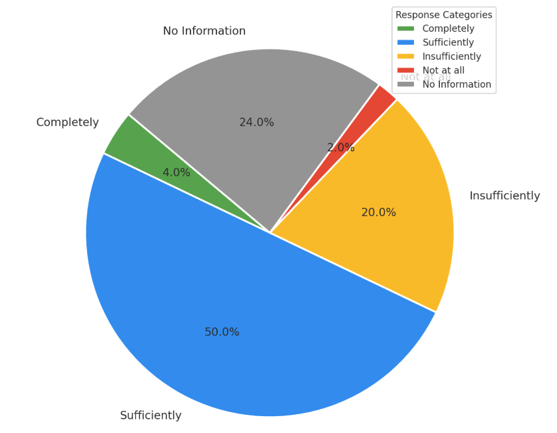
Source: On-line survey- UN programme and management
Despite these operational criticisms, tangible achievements were evident. Primary and secondary data analysis confirmed improved access to nutrition and health services for women and children in vulnerable regions, enhanced legal identity documentation for marginalised populations, increased educational inclusivity for children with disabilities, and climate adaptation support for high-risk communities. Yet effectiveness and sustainability varied significantly by geographic area and sector, emphasising the uneven nature of the CF’s impact and underscoring the need for enhanced local capacities and sustained national ownership.
F5. The UNCT demonstrated initial relevance, but also adaptability in responding to the evolving needs of groups in vulnerable positions through context-sensitive programming and rights-based mainstreaming.
The UNCT demonstrated notable adaptability in addressing the evolving priorities and vulnerabilities of marginalised groups through flexible, context-sensitive programming and rights-based mainstreaming, especially in response to overlapping global and regional shocks and geopolitical instabilities. Key initiatives included scaling up nutrition programmes, digital learning platforms for disrupted education, employment programmes targeting returnees, informal workers, and young women, and resilience-building initiatives at the community level. Adaptations were evident in the revision of the Decent Work Country Programme to address post-pandemic employment dynamics and integration challenges faced by return migrants. Furthermore, the UNCT's collaboration with the Agency on Statistics notably strengthened national SDG data tracking systems, improving responsiveness to regional disparities. However, persistent gaps in real-time, local disaggregated data constrained dynamic and precise adjustments, limiting the effectiveness of these responsive interventions.
While the SDG Financing initiative represented an important step towards inclusive fiscal policy, stakeholders underscored uneven institutional capacities, insufficient funding, and inconsistent implementation at the ministry level. The UNCT staff survey validated the positive impact of adaptive measures yet highlighted ongoing structural challenges such as superficial operationalisation, inadequate resource allocation, and insufficient technical capacities in rural areas, indicating critical gaps between policy commitments and practical implementation.
The CF’s dual approach, combining standalone initiatives with mainstreaming human rights, gender equality, and environmental sustainability across outcomes, demonstrated effectiveness in supporting marginalised populations. Nevertheless, consultations consistently identified significant operational constraints, including weak enforcement mechanisms, fragmented governance structures, and uneven local service delivery, particularly in remote areas.
The triangulated data revealed that these persistent limitations are linked to systemic challenges; the analysis emphasised the need for strengthened operational funding, enhanced frontline staff training, reinforced accountability mechanisms, and improved inter-ministerial and inter-agency coordination to ensure cohesive, integrated, and sustainable responses. Despite these systemic barriers, stakeholders widely recognized the UNCT’s critical role in supporting inclusive development interventions and providing reliable technical expertise and policy support, particularly during times of significant socio-economic disruptions.
EQ1.3. To what extent has the CF integrated key issues and development challenges identified by the UN Common Country Analysis (CCA)?
F6. The CF exhibits a high degree of integration with the CCA, which identified systemic and emerging challenges and helped UNCT translate them into context-responsive priorities, cross-sectoral plans, and targeted actions. The CCA is perceived as a dynamic tool for development programming that enabled CF’s strategic relevance and coherence with national and SDG frameworks, and adaptability to Tajikistan’s development.
The CCA and its subsequent annual updates have served as foundational tools for translating complex development challenges into contextually relevant CF priorities, outcomes, and targeted interventions. The CF formulation was participatory and evidence-based, directly involving over 30 government ministries and more than 50 partners—including civil society organisations, private-sector actors, academia, and international agencies—thus strengthening its strategic relevance and coherence with national and SDG frameworks.
The 2021–2022 CCA provided an essential diagnostic basis, identifying core structural challenges, including persistent poverty, widespread food insecurity, gender and spatial inequalities in education, healthcare, social protection, rural economic vulnerability, environmental degradation, governance weaknesses, and constrained civic space. These challenges have been systematically addressed across the CF’s outcomes. For example, Outcome 1 explicitly targets deficits in health infrastructure, inclusive education access, fragmented social protection systems, and widespread nutrition gaps. Outcome 2 addresses economic informality, insufficient employment opportunities, the need for sustainable value chains, and the creation of decent and green jobs. Outcome 3 addresses climate vulnerability, disaster risks, and resource management gaps, while Outcome 4 focuses on governance deficits, limitations to civic space, and the need for enhanced transparency and accountability mechanisms.
The 2023 CCA Annual Update further sharpened the analytical focus by capturing the challenges of post-pandemic recovery, the impacts of geopolitical instability, and regional economic vulnerabilities. It underscored Tajikistan’s continued dependency on remittances, persistent regional disparities, food price inflation, and enduring child malnutrition as critical obstacles to inclusive development. These findings informed adjustments in CF programming, including targeted nutritional interventions such as expanded school feeding programmes, nationwide maternal and infant nutrition counselling, and Vitamin A supplementation campaigns. The CF also responded to CCA recommendations on SDG implementation tracking and data disaggregation, evident in efforts to strengthen national statistical systems, support institutional capacities for SDG monitoring, and embed LNOB considerations more comprehensively within programme design and evaluation frameworks.
In 2024, the CCA update further refined the situational analysis, highlighting challenges such as inflationary pressures impacting household purchasing power, limited fiscal resources for expanding social services, intensifying climate-induced risks (including floods and droughts), the high burden of out-of-pocket health expenditures, persistent gender disparities in economic participation, and rising educational dropouts, particularly in remote areas. The CF effectively incorporated these insights by supporting new interventions, such as adopting the National Action Plan for Antimicrobial Resistance and the Costed State Reproductive Health Programme, addressing specific gaps identified in the health system. Similarly, the Mid-Term Education Action Plan (2024–2026) adopted inclusive education principles, digital learning frameworks, and comprehensive teacher training, directly responding to education inequalities highlighted by the CCA. Economic empowerment initiatives for women, youth, and returnee migrants, such as remote job centres and expanded skills-building interventions, were specifically designed to address labour market exclusion challenges identified in the CCA. Additionally, Outcome 3’s enhanced climate resilience efforts—including watershed management plans and community-based ecosystem interventions—were driven directly by the recognition of environmental vulnerabilities.
Stakeholders confirmed that the iterative and dynamic use of the CCA and its annual updates “critically enhanced the CF’s responsiveness to Tajikistan's evolving context”. Interviews indicated that regular mid-year reviews and Result Group discussions consistently used updated CCA findings to recalibrate programming priorities. For example, the 2024 CCA highlighted digital exclusion and limited digital literacy among rural youth and women, prompting the UNCT to introduce targeted digital learning initiatives and entrepreneurship platforms. Stakeholders particularly recommended institutionalising data innovations such as vulnerability mapping tools into government systems, to ensure sustainable integration of evidence-based programming in line with CCA findings.
F7. A broadly sound problem analysis underpins the UNSDCF 2023–2026. Still, the outcomes remain highly ambitious in scope, and their achievability within the CF cycle is uncertain. Horizontal integration between outcomes is limited, and while indicator alignment with SDG frameworks is a strength, concerns remain regarding the specificity, realism, and disaggregation (of some of them). Still, outputs are generally well-formulated to address medium-term institutional and policy gaps..
The evaluation finds the CF’s outcome and output structure to be logical and grounded in comprehensive problem analysis. The formulation of CF outcomes reflects a clear understanding of structural, systemic, and emerging development challenges derived from the CCA and its updates. However, certain outcomes remain ambitious, and their full realisation within the CF timeframe is uncertain.
At a vertical level, the logical linkages between CF outputs and outcomes are generally evident and credible, particularly in relation to strengthening institutional capacities, enhancing policy frameworks, and improving service delivery mechanisms. For example, Outcome 1’s outputs effectively target public institutions to enhance access and quality in education, health, nutrition, and social protection sectors. These outputs provide plausible pathways toward achieving inclusive and equitable human development outcomes. Similarly, under Outcome 3, the outputs effectively align with enhancing environmental resilience, disaster preparedness, and sustainable management of natural resources.
However, Outcome 2 demonstrates weaker vertical linkages, with certain outputs inadequately anchored in detailed problem analyses. Challenges such as labour informality, limited private sector growth, and structural economic exclusion identified in the CCA are addressed insufficiently, with outputs often formulated in a fragmented and generic manner rather than explicitly targeting core systemic barriers. Consequently, the causal relationship between outputs and intended outcomes remains somewhat abstract and inadequately evidenced.
From a horizontal integration perspective, outcomes generally remain sector-specific, limiting opportunities for integrated cross-sectoral interventions. Despite recurring thematic areas (digitalisation, gender equality, resilience) across multiple outcomes, there is limited explicit interconnection or shared indicators that systematically capture these cross-cutting themes. Furthermore, several outcomes are articulated in ambitious or near-impact-level terms, raising concerns about their practical feasibility and evaluability within the CF timeframe. Outcome 4 exemplifies this, aiming for comprehensive governance improvements, expanded civic space, and strengthened rule of law without adequately clarifying intermediate pathways or realistic short-term institutional and behavioural milestones.
Additionally, the absence of an overarching country-level and comprehensive ToC limits the CF’s ability to articulate a unified strategic vision of systemic change clearly. Without an integrated ToC, stakeholders find it challenging to track causal pathways comprehensively across outcomes and towards the broader vision, making it difficult to manage and measure strategic progress, or establish a clear narrative linking sector-level interventions to outcomes, and then to major strategic objectives. In addition, the Results Framework presents a mixed picture in terms of indicators (see more details under F8).
F8. The ET finds that the UNSDCF includes a solid foundation of relevant, measurable and in many cases, realistic indicators and benchmarks. However, the ET also finds gaps in coverage, disaggregation, and strategic fit of some of these indicators with the full scope of UN programming.
The ET finds that the CF’s Results Framework incorporates performance indicators aligned with national development strategies and the global SDG indicator framework. Many of these indicators are supported by established administrative data sources, such as the Agency on Statistics, sector ministries, and recognised international agencies, which enhances their credibility, promotes data harmonisation, and reduces duplication of effort. While the inclusion of SDG-aligned indicators represents a sound step toward coherence with national monitoring systems and international commitments, the ET finds that the overall quality, specificity, and strategic fit of the indicators remain uneven. Some indicators are appropriate and measurable, and several are supported by defined baselines and time-bound targets drawn from national statistical systems. However, significant discrepancies persist in the formulation, applicability, and evaluability of several of them.
Outcome | Nr Indicators | With Baseline | With Target | Disaggregation | Gaps / Issues
Outcome 1: Inclusive Human Development | 13 | 10 | 11 | 6 | Majority indicators lack gender, disability, and geographic disaggregation; two rely on proxy satisfaction metrics
Outcome 2: Inclusive Green Economic Growth | 10 | 6 | 7 | 3 | Baselines missing for private sector and green investment indicators; no disaggregation on vulnerable groups
Outcome 3: Climate and Environmental Risk Governance | 8 | 5 | 5 | 2 | No Sendai DRR indicators; limited outcome-level tracking of resilience or early warning coverage; indicators are not gender and socially inclusive
Outcome 4: Governance, Rule of Law, and Human Rights | 11 | 7 | 6 | 2 | Overreliance on administrative metrics (e.g., registration rates); limited institutional performance or rights-based measures
The ET finds that some indicators are overly broad or framed as proxy variables, thereby undermining their ability to capture the changes to which UN-supported interventions are expected to contribute meaningfully. For example, indicators such as the “share of population satisfied with access to legal aid” or the “existence of gender equality legislation” provide only partial visibility into deeper systemic transformations, including institutional responsiveness, the quality of service provision, or de facto access by groups in vulnerable or marginalised positions. These proxy-based formulations may be useful for perception monitoring or signalling policy intent, but they do not trace actual behavioral, institutional, or structural change. Similarly, some indicators fail to uphold the LNOB principle in practice, as they lack the necessary disaggregation. This is particularly problematic for sectors such as education, WASH, and social protection, where national averages mask substantial disparities across regions and population groups. In several instances, performance indicators lack defined baselines or have not been paired with realistic and time-sensitive targets. For example, indicators related to private-sector investment in green economy sectors or formalization of employment among vulnerable groups are not supported by baseline data and are vaguely defined, thereby diminishing their evaluability. Where targets do exist, their realism varies widely, with some overly ambitious given existing institutional and fiscal constraints, while others are overly modest.
The indicator architecture does not adequately reflect the complexity of certain outcomes, particularly those that combine normative and operational objectives. This is most visible in Outcome 4, as the corresponding indicators focus largely on administrative outputs (e.g., civil registration rates, budget allocations to justice sectors) and do not capture qualitative dimensions such as institutional legitimacy, access to remedies, or civic space. Despite the strategic relevance of digitalization to Tajikistan’s development path, no dedicated indicators are tracking digital literacy, internet access among vulnerable groups, uptake of e-services, or institutional digital readiness. The informants stated the need to measure one of the most prominent cross-cutting areas of UN support, suggesting use of internationally accepted metrics
The ET finds that the survey participants highlighted that “important thematic gaps in the indicator framework that constrain its ability to reflect the breadth of UN support” and this finding emerged during interviews. For example, despite substantial programming in disaster risk reduction (DRR), the Results Framework does not include any indicators drawn from the Sendai Framework for Disaster Risk Reduction—an internationally recognized commitment to which Tajikistan is a party. Currently, indicators in this area are limited to the number of watershed management plans or the presence of district-level strategies, without a clear link to actual resilience outcomes. A similar gap is found in the area of digital transformation, which cuts across all four outcomes of the CF—from digital learning and e-health to entrepreneurship and e-governance.

Coherence
The ET assessed coherence and coordination by examining the degree to which UN agency work plans were strategically aligned with the CF, in terms of initial design and operational implementation. It also evaluated the effectiveness of the reinvigorated RCO in fostering inter-agency convergence, noting whether its leadership and convening functions enabled more coherent delivery toward shared outcomes. Special attention was given to how the CF promoted unified support for national development challenges. Finally, the evaluation assessed the functioning of key coordination mechanisms, evaluating the roles in tracking progress, supporting cross-agency synergies, and translating joint priorities into tangible results.
2.1. To what extent have UN agency programs and work plans been effectively and meaningfully derived from the CF both in design and implementation?
F9. The UNSDCF has effectively strengthened strategic coherence by enabling UN agencies to align their country programs, work plans and initiatives with its defined outcomes and priority areas.
The Annual Joint Work Plans (JWPs), particularly, have emerged as crucial instruments for enhancing coordination, institutionalizing agency collaboration, and enabling systematic alignment with national development priorities. Supported by the use of UN INFO, these JWPs have facilitated regular exchange of information and structured implementation across outcome-specific and thematic groups. The JWPs have also successfully integrated critical cross-cutting principles, notably gender equality, human rights, climate action, and the LNOB principle, reflecting a deliberate and coherent approach in addressing multidimensional development challenges.
The ET finds that the CF has enhanced strategic coherence and planning across the UN Agencies in Tajikistan, most visibly through the development and implementation of Annual Joint Work Plans (JWPs). During this programming cycle, the JWPs have evolved into institutional mechanisms that structure agency collaboration, facilitate implementation and exchange of information through thematic and Outcome Groups. This structured approach, supported by the use of UN INFO, has enabled consistent planning across annual cycles and improved transparency in progress tracking.
In addition to interviews and the UN staff survey, the Evaluation Team conducted an independent document review to verify alignment. The ET analysed each agency’s available country programme documents (or equivalent strategic notes for resident agencies and regional/global frameworks for non-resident agencies), together with 2023–2024 agency work plans, the 2023–2024 JWPs and UN INFO records. Using an alignment matrix, agency outputs and activities were mapped to UNSDCF sub-outputs/outputs/outcomes and rated for degree of alignment (none/partial/substantial/full). Indicator formulations, baselines and targets were compared, and budget tagging in JWPs/UN INFO was cross-checked to confirm that planned resources were attributed to the relevant UNSDCF results.
This cross-walk corroborated the survey and interview patterns: resident agencies with current CPDs demonstrated substantial or full alignment, while non-resident agencies or those operating under regional/global frameworks exhibited more variable—often partial—alignment due to corporate mandates and funding structures. Where gaps were observed (e.g., agency-specific indicators not matched to the UNSDCF Results Matrix), the ET documented them as limitations and triangulated with additional key-informant interviews and supporting evidence.
Stakeholders confirmed the relevance and effectiveness of the CF and JWPs in providing a unified strategic framework, which guided UN agency programming and planning. According to the survey of UN management and programme staff, a majority (approximately 69%) confirmed that agency-level plans and programmes have been effectively or sufficiently derived from and aligned with the CF. Nevertheless, qualitative insights highlighted varying degrees of alignment across UN agencies. For example, UN Agencies with in-country presence and well-defined their own CPDs have ensured a higher degree of alignment, while non-resident agencies or those operating under regional or global frameworks experienced challenges in fully integrating their programming approaches within the CF structure. Respondents particularly noted that agencies dependent on external mandates or those without dedicated core funding faced additional difficulties in achieving complete coherence with CF priorities.
The interviewed stakeholders stated that the CF and JWPs have provided a unifying framework that enabled UN agencies to derive their respective country programmes, strategies, and work plans from shared priorities, outcomes, and results areas. Similarly, survey responses revealed that while a majority of UN staff consider agency work plans and programmes to be sufficiently aligned with the CF, the degree of derivation from the CF varies notably by agency. Approximately 69% of respondents felt that agency-level planning was either completely or sufficiently grounded in the UNSDCF. However, qualitative feedback suggests that alignment is stronger among agencies with dedicated Country Programme Documents (CPDs). In contrast, non-resident agencies or those guided by regional or global frameworks struggle to ensure complete consistency. Some respondents noted that agencies without core funding or those with external programming mandates face additional constraints in fully aligning with the CF. This uneven integration highlights the need for a more harmonized approach to planning and more precise mechanisms to incentivize alignment with UNSDCF outcomes across all agencies.
The ET finds that outcome-level alignment has enabled agencies to operate within a common strategic framework, reinforcing coherence and coordination at the higher levels of planning. However, this alignment has not consistently translated into harmonized operational systems. Most agencies continue to maintain parallel country programme frameworks, reporting structures, and internal monitoring and evaluation (M&E) systems, often shaped by global mandates or donor-specific requirements.
At the output level, fragmentation is particularly evident. For example, agencies rely on agency-specific output indicators that are not systematically aligned with those in the UNSDCF Results Matrix. These indicators often differ in definitions, data collection methodologies, baselines, and reporting frequencies. Additionally, the coexistence of CF and agency-specific planning and reporting systems has introduced a dual structure, which increases complexity throughout the planning, monitoring, and reporting processes. Agency staff are frequently required to report against both their internal frameworks and the CF’s sub-outputs, outputs, and outcomes, resulting in overlapping efforts and increased administrative burden.
The UN representatives recognized these operational challenges and underscored the importance of harmonizing output-level indicators and developing interoperable monitoring systems. Improved alignment between agency-specific reporting frameworks and the CF would enhance data consistency, reduce duplication of effort, and strengthen joint accountability. In this context, it is important to highlight that representatives stated that the UN Sustainable Development Group’s recommended menu of 64 output indicators, suggesting UNCTs select at least 15 joint, SMART indicators from this list- considering this as a solid basis and good starting point. These indicators align directly with the SDGs and have clearly assigned custodian UN agencies responsible for their collection and reporting.
2.2. To what extent did the Resident Coordinator office’s roles and responsibilities enable UN Agencies to achieve coherence in implementing UNSDCF?
F10. The ET finds that the UN RCO in Tajikistan played a critical, yet nuanced, role in facilitating coherence among UN agencies in implementing the UNSDCF. Generally, representatives of UN Agencies and national stakeholders acknowledged the UN RCO and RC for demonstrating strong and strategic leadership. This leadership has been instrumental in aligning the UN’s collective efforts with the Government’s development agenda, noting the RC’s engagement with senior government officials as critical in this process.
The reinvigorated RC system, established under the UN development system reform (General Assembly resolution 72/279), was designed to empower and enhance the UNRCO’s role in Tajikistan. This reform introduced the Management and Accountability Framework (MAF), institutionalising mutual accountability among UNC) members, establishing clear lines of reporting to both their own entities and the RC. This reform aimed to strengthen collective leadership, enhance coherence, and ensure unified strategic planning and accountability for results, positioning the RC and the RCO as pivotal mechanisms for integrated delivery and oversight of the UNSDCF.
Senior officials and national stakeholders have generally affirmed the enhanced role of the RC and RCO. Key government partners, notably the Ministry of Economic Development and Trade and the Ministry of Foreign Affairs, acknowledged the RC’s active and constructive engagement, underpinned by mutual trust and respect. The RC's involvement in inter-ministerial dialogues has notably enhanced clarity, coherence, and consistency in UN-government interactions, strengthening the credibility of the CF as a joint development platform. These positive assessments were further supported by the survey among UN Programme and Operations staff, in which 57% of respondents positively evaluated the RCO’s role. Staff members particularly emphasised the RCO's leadership in strategic positioning, aligning UN system activities with national priorities and the SDGs, and coordinating RGs and JWPs. Conversely, some survey participants voiced concerns that new coordination mechanisms introduce extra bureaucracy – they note that post-reform reporting requirements on agencies can be onerous, and caution that limited RCO capacity in some contexts, along with lingering competition for funding between agencies, has hindered a truly unified team approach. They also emphasize that the RCO need to have more respect for individual agency mandates and avoid one-size-fits-all solutions when coordinating diverse entities.
Figure 7 Perception of the UNRCO to coherence among UN Agencies
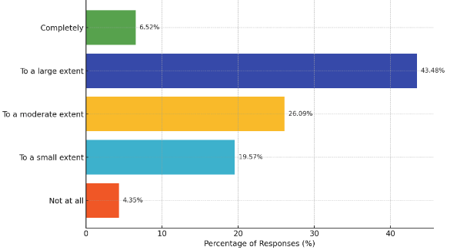
Source: Online survey among UN Programme and Management staff
Overall, despite these critiques, most stakeholders agree that a well-functioning RCO is vital for system-wide coherence and collective accountability. The key expectation is that the RCO’s coordination should add value through empowered leadership and mutual accountability – facilitating collaboration and building on agencies’ comparative strengths, rather than duplicating efforts
Smaller and non-resident UN agencies expressed especially favourable views of the RCO, underscoring that it facilitated their involvement in strategic planning discussions and high-level national dialogue platforms that otherwise would have been inaccessible. The inclusive nature of established mechanisms was frequently cited as enabling effective coordination and technical input from these entities.
However, perspectives from larger UN agencies with substantial operational autonomy and significant portfolios revealed ambivalence regarding the RCO’s added value. These agencies indicated that, while the RCO did not impede their operations, it also did not substantially enhance their core tasks and programmatic interventions. Criticism focused on the expanding size and associated costs of the RCO, perceived as primarily dedicated to coordination without substantial support in resource mobilization, programming, or implementation. According to the same staff survey, 27.5% of respondents expressed critical views, with an additional 3% highly critical, citing limited added value for larger agencies. Specific services offered by the RCO, including vulnerability assessments, human rights-based approaches (HRBA), and economic analyses, were described as inadequately aligned, delayed, or insufficiently integrated into operational processes. Questions were also raised about the cost-effectiveness of high-level international staffing within the RCO, especially given constrained financial resources. Moreover, 12.5% of survey respondents stated no clear opinion, suggesting low engagement or insufficient visibility of the RCO’s contributions among UN staff.
Evidence from document reviews, stakeholder interviews, and survey responses indicates a dual reality regarding the Resident Coordinator Office’s (RCO) role in Tajikistan. Multiple sources confirm that the RCO has significantly enhanced strategic coherence within the UN Country Team by effectively coordinating joint planning processes, strengthening engagement at high-level policy dialogues with key government ministries, and improving the quality of overall results reporting and monitoring. Stakeholders consistently acknowledged the RCO’s constructive engagement with national institutions, notably the Ministries of Economic Development and Trade, and Foreign Affairs, as critical in solidifying the Cooperation Framework as a credible platform for joint development action.
However, evidence also reveals that the RCO’s contribution to operational coordination and programmatic synergies has been notably weaker, particularly in interactions with larger UN agencies that possess extensive field presence and operational autonomy. Larger agencies expressed ambivalence, citing limited tangible support from the RCO regarding core programmatic implementation tasks, resource mobilization, and technical advisory functions. According to the UN staff survey, respondents indicated a critical need for the RCO to clarify its operational role, strengthen its technical advisory capacities, enhance the timeliness and relevance of its analytical outputs, and actively support joint resource mobilization and implementation efforts. Stakeholders from both national and UN entities emphasized that addressing these gaps would significantly enhance the RCO’s effectiveness as a strategic convener and facilitator of unified UN system actions in Tajikistan.
2.3. How has the UNSDCF strengthened the coherence of UN agencies’ support in addressing specific national development challenges and enhancing the achievement of results?
F11. The UNSDCF has provided a solid foundation for inter-agency coherence, introducing key coordination tools such as JWPs (pre-prepared and reviewed through the Results Group). The revised structure of the JWPs, with one outcome and only a few outputs that link relevant interventions of UN Agencies, has improved alignment, transparency, and planning discipline, bringing the UN system closer to coherent, impact-driven programming. However, coherence in joint programming and delivery remains uneven, with persistent challenges in operationalization, monitoring and evaluation, and joint resource mobilization.
The evaluation found that the UNSDCF enhanced inter-agency coherence by introducing key coordination instruments, particularly the JWPs, which structured joint agency planning, implementation, and monitoring efforts around clearly articulated outcomes and outputs. Stakeholders, including national partners and UN programme staff, consistently highlighted the revised structure of JWPs—with fewer, more strategically defined outcomes and outputs—as a substantial improvement. This new structure improved alignment and transparency, creating a clearer line of sight between UN interventions and national development priorities. According to survey data, approximately 58% of UN staff affirmed the value of the JWPs, highlighting their role in sharpening the UNCT’s collective focus and providing clarity for government counterparts regarding the links between UN-supported initiatives and sectoral reforms.
Despite this notable progress, evidence indicates that operational coherence in joint programming and delivery remained uneven. There were persistent challenges related to operationalisation, joint monitoring and evaluation, and joint resource mobilisation. While the JWPs provided a solid foundation for integrated planning, there were frequent instances of overlapping activities and persistent competition among agencies for limited donor resources, evident in education, social protection, and climate-resilience programming. This duplication diluted efficiency gains and underscored the reality that agency-specific incentives, particularly linked to individual resource mobilisation, were stronger than incentives for genuinely joint programming.
Furthermore, the evaluation revealed limitations in the JWPs' operational clarity. Despite logical hierarchies of outcomes and outputs, the underlying activities and sub-outputs were often vaguely articulated, limiting the traceability of UN contributions. For example, under Outcome 1 ("Inclusive Human Development"), several interventions lacked specificity in delivery methods, target populations, and intended behavioural results. Similarly, Outcome 2 ("Sustainable, Inclusive, and Green Economic Growth") presented clearly defined outcome-level indicators but failed to articulate concrete operational activities linked clearly to these indicators, weakening the causal logic of planned interventions and expected outcomes.
Additionally, the monitoring frameworks underpinning the JWPs were insufficiently detailed. Intermediate milestones were rarely specified, data disaggregation was inadequate, and coordinated tracking tools were lacking, reducing the JWPs’ potential as strategic instruments for adaptive management and progress tracking. Many activities remained predominantly micro-level in nature, with limited clarity on how they influenced higher-level reforms, despite indicators focused primarily at the macro-policy level.
Nonetheless, the evaluation identified promising steps toward joint programming within the current UNSDCF cycle. Notable examples include the UNAIDS/UBRAF-supported Joint Initiative on HIV/AIDS (2023–2024), involving UNDP, UNICEF, UNFPA, WHO, and UN Women. Additionally, two significant new joint initiatives were initiated in 2024: “Aligning Local Financing for SDGs” (by UN Women and UNICEF) and “Transforming Food Systems for Better Nutrition” (2025–2027, by FAO, UNICEF, WFP, and WHO). These initiatives, though still in early implementation stages, demonstrated a practical commitment to multi-agency collaboration, particularly in critical sectors such as public health, nutrition, governance, and gender equality. Yet their full institutionalisation and sustainability require further consolidation.
The evaluation finds that the Joint Work Plans (JWPs) under the UNSDCF have significantly contributed to improved joint planning and strengthened inter-agency coherence. Stakeholders widely recognized the JWPs as instrumental in aligning UN agencies around shared outcomes and enhancing transparency for national counterparts. However, the analysis identified several areas requiring further enhancement. Notably, activity descriptions within JWPs often lacked sufficient clarity and specificity, complicating the linkage to measurable indicators and outcomes. Additionally, intermediate milestones were frequently not well defined, which limited the JWPs’ effectiveness as instruments for adaptive management and tracking of progress. Evidence also revealed an absence of joint or pooled funding mechanisms, cost-sharing modalities, and clear results-based allocation frameworks, hindering genuine operational synergies and more cohesive implementation. Addressing these identified gaps could strengthen the JWPs further, translating their strategic coherence more effectively into concrete collaborative actions and improved developmental outcomes.
F12. The RCO has been effective in strengthening partnerships with development partners- with the DCC as a critical partnership platform for more effective coherence in development cooperation The ET finds the need for the RCO to sustain and expand this relevance, increasingly position itself as the principal support structure for national coordination mechanisms, strengthening the institutional capacity of government counterparts and facilitating integrated, multi-partner development (reflecting both national and UNSDCF priorities).
The evaluation finds that the RCO has effectively strengthened partnerships with external development partners, particularly through its strategic role in the Development Coordination Council (DCC). Stakeholders consistently highlighted the RCO’s critical role in enhancing coherence in development cooperation, emphasizing the RC’s dual function as DCC co-chair and integrator of UN values and development effectiveness principles. International development partners and national stakeholders recognised the DCC as a pivotal mechanism, providing a formal interface between the Government and its international partners, which significantly strengthens the alignment of external assistance with national priorities and the SDGs.
The RC’s active role within the DCC notably improved the visibility, strategic positioning, and credibility of the UNSDCF. This involvement has facilitated inter-agency dialogue, promoted cross-sectoral integration, and mitigated the fragmentation common in donor-supported initiatives, particularly relevant in Tajikistan's context, where parallel donor strategies often lead to duplication and inefficiencies. Moreover, the RC’s leadership within the DCC has fostered policy convergence and collective accountability, particularly on cross-cutting issues such as gender equality, climate action, digital transformation, and inclusive governance.
However, while the survey results revealed a solid majority (67%) of UN programme staff appreciating the RCO’s partnership arrangements as "sufficient," only a small minority (7%) judged them "completely effective." Respondents frequently noted challenges such as fragmentation, competition for visibility and resources among agencies, and limited genuine coordination even within formally joint initiatives. Civil society representatives reported similar difficulties, highlighting the limited and repetitive partnerships that involve a small number of well-established NGOs. Emerging or rural-based civil society organisations face significant barriers, including overly digitalised processes and extensive bureaucratic procedures, which restrict broader participation and diversity. Private-sector collaboration faced comparable issues, with shifting internal agency priorities and siloed approaches hindering sustained partnerships.
These findings highlight that while the RCO strengthened strategic partnerships, particularly at higher-level national dialogues and coordination platforms, practical operationalisation of partnerships remains suboptimal. Stakeholders emphasised the need for more proactive outreach mechanisms, simplified partnership modalities, and transparent guidelines for equitable partner selection. In this context, they perceive that the RCO's future effectiveness depends substantially on positioning itself as the principal support structure for national coordination, enhancing institutional capacities of government counterparts, and actively facilitating integrated, multi-partner development initiatives aligned with both national and UNSDCF priorities.
EQ2.4. How functional and effective have the UNSDCF joint coordination structures and national SDG governing bodies been in ensuring progress towards outcomes?
- F13. The institutional coordination architecture under the UNSDCF in Tajikistan—including the Joint Steering Committee (JSC), Results Groups (RGs), Thematic Groups (TGs), Interagency Task Forces, and national SDG coordination mechanisms—was established early in the CF cycle, aligned strategically to support integrated implementation of the 2030 Agenda. However, its operational effectiveness in driving SDG progress and CF outcomes has been uneven, impacted significantly by inconsistent government engagement, insufficient institutional capacities, unclear roles, and fragmented interlinkages between coordination bodies.
The Joint Steering Committee (JSC), co-chaired by the Minister of Economic Development and Trade and the UN Resident Coordinator, has regularly convened and successfully provided high-level endorsement and oversight of annual results reporting and Joint Work Plans (JWPs). Nonetheless, evidence gathered from stakeholder consultations and meeting reviews indicates that JSC discussions were largely procedural rather than strategic, limiting their potential for meaningful policy guidance, adaptive management, and strategic decision-making. Strengthening the JSC’s functionality requires empowering it as a policy-oriented body capable of systematically reviewing implementation challenges, commissioning analytical reviews, proposing corrective actions, and guiding strategic adjustments to CF priorities and implementation pathways.
The Results Groups (RGs), established under each CF outcome, aimed to translate strategic outcomes into operational plans, facilitating integrated policy dialogue and coordinated implementation across UN agencies. Initially, UN agency participation was robust but notably diminished over time. UN agencies highlighted significant efforts required to organise RG meetings and expressed challenges in clearly seeing the benefits from these engagements, given the operational difficulties elaborated below. Efforts to engage specialised UN Agencies, including through the appointment of non-resident agency chairs, faced practical problems. Non-resident chairs encountered logistical challenges in organising consultations and ensuring substantive national engagement. Consequently, responsibilities largely fell to alternate chairs, causing internal frustration and limiting the effectiveness of RG deliberations.
Government participation in RGs was inconsistent and often superficial, characterised by the involvement of junior or ad hoc personnel without apparent decision-making authority or institutional mandates. Frequent turnover among government representatives further disrupted institutional memory, continuity, and strategic coherence. Government members often reported unclear expectations regarding their roles within RGs and cited inadequate preparation due to the late receipt of meeting materials, which prevented thorough analysis. Furthermore, limited access to robust monitoring data and technical inputs further constrained the ability of RG members to oversee progress and adaptively manage interventions effectively.
To enhance RG effectiveness and ensure meaningful government engagement, stakeholders recommended formalising participation at departmental levels within line ministries, ensuring nominated representatives have clear mandates, institutional backing, and decision-making authority. Introducing structured rotation mechanisms for co-chairing RGs among government entities could further strengthen ownership and accountability, shifting the collaboration from assistance-driven interactions to genuine partnerships characterised by shared responsibility and joint stewardship.
Additionally, RGs require bolstered analytical and coordination capacities, supported through dedicated technical backstopping, integrated data dashboards, and enhanced alignment with national sector strategies. Ensuring RGs function as effective, credible platforms for integrated delivery and mutual accountability will necessitate investing in capacity-building programs focused on results-based management (RBM), strategic planning, and adaptive management.
Several Thematic Groups (TGs)—including the UN Gender Theme Group, the Disability Inclusion Focal Points Network, the Youth Theme Group, UNGTG, and the Data and M&E Group—have been established with a central role in mainstreaming cross-cutting principles such as gender equality, LNOB, youth participation, and human rights. These TGs have contributed to select initiatives (e.g., support to youth volunteering platforms, promotion of gender-responsive planning), but their contribution to broader CF delivery and policy coherence has been modest. A common constraint has been the lack of institutional resourcing—many TGs function without coordination support, meeting irregularly (if meeting at all) and omitting to fulfil their policy-influencing and advocacy roles. Their mandates often span a wide array of issues without prioritization, diluting focus. Moreover, links between TGs and the RGs/JSC are not always formalised, reducing their visibility in strategic discussions.
The establishment of the UN Interagency Task Force on Data has been a significant step forward. This group has supported efforts to improve SDG monitoring frameworks and align UN agency indicators with national statistical efforts. However, this work is still early, and coordination with the Agency on Statistics under the President of the Republic of Tajikistan and the National SDG Working Group remains fragmented. The lack of regular joint data reviews and integrated SDG dashboards constrains performance monitoring and evidence-based policy dialogue.
More broadly, the linkages between the CF coordination platforms and national SDG governance mechanisms, such as the Coordination Council on SDGs and the National SDG Secretariat, have remained weak. The CF Results Groups have not systematically informed national SDG reporting, including the 2023 Voluntary National Review, and national planning institutions often do not view RG outputs as strategic inputs. This structural disconnect risks parallel reporting and planning processes, weakening the coherence and utility of both systems.
The ET finds that Tajikistan’s UNSDCF coordination architecture has established essential frameworks, but the current structures and processes are not yet fully fit-for-purpose. Ensuring their effectiveness requires stronger government ownership, clearly defined institutional roles, enhanced technical and analytical capacities, and robust inter-sectoral linkages. By institutionalizing deeper government engagement, promoting integrated joint programming, and transitioning from a predominantly assistance-based approach toward true partnership, the coordination structures can be transformed into dynamic, strategic platforms capable of delivering sustainable and impactful development outcomes aligned with Tajikistan’s national priorities and the 2030 Agenda.
The ET finds that Tajikistan’s UNSDCF coordination architecture has laid down essential frameworks for joint planning and implementation. However, evidence from stakeholder interviews, document review, and JWP implementation assessments reveals that the current structures are not yet fully functional or responsive to the evolving demands of integrated delivery. Persistent challenges include insufficient government ownership, fragmented institutional mandates, limited analytical capacity within coordination mechanisms, and weak intersectoral linkages. Survey feedback indicates that the current coordination setup under the UNSDCF is not yet fully strategic or results-oriented. Stakeholder comments point to the need for deeper and more sustained government engagement, clearer institutional roles, and enhanced technical capacities, particularly for outcome-level planning and monitoring. Furthermore, the prevailing coordination model continues to reflect an assistance-oriented logic rather than a true partnership approach. This constrains the ability of the coordination architecture to operate as a dynamic platform for integrated, impactful, and sustainable development aligned with national priorities and the SDGs.

Effectiveness
The ET assessed the CF’s effectiveness by examining whether the achieved outputs contributed to the planned outcomes, with a specific focus on progress toward national targets and SDG-aligned goals. This included a review of the results matrix, Joint Work Plans, and annual reporting data to determine the degree of progress and whether foundational outputs established the basis for sustainable impact. The ET also analysed how the CF contributed to institutional, behavioural, and legislative changes—particularly in the domains of gender equality, human rights, and environmental sustainability—and how it strengthened national capacities across sectors. Emphasis was placed on understanding the benefits delivered to vulnerable and marginalised populations, including the extent to which specific measures were implemented to address inequalities and uphold the LNOB principle. Key implementation factors—such as inter-agency collaboration, leadership, and resource availability—were evaluated to identify enablers and barriers that influenced the delivery of intended results.
EQ 3.1 – Have the outputs been achieved, and to what extent do they contribute to the UNSDCF Outcomes? To what extent has the UNCT contributed to, or is likely to contribute to the achievement of the outcomes defined in the UNSDCF?
- F14. Across all four outcomes of the UNSDCF, the UNCT has demonstrated contributions to both immediate results and long-term systemic change. Outputs have been delivered effectively, aligning with national goals and global commitments. The analysed evidence confirms substantial progress under multiple outcome indicators, particularly in health, education, climate resilience, employment, and access to justice. Structural reforms supported by the UNCT have laid the groundwork for sustained change, even where quantitative targets are still being implemented. Continued progress toward final targets will depend on maintaining interagency synergy, government leadership, and robust investment partnerships.
Since the commencement of the CF cycle, the UN Agencies have demonstrated effectiveness in delivering planned outputs and facilitating early progress toward achieving the four outcomes. The programming and implementation modalities, coordinated through JWPs and Outcome Groups, have ensured that UN interventions were strategically aligned with national development priorities, SDGs, and the overarching commitment to LNOB. Across all outcomes, outputs have contributed to the expansion and improvement of services while also supporting the enabling environment for systemic, policy, institutional, and behavioural change. These achievements are evidenced by progress against quantitative indicators and qualitative shifts observed in governance, policy coherence, and institutional performance.
To verify contribution (distinct from attribution), the ET triangulated agency CPDs/work plans, JWPs and UN INFO entries, budgets, and monitoring data to map clear contribution pathways to CF results.

Outcome 1: Inclusive Human Development
Substantive progress has been achieved under Outcome 1, where UN Agencies supported the development and implementation of 14 national health-related policy documents, contributing to measurable improvements in reproductive health coverage, immunization rates, and skilled birth attendance. Country-wide measles–rubella campaigns were delivered, and over 3.7 million children were reached with micronutrient interventions, including vitamin A supplementation for ~281,000 infants (6–11 months) and ~2.1 million children (12–59 months). The proportion of children receiving a minimum acceptable diet showed early improvement in targeted regions, while national systems for nutrition surveillance and cross-sectoral WASH coordination were strengthened.
In early childhood education (ECE), the increase in enrollment from 15.9% to 22% resulted from broader improvements in the early learning policy framework—combining the updated curricula, adoption of the Mid-Term Education Action Plan (2024–2026), and sustained advocacy efforts—rather than the curriculum revision alone. The Mid-Term Review of the Compact partnership on competency-based education (CBE) produced a roadmap/action plan to guide and track reform implementation. At the same time, the approved Concept on Inclusive Education aligned definitions of disability and inclusion with the CRPD. A national Digital Roadmap for Education emphasised universal connectivity to improve access to education. Although an online EMIS has been launched, it is too early to confirm its impact on data-based planning, and the implementation of these concepts and roadmaps remains challenging in the current context. In WASH, ~77,000 people (2023) and a further 177,226 people (2024) gained access to basic drinking water; ~300,000 (2023) and 180,977 (2024) gained access to basic sanitation. In the context of food security, school feeding programmes reached over 550,000 children, and treatment for acute malnutrition was extended to ~5,600 children (2023) and 4,000+ (2024). Advancements have been observed in the accessibility of family planning services, particularly through a UN-backed co-financing agreement for contraceptives. As a result, the percentage of women satisfied with modern contraceptive methods rose to 54% in 2024. This increase reflects a heightened commitment to prioritising human capital development and aligning resources with demographic health needs.
In social protection, while SDG indicator 1.3.1 (coverage of social protection systems) remains partially achieved, a comprehensive three-year Action Plan (2024–2026) was adopted and implementation initiated, along with digital tools for improved beneficiary targeting. Although public expenditure as a share of GDP on social services (SDG 1.a.2) has yet to show a consistent upward trend, investments supported under the UNSDCF are contributing to more equitable and efficient resource allocation.
The UN supported drafting/operationalisation of the 14 health policies and a costed State Reproductive Health Programme (2023–2027; ~US$0.74m); delivered immunisation and RH/HIV services; expanded WASH access (figures above); scaled school feeding and vitamin A programmes; and advanced the ECE policy package (curricula, planning tools, inclusive education concept) alongside the launch of EMIS. These inputs collectively underpin the reported improvements in coverage and systems performance. This outcome is broadly on track, with strong indications that most output- and outcome-level targets will be met by the end of the cycle.

Outcome 2: Sustainable, Inclusive, and Green Economic Growth
Under Outcome 2, the UNCT facilitated policy, institutional, and grassroots-level efforts to promote economic diversification, inclusive employment, and green transition. The National Agriculture Reform Plan was finalised, incorporating climate-sensitive and gender-responsive principles. Concurrently, digital registration and certification systems for seed production were piloted to improve agri-business productivity and traceability.
The National Programme on Productive Employment (2023–2027) was launched, with over 13,000 individuals—~55% women—benefiting from upskilling and employment initiatives. In parallel, ~170 SMEs reported increased productivity after targeted support interventions. Gender-disaggregated labour force participation and youth NEET indicators began to reflect localised improvements, although national averages remain below UNSDCF targets, and informal employment rates (SDG 8.3.1) remain high.
Progress was also observed in enabling policy environments, with the adoption of new legislation to support green public–private partnerships and promote inclusive urban mobility. National dialogues were convened around SDG-aligned financing and private sector investment strategies.
UN support to the National Programme on Productive Employment (concrete): The UN provided the operational backbone for active labour-market measures by establishing remote job centres (Dushanbe, Khorogh, Panjikent); deploying national digital platforms for job-matching/entrepreneurship and volunteering; and delivering market-oriented skills training, enterprise services and business coaching that reached >13,000 people (≈55% women). In addition, targeted enterprise support enabled ~170 SMEs to report productivity gains. These instruments allowed NPE beneficiaries to be identified, trained and linked to jobs or entrepreneurship support, providing a clear contribution pathway from UN-supported tools to programme implementation.
The UNCT also supported digitalisation and innovation in agriculture, cooperative/seed-system reforms and cross-sector coordination platforms on employment, trade and sustainable enterprise development. The establishment of Integrated National Financing Frameworks improved alignment between public investment and the SDGs. While some structural indicators will require longer-term shifts, mid-term results suggest the trajectory is positive and partially on course.

Outcome 3: Integrated Management of Climate and Environmental Risk
The UNCT has been a key driver of policy coherence, institutional preparedness, and community-level resilience under Outcome 3. Tajikistan operationalised 14 watershed management plans in the Kofarnihon Basin and integrated DRR into district development plans across 35 districts. Six sectoral climate adaptation plans were implemented, while the Fourth National Environmental Performance Review was finalised and submitted.
At the outcome level, improvements were observed in the degree of integrated water resources management (SDG 6.5.1), which showed an upward trend from the 2020 baseline of 46. Over 67,000 people directly benefited from climate-resilient livelihoods programmes, and more than 6,600 participated in ecosystem-based adaptation activities; 670+ specialists were trained through 13 capacity-building interventions. Humanitarian assistance reached over 214,000 disaster-affected persons.
Progress remains ongoing under indicators such as SDG 13.2.1 (integration of climate policies), SDG 11.b.2 (DRR-integrated planning), and SDG 2.4.1 (sustainable agriculture). Financing gaps and weak intersectoral coordination were identified as constraints; however, the foundations for a resilient policy and planning framework have been established.
The UNCT supported national and subnational institutions through risk-informed planning aligned with global frameworks, climate scenario modelling, and technical training and demonstration projects. In parallel, national visibility was increased through advocacy at international events, including the UN Water Conference and COP28. The outcome is broadly progressing, though some structural targets will require continued investment and cross-sector integration.

Outcome 4: People-Centered Governance and Rule of Law
Progress under Outcome 4 reflects significant institutional and legislative development. The most transformative result was the adoption of the National Human Rights Strategy (2023–2038), representing a foundational commitment to rule of law, inclusion, and accountability. In parallel, legislative reforms strengthened protection against GBV, banned corporal punishment, removed age limits for filing complaints (including SGBV) and guaranteed the child’s right to be heard in judicial/administrative proceedings—expanding the scope of child-protection laws and access to justice.
The National Human Rights Institution’s status was upgraded in line with the Paris Principles, and approximately 2,000 public officials and 330 civil society staff were trained in rights-based governance and legal frameworks. More than 4,800 stateless persons and asylum-seekers accessed legal aid/documentation (including 1,832 identified as stateless, 3,379 gaining Tajik citizenship, and 651 refugees recognised). Civil registration systems were digitised—including issuance of unique ID numbers for newborns—and user satisfaction in pilot regions rose from ~35% (2022) to ~86% (2024). While SDG 16.6.2 (satisfaction with public services) and SDG 5.1.1 (non-discriminatory legal frameworks) require more robust national data, progress is also evident through the uptake of UPR recommendations and improved civic-engagement platforms.
The UNCT supported multi-stakeholder dialogues, technical reviews of legislation, and the rollout of inclusive justice services (notably, the transfer of the Free Legal Aid system to full Ministry of Justice financing and oversight). Emphasis was placed on building institutional resilience, facilitating community-level feedback, and mainstreaming gender and child rights across governance reforms. As a result, this outcome is assessed as being on track, with a strong likelihood of meeting most indicators by 2026.
F15. UN staff (and partners) statements reflect a broadly positive assessment of the UNSDCF’s achievements, particularly in terms of normative progress and early-stage institutional reforms. Yet, they also reveal critical structural and operational limitations that constrain the realisation of integrated, transformative changes, especially highlighting deeply rooted inequalities and the need for consistent inter-agency collaboration across all outcomes.
The UN staff, nearly 80% of those who participated in the survey, recognized that UN agencies have been either “completely” or “sufficiently” effective in achieving results under the UNSDCF. This reflects overall confidence in the UN’s delivery capacity, especially in policy advisory and systems strengthening roles. However, narrative feedback cautioned that the Cooperation Framework is highly ambitious for a four-year cycle and risks becoming a compilation of loosely connected agency results rather than a cohesive strategy. The complex structure and high-level nature of many targets were seen as making it difficult to attribute specific changes directly to the CF, particularly when joint planning and implementation remained uneven.
The responses highlight a broad spectrum of achievements, with staff emphasizing progress at the normative, institutional, and service delivery levels. Respondents frequently cited the adoption of major policy frameworks, including the National Human Rights Strategy, as well as roadmaps on digital education, inclusive education, and youth development, as evidence of the UN’s strategic contribution to upstream systems change. These achievements were seen as central to advancing rights-based and inclusive governance, reflecting the UN’s comparative advantage in technical assistance and policy influence. Several staff members also highlighted improvements in national coordination structures, particularly in areas such as child protection, disaster risk reduction, and social protection, where UN support contributed to the creation or strengthening of inter-ministerial working groups and cross-sectoral platforms.
At the beneficiary level, respondents acknowledged tangible improvements in the lives of people in marginalized and vulnerable situations. These included enhanced access to reproductive health services and immunization, provision of services for victims of domestic violence, micronutrient support for millions of children, increased school enrollment in underserved areas, and the scaling up of employment and skills-building programmes targeting youth, women, and returnees. The integration of these interventions into national and subnational systems was often highlighted, suggesting growing institutional ownership. However, some respondents emphasized that these achievements are still in an early stage, requiring further consolidation and consistent funding to ensure long-term sustainability and the full realization of outcomes.
Despite notable progress, a significant proportion of respondents (approximately 25%) identified thematic gaps or areas of underperformance, especially in relation to gender equality, disability inclusion, youth engagement, and climate resilience. These gaps were attributed to fragmented delivery approaches, funding imbalances, and a lack of high-quality disaggregated data, particularly at the subnational level. While the CF has helped to elevate these cross-cutting issues rhetorically, respondents noted that in practice, implementation often falls short of transformative change. Q22 responses reinforced this view, with staff pointing to missed opportunities for mainstreaming and greater coherence, particularly in sectors where agency mandates and delivery models remain siloed.
EQ 3.2. To what extent has the UNSDCF contributed to national capacities and fostered key institutional, behavioural, and legislative changes necessary for advancing its desired changes, particularly in gender equality, women’s empowerment, and human rights?
F16. The UNSDCF has laid essential institutional and legislative foundations across key sectors, but sustained impact will require greater national ownership, stronger integration across systems, and investments in data and capacity. To advance beyond fragmented, project-based delivery, a shift toward whole-of-government, policy-led implementation is needed.
In the areas of gender equality and women’s empowerment, the UNSDCF facilitated critical legal and institutional advancements, including the amendment to the Law on the Prevention of Domestic Violence and the institutionalization of survivor-centred services. These included mobile psychosocial and legal teams and 24/7 crisis centers for women and girls. However, while 78% of surveyed UN staff acknowledged the CF’s contributions in this area, concerns persist over long-term sustainability due to dependency on donor funding and uneven capacity at the subnational level. The key informants Survey responses further pointed to limited uptake of gender tools into core government systems, which undermines systemic impact.
In the realm of human rights, the CF contributed to the formulation of the National Human Rights Strategy 2023–2038 and supported the capacity development of the Ombudsman’s Office and key state institutions. The UN achievements were instrumental in expanding free legal aid provision—particularly for marginalised groups—and institutionalizing cooperation with CSOs and the Bar Association. Nevertheless, concerns about sustainability and absorption persist, and non-governmental actors have expressed concerns regarding the established partnerships. Almost complementing these views, survey findings highlighted that while human rights frameworks have improved, practical implementation is often constrained by insufficient public financing, high staff turnover, and lack of robust monitoring systems.
Concerning disability inclusion, the CF promoted disability-sensitive service provision, for example, within GBV response, education, and digitalization efforts. However, only 52% of programme staff considered disability inclusion sufficiently addressed. Staff feedback consistently emphasized the absence of a coherent strategy to elevate disability beyond cross-cutting rhetoric into operational programming with clear accountability structures. In addition, the ET finds that key barriers include the lack of institutionalized disaggregated data, weak cross-sectoral accountability, and under-resourced DPOs.
The CF helped establish institutional mechanisms for multi-hazard risk planning, local watershed governance, and early warning systems, contributing to environmental sustainability and disaster risk reduction. Initiatives such as the green loan scheme in GBAO contributed to community resilience and women’s economic empowerment. However, national ownership and integration within national systems have been. Yet, only 29% of surveyed staff considered these interventions to be adequately institutionalized within national systems. Limited policy coherence, fragmented mandates, and underdeveloped inter-ministerial coordination continue to hinder systemic progress in this area.
Finally, digital transformation has emerged as one of the most cross-cutting and systemically relevant areas supported under the CF. It enabled digital innovations across governance, education, social protection, and service delivery. These included expanding e-governance platforms, developing digital skills frameworks, mobile outreach technologies, and increased public access to digital tools—particularly in civil registration, health, and education. The digitalization of service delivery was supported by the launch of the Education Management Information System (EMIS) and the introduction of online platforms for birth registration and legal aid access. Survey responses highlighted digitalization as a key enabler of inclusive development, yet flagged that infrastructure gaps, limited internet coverage in rural areas, and a shortage of digital competencies within the civil service constrain uptake. Furthermore, without robust cybersecurity frameworks and sustainable financing, digital governance reforms risk remaining project-bound.
F17. Through CF implementation, UN agencies have facilitated institutional, behavioral, and legislative advancements across Tajikistan’s key development sectors, including momentum in digital transformation. However, the durability and scalability of these gains depend on addressing implementation asymmetries, infrastructure constraints, and cross-sectoral coordination. Advancing to systemic reform requires increased domestic investment, national integration of critical strategies (particularly national digital governance strategies), and consistent performance monitoring frameworks.
In education, the rollout of the Digital Education Transformation Roadmap, competency-based learning approaches, and inclusive pedagogical methods contributed to systemic modernization. The launch of EMIS improved data-driven planning and monitoring. Teacher training programs promoted more inclusive and participatory practices in classrooms. However, the large majority of the interviewed stakeholders and the survey results showed that education reforms require further institutionalisation, highlighting persistent rural–urban inequalities in access to infrastructure, teaching quality, and digital tools. In connection with this, the ET finds that important health and social protection achievements included standardized reproductive health protocols, GBV case management, and infection prevention, improved service delivery. At the same time, the Social Protection Modernization Action Plan introduced new mechanisms for reaching underserved populations. Behavioral changes in patient interaction and administrative practices were also observed. Nevertheless, less than 60% of respondents considered these institutional gains sustainable, referencing uneven delivery capacity across regions and fragile budgetary frameworks.
The CF implementation enabled several policies and operational innovations in digital governance, including stronger inter-institutional links between civil registration and health systems, online legal aid access, digital health and education platforms, improvements in social protection and early warning communication systems. These interventions promoted behavioral shifts in service providers and users. Staff noted increased awareness of digital rights, user expectations of service quality, and institutional openness to e-governance. Yet, challenges remain: digital uptake is hindered by uneven access to broadband, lack of localized content, cybersecurity vulnerabilities, and weak integration between platforms. Survey findings underscored that while digitalization was among the most visible areas of transformation, it has yet to evolve into a fully coordinated national digital governance strategy.
In climate change and DRR, the CF introduced locally led watershed management, community-based risk planning, and nature-based solutions that empowered women and improved local capacity. However, integration into national policy systems remains limited. Survey responses confirmed that while DRR and climate adaptation have improved at the local level, vertical policy coherence and dedicated financing remain insufficient.
A consistent finding across the surveys was that institutional gains were often siloed within agencies or thematic areas, with 43% of staff reporting that results “remain isolated” and are not embedded in whole-of-government systems. Respondents emphasized the need for enhanced inter-agency planning, stronger sectoral leadership, and the integration of reforms into legal and budgetary frameworks.
EQ3.3. What have been the benefits for the people targeted by the interventions, including the most vulnerable, disadvantaged, and marginalized populations?
F18. The CF implementation improved lives of vulnerable populations across Tajikistan through inclusive policy reforms, institutional support, and targeted services. Significant benefits occurred where interventions were context-sensitive and embedded in broader systems like social protection, health, legal identity, digital inclusion, or climate resilience. However, progress is uneven, and benefits are challenged by institutional fragmentation, dependence on external funding, and limited subnational capacities.
The results of the survey among UN programme and management staff revealed that approximately 70% of staff considered the CF to be “completely” or “sufficiently” responsive to the needs of groups in marginalized and vulnerable situations. Respondents highlighted the most impactful interventions of school feeding, disability-inclusive education, mobile legal and psychosocial support, green livelihoods for women, and social protection scale-up. Several emphasized that “beneficiary-level improvements were tangible but fragile,” with many gains dependent on continued donor support or lacking clear institutional mandates. Still, on the negative side, limited inter-agency coordination, insufficient use of disaggregated data, and unclear definitions of vulnerability have been recognized as factors that affected implementation. The survey participants noted that interventions were often implemented in silos, lacking the synergy needed for broader impact, and that the absence of disability-disaggregated and other LNOB-relevant data hindered effective targeting. Additionally, persistent funding shortfalls, bureaucratic inefficiencies, and the inconsistent integration of the LNOB principle across outcomes and outputs further undermined the UN’s ability to deliver timely and inclusive responses. The absence of disaggregated data, particularly by disability, age, and migration status, was repeatedly cited as a limitation to adapting or scaling services.
The ET analyzed interventions under Outcome 1, which delivered some concrete benefits for groups in marginalized and vulnerable situations. As already highlighted, the results of the survey and interviews with the stakeholders showed that school feeding and deworming programs helped improve learning outcomes and retention for children in food-insecure areas, while integrated maternal health, HIV services, and adolescent health programs expanded access for rural women and vulnerable youth. Disability-inclusive curricula and community-based school governance promoted the participation of children with special needs. Mobile outreach and community-based protection mechanisms made GBV services accessible in remote areas. These efforts were repeatedly affirmed in the GESI Analysis, programme evaluations and results reports as instrumental in improving access and quality of critical social services. However, the sustainability of these service models—particularly at the local level—remains constrained by unclear financing pathways and staffing shortages.
The ET finds that economic empowerment initiatives under Outcome 2 extended benefits to young people, returnees, and women previously excluded from formal labor markets. Job-matching platforms, youth entrepreneurship hubs, financial literacy training, and small grants in cross-border regions provided new employment opportunities. Internships for female graduates and targeted business support in agriculture and rural crafts were also reported as helping overcome structural barriers to economic participation. Yet, both survey respondents and the ARR 2024 noted that people with disabilities, elderly returnees, and informal workers were still underrepresented in such schemes, pointing to gaps in targeting and follow-up.
Under Outcome 3, the stakeholders recognized that UN Agencies have effectively addressed the need for community-based disaster preparedness, green loan schemes, and ecosystem-based climate adaptation, thus increasing the resilience of high-risk communities. These interventions engaged women and CSOs in local planning processes and promoted gender-responsive access to clean energy and agricultural inputs. The analysis confirms that DRR mechanisms such as Early Warnings for All improved awareness and community response capacities in hazard-prone districts. Nonetheless, challenges remained, as coordination between national and local institutions and between climate, environment, and DRR actors was often fragmented, limiting scalability and long-term resilience.
To ensure more transparent and accountable governance, the UN under Outcome 4 supports national systems and institutions in providing access to legal identity and public services, for example, through the #IBelong campaign and civil registration reform. Legal aid became more accessible, especially for women and marginalized groups, by institutionalizing primary and secondary legal aid models. This was viewed as one of the flagship examples of empowerment through rights. However, as confirmed in the Rule of Law Programme evaluation and staff survey responses, questions remain over the long-term viability of these models in the absence of budgeted commitments and continued technical support
Complementary to these efforts, digitalisation emerged as a double-edged benefit. It enabled rapid expansion of access to services, particularly for youth and educated populations in remote areas. Civil registration, legal support, health and employment, and even GBV reporting were made more accessible through online platforms. Survey and GESI findings confirmed that digital access remained stratified (with a divide gap, excluding elderly people, women in conservative communities, and those without digital literacy).
F19. UN Agencies under the UNSDCF implementation introduced a range of concrete measures that signalled a shift toward equity and inclusion, resulting in visible improvements when supported by strong partnerships, technical support, and localised engagement. However, sustainability and scale depend on more deliberate institutionalisation: embedding inclusion standards into national plans, allocating domestic resources, and linking interventions to long-term accountability systems.
Though their effectiveness and sustainability varied, a wide range of targeted measures were introduced under the UNSDCF to address inequalities and promote inclusion across sectors. In the social sectors, efforts combined integrated nutrition and school health programs, disability-sensitive WASH interventions, and GBV referral systems linking health, legal, and psychosocial support, especially in underserved areas. Inclusive education was advanced through the adoption of the National Concept on Inclusive Education, prioritising promoting inclusion from early childhood and ensuring equitable access to quality education for all children, including those with disabilities. The school curricula have been strengthened to move beyond traditional integration and mainstreaming, emphasising the child's right to participate and the school's responsibility to provide gender- and disability-responsive approaches in early childhood and primary care; however, quality assurance mechanisms often remained weak. In the economic domain, affirmative measures supported skills development for women, youth, and returnees, alongside tailored assistance for rural women-led enterprises and green entrepreneurship initiatives. However, weak data systems and limited institutional follow-up hindered the tracking of long-term inclusion outcomes for these efforts. Climate resilience and disaster risk reduction programming also embedded inclusion, with participatory vulnerability mapping, gender-informed adaptation planning, and incentives for sustainable practices among rural women. Initiatives such as watershed-based planning in GBAO have linked environmental and livelihood goals; however, many remained donor-driven and were not fully integrated into national frameworks or budgetary processes. Governance-related inclusion measures focused on legal empowerment—expanding access to free legal aid, promoting civil registration for undocumented children, and drafting inclusive legal frameworks on statelessness and child protection. Although DPOs and CSOs were engaged in consultative processes, their roles in policymaking and oversight were limited, and formal accountability mechanisms—such as grievance redress, participatory budgeting, and citizen monitoring—remained inconsistent across sectors.
Survey respondents emphasised the importance of these measures but also identified recurrent implementation challenges: lack of follow-through, overlap between agency mandates, weak subnational capacities, and absence of standardised tools to assess whether inclusion measures are working. Disaggregated data, particularly on disability, youth, and intersecting vulnerabilities, was cited as one of the most pressing systemic gaps.

Efficiency
The ET assessed efficiency by examining the extent to which an integrated funding framework supported the CF, aligned financial and human resources, and effectively used inter-agency synergies. The analysis focused on whether resources were mobilized and delivered in line with Joint Work Plans and outcome priorities, and whether funding gaps were strategically addressed. The ET also considered how coordination mechanisms and agency collaboration contributed to cost-effective delivery, highlighting persistent inefficiencies linked to fragmented pipelines and limited shared accountability.
EQ4.1. Was the UNSDCF supported by an integrated funding framework and adequate funding instruments?
F20. The CF included some elements of an Integrated Funding Framework, such as Joint Work Plans and links to national SDG financing. Still, the funding approach remained fragmented and lacked the coherence, joint accountability, and shared resource mobilization needed for a fully integrated system.
An Integrated Funding Framework (IFF) for the UNSDCF is intended to ensure that financial resources—regardless of source or modality—are strategically aligned with the Cooperation Framework’s collective outcomes. In the case of Tajikistan, the CF incorporates some foundational features of such a framework. Notably, the development and annual revision of Joint Work Plans under each outcome have provided a platform for aligning agency-level programming and associated funding with agreed priorities. This has allowed the UNCT to track financial delivery against outcome areas and to assess resource gaps more systematically. Additionally, the integration of the SDG budgeting methodology into national planning processes and the advancement of an Integrated National Financing Framework (INFF) have created opportunities for closer alignment between UN support and the government’s financing strategies for the SDGs. These efforts represent steps toward a more integrated approach to development financing.
However, despite these emerging practices, the current funding architecture supporting the UNSDCF remains highly fragmented, with the majority of resources mobilized and managed through individual agency pipelines and donor relationships. There is limited use of common financing instruments, and the absence of a unified funding strategy across outcomes has constrained the UN’s ability to optimize synergies, address cross-cutting priorities, and shift toward truly collective results. As a result, while the building blocks of an INFF are present in Tajikistan’s CF architecture, they are not yet consolidated into a fully integrated system. Institutional mechanisms to coordinate and steer resource mobilization across the UNCT—beyond information sharing—remain underdeveloped, and the full operationalization of an INFF would require more deliberate efforts to link financing with joint implementation, joint accountability, and longer-term sustainability.
F21. The UN Agencies have succeeded in mobilizing over half of the required resources for the CF and achieved relatively high delivery rates. The largely decentralized, agency-driven funding model—combined with recent donor withdrawals and limited alternative financing mechanisms—has constrained strategic coherence, equity in resource distribution across outcomes, and long-term sustainability of interventions.
From a financing perspective, the UNSDCF funding framework remains largely decentralized and agency-driven, with limited utilization of collective funding modalities. Although the total resource mobilization to date—approximately $235 million—demonstrates the UNCT’s capacity to attract significant financing, the model lacks the flexibility and predictability that a fully integrated funding approach would offer. Funding is predominantly tied to bilateral donor agreements with individual UN entities, and there are few mechanisms for pooling or reallocating resources toward underfunded priorities. The recent termination of several USAID-funded programmes, notably in the health, gender and education sectors, has further exacerbated the volatility of the funding landscape. This development is raising concerns about the long-term sustainability of specific initiatives. The experience highlights the need for more strategic resource planning and for diversifying the donor base to ensure continuity and alignment of financing with results.
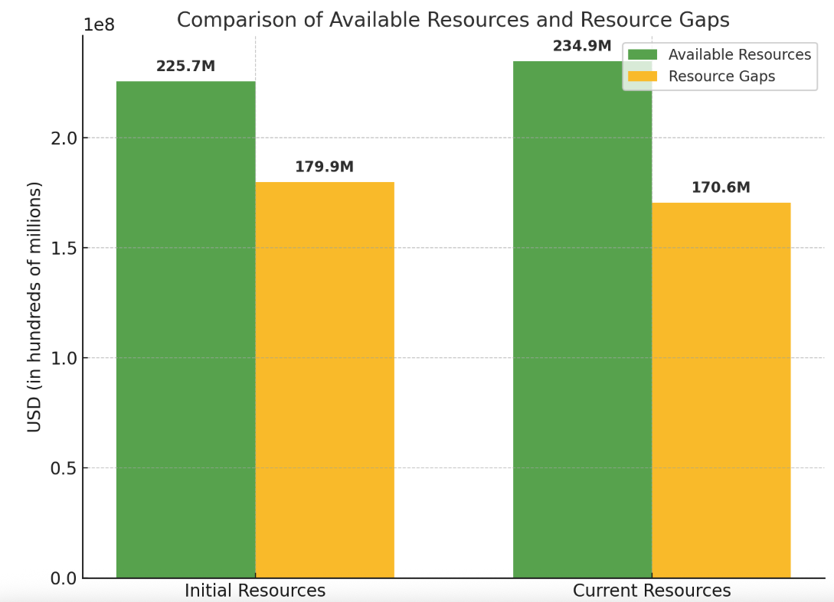
Figure 8: Estimates at the design stage and current state of resources
Source: UNINFO
Source: UNINFO- Tajikistan
The total budget planned under the CF amounts to approximately $405.5 million, with $234.9 million mobilized and available to date. This reflects a current funding gap of $170.6 million, indicating that approximately 58% of total needs have been covered to date. Resource availability has significantly supported progress; however, future success depends on addressing remaining funding gaps. A key challenge is that donors typically do not provide funds at the start of the year, causing delays and uncertainty. This affects the timely planning and implementation of activities. The interviewed UN staff recognized the need for ensuring more predictable and timely funding as crucial for sustaining effective programme delivery.
Delivery rates have been relatively high in the first two years of implementation, with 83% in 2023 ($80.6 million spent out of $97.2 million available) and 73% in 2024 ($74.1 million spent out of $101.2 million).
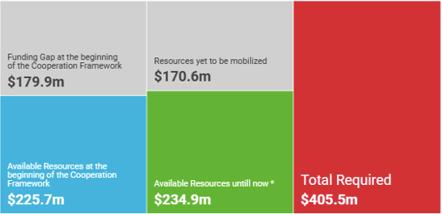
Figure 9: Funding Gap for the UNSDCF 2023-2026 in Tajikistan
Source: UNINFO- Tajikistan
The ET finds that the expenditure pace is commendable, highlighting absorption challenges as programmatic complexity increases or multi-year commitments slow disbursement in the second year. For 2025, although $79.9 million has already been secured, no expenditures have been reported yet, as financial execution data will only be available post-April 2026.
Figure 10 Total required funding by CF Outcome
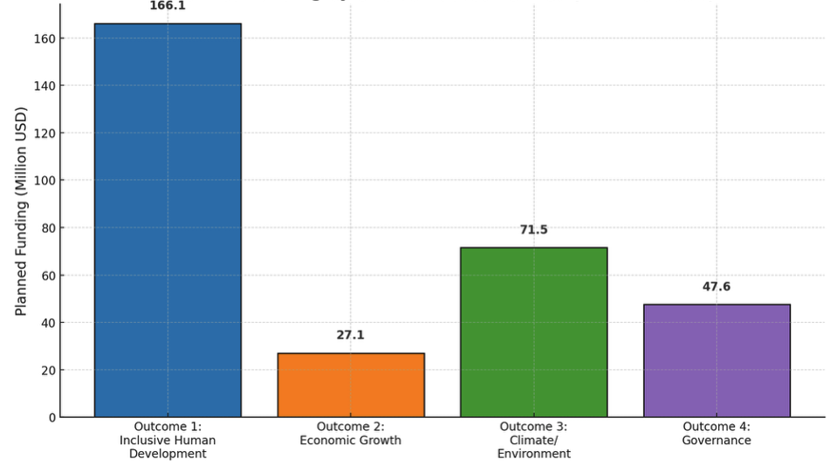
Source: UNINFO- Tajikistan
From a results-based budgeting standpoint, Outcome 1 (inclusive human development) received the largest share of resources, with a total requirement of $166.1 million, and high alignment with both gender and human rights markers. Outcome 3 (climate/environment) and Outcome 4 (governance) follow in financial importance, with $71.5 million and $47.6 million, respectively. Outcome 2 (economic growth) lags behind in total planned funding ($27.1 million), possibly reflecting both limited resource mobilization and narrower donor engagement in this thematic area.
Figure 11: Delivery in 2023  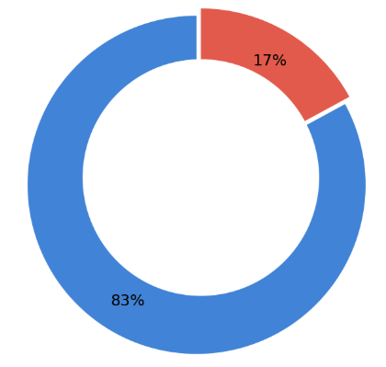  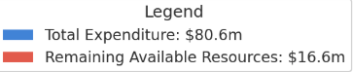 | Figure 12: Delivery in 2024  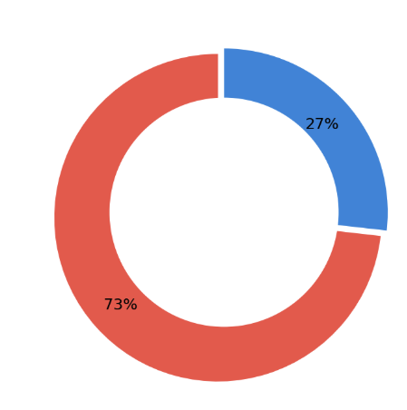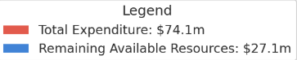
Source: UN INFO Tajikistan
The CF’s funding focus reveals a pronounced orientation toward capacity development and technical assistance, which accounted for the largest number of implemented and planned initiatives. This emphasis reflects the UN’s role in strengthening institutional and human capacities across sectors, particularly in public administration, social services, and climate resilience. Significant resources were also directed toward convening, partnerships, and knowledge sharing, as well as policy advice and thought leadership—functions essential for shaping national strategies, supporting sectoral reforms, and aligning policy frameworks with SDGs. By contrast, relatively fewer interventions were recorded under direct service delivery and normative support, suggesting that the UN’s comparative advantage in Tajikistan remains centered on upstream engagement and systemic transformation, rather than direct operational delivery. This strategic allocation underscores the deliberate shift from project-based assistance to enabling, influencing, and sustaining nationally led development processes.
Survey responses revealed nuanced staff perceptions of how effectively the UN in Tajikistan has mobilized and used its resources under the UNSDCF and what structural improvements are needed. While nearly half of the respondents (48.7%) considered the use of human, technical, and financial resources “sufficient,” only 2.2% believed it was “fully optimal,” and a substantial proportion expressed uncertainty or dissatisfaction. This reflects a shared recognition that while the UN has mobilized considerable resources, its ability to harness them strategically across agencies remains limited.
F22. UN staff highlighted that fragmented resource mobilisation, limited joint planning, and weak coordination mechanisms—exacerbated by reduced bilateral funding—undermine effective collaboration and pose risks to the sustainability and coherence of UNSDCF implementation
Qualitative feedback from respondents underscores several systemic constraints. Staff highlighted that resource mobilization is still largely fragmented, with agencies pursuing separate funding pipelines and limited joint planning. Many observed that so-called “joint” programmes are often a collection of parallel activities bundled together, lacking genuine integration. This siloed approach, combined with competition for visibility and funding, was perceived as undermining collaboration and discouraging trust between agencies. Furthermore, there were concerns about weak coordination mechanisms and limited incentives for active engagement in the CF’s governance structures. The absence of collective financial accountability or shared risk-taking was also flagged as a barrier to fully leveraging inter-agency synergies. Many respondents cited fragmented planning and delivery modalities as a limiting factor in maximizing impact. This was particularly evident in how financial resources were mobilized and allocated—largely through agency-specific pipelines—with limited cross-agency coordination. Several staff members also referenced the challenges posed by the sudden reduction in bilateral donor funding, particularly following the withdrawal of USAID support, which created uncertainty in programme continuity and exposed the system's vulnerability to external funding shifts. While delivery rates remained relatively high, these observations suggest that ensuring the long-term coherence and sustainability of interventions will depend not only on securing adequate funding but also on addressing institutional mechanisms that currently limit the strategic deployment of resources.
In terms of forward-looking solutions, staff proposed a shift toward more meaningful joint programming, starting from co-design and joint fundraising, rather than simply co-reporting. More decisive leadership from the Resident Coordinator’s Office was encouraged to streamline coordination, clarify agency roles, and promote convergence around shared outcomes. The need for area-based and thematic programming, more precise financial alignment, and greater use of digital tools for monitoring and planning were also emphasized.
While gender equality and human rights are somewhat mainstreamed within the UNSDCF resource allocation, as evidenced by substantial funding marked with the relevant indicators, a notable portion of funding remains uncoded. This underscores the necessity to establish more consistent application of marker frameworks across all programme domains.
F23. Despite a relatively diverse donor base and strong government contributions, the low share of inter-agency funding suggests that financing under the UNSDCF in Tajikistan remains largely fragmented and agency-specific, limiting the potential for fully integrated and flexible resource allocation.
The donor landscape shows a relatively diverse base. The top contributors include the European Union (EU) with $35.3 million, Global Fund (GFATM) with $29.8 million, while USAID was at the top of this last with planned $27.9 million- however, recent decision to stop funding within this framework will significantly affect CF’s funding plan.
Figure 13 Donor Funds Budget vs Expenses for 2023 and 2024
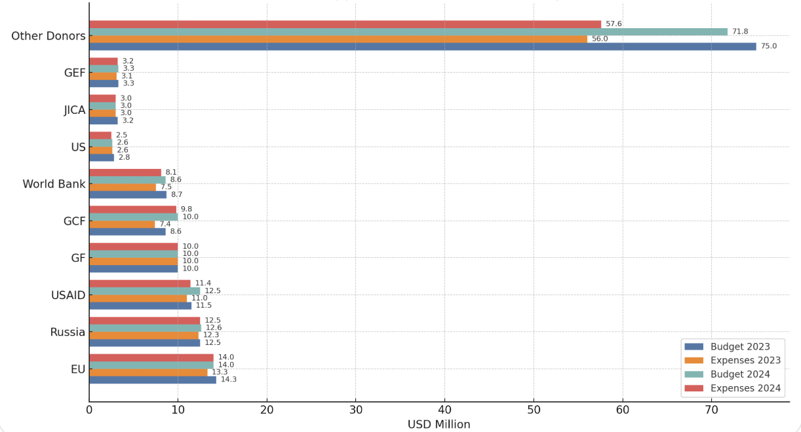
Source; ARR 2024
These are followed closely by multilateral donors such as WFP ($26.9 million), Green Climate Fund (GCF) ($13 million), and the Islamic Development Bank (IDB) ($12.5 million). Bilateral support also plays a notable role, with Russia, Switzerland, and Canada among the top ten contributors. Within the UN system, agencies like UNICEF, UNDP, and UNFPA have contributed resources either as implementing partners or direct funders.
In terms of funding modalities, bilateral contributions amount to $85.8 million, indicating a relatively strong commitment to foreign aid. Other sources include global vertical funds (e.g., GAVI, GCF) with $59.7 million, multilateral institutions excluding pooled funds ($52.1 million), and EU institutions ($39.3 million). Contributions through inter-agency pooled funds, however, remain low at $6.6 million, suggesting limited use of joint funding mechanisms to date.
The Gender Equality Marker (GEM) is a UN system-wide coding framework used to assess the extent to which programmes and budget allocations contribute to gender equality and the empowerment of women and girls (GEWE).
Under this system, activities are categorised from GEM 0 (no contribution to gender equality) to GEM 3 (principal contribution, where GEWE is the main objective). GEM coding is applied at the sub-output level of UN planning frameworks, including the UNSDCF, and serves as a key metric in global monitoring and UNCT-SWAP reporting processes.
Figure 14 UNSDCF GEM for 2023-2024
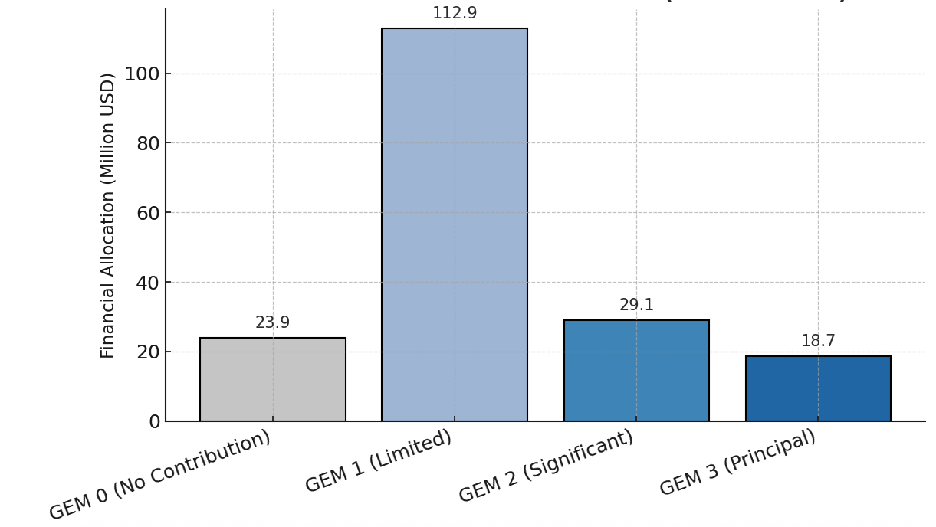
The evaluation finds that while Tajikistan’s UNCT has made some progress in applying GEM coding to the 2023–2024 UNSDCF sub-outputs, gender equality remains only moderately integrated into programme planning and budgeting. According to the GEM analysis conducted as part of the UNCT-SWAP Gender Equality Scorecard process, the majority of the financial resources—specifically $112.9 million or 61% of the total $184.6 million budget—were allocated to sub-outputs coded as GEM 1, reflecting limited contributions to gender equality. In contrast, only $29.1 million (16%) was attributed to GEM 2, and $18.7 million (10%) to GEM 3, which correspond to significant and principal contributions, respectively. Together, GEM 2 and GEM 3 allocations account for just 26% of total resources.
This falls significantly short of the UN system-wide benchmark, which requires that at least 70% of annual allocations support activities coded as GEM 2 or GEM 3. The evaluation interprets this shortfall as evidence that gender equality has not been systematically mainstreamed across UNSDCF outcomes. It also suggests that planning processes may lack adequate gender analysis and that there are limitations in institutional capacity to translate UN normative commitments on gender equality into operational practice. The overall pattern of GEM allocation indicates that GEWE considerations are not sufficiently prioritised in Tajikistan’s UNSDCF implementation cycle. This has implications for the transformative potential of UN programming, the visibility of gender results, and the credibility of the UNCT’s commitment to LNOB principle and SDG 5.
The human rights marker indicates $174.4 million coded with Marker 2 and $59.5 million with Marker 3, suggesting a degree of intentional design for rights-based programming.
Figure 15: Human rights marker
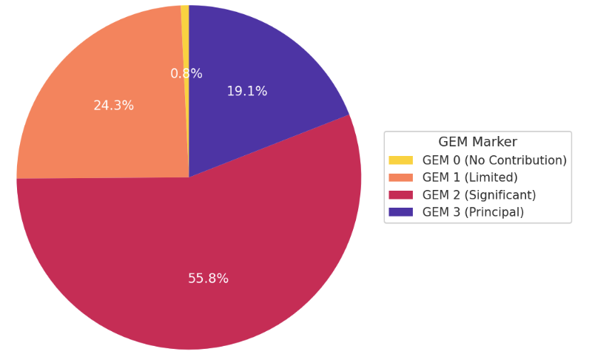
Source: UN-IFO
Nonetheless, funding not aligned with any marker remains sizable—suggesting room for strengthening mainstreaming practices across all outcomes and outputs. The human rights marker should be thoroughly reviewed, analysed and quality assured by Result Groups, considering there were no annual reviews, introductory sessions conducted during JWP planning stage, implementation and reporting and thus HR markers were coded by default without consultative considerations and validation, as it was done for GEM coding.
EQ 4.2. How has the UN system mobilised and used its resources (human, technical and financial) and inter-agency synergies to achieve the planned UNSDCF results?
F24. The UNCT has demonstrated progress in mobilising resources under the UNSDCF in Tajikistan. Still, the disparities in agency-level funding, thematic distribution, and transformative investment highlight the limitations of the current approach. The suggestions for supporting the GoT to diversify funding opportunities have been recognized as a response to financial constraints and a strategic opportunity to consolidate efforts, address funding inequities, and ensure that all four outcomes of the UNSDCF are implemented with the level of ambition and cohesion they require.
The funding landscape of the UNSDCF in Tajikistan, as of mid-2025, reveals a mixed picture of strong overall resource mobilization efforts and pronounced disparities in financial coverage among participating UN agencies. While the UN Country Team has collectively mobilized approximately $234.9 million, covering 58% of the total requirement of $405.5 million, the remaining ($170.6) million funding gap continues to pose challenges to achieving the full ambition of the Cooperation Framework.
A closer look at the agency level highlights significant variances in mobilization and delivery performance. UNDP, the largest agency, secured nearly full funding of its substantial $84.3 million requirement (99.7%), yet exhibits a relatively low delivery rate (51.9%). WFP has mobilized $65.9 million against a requirement of $81.1 million (81.2% funded), marking the largest absolute funding gap of $15.2 million, combined with a moderate delivery performance (60.8%). Similarly, UNICEF is almost fully funded at 98.7% ($64 million available vs. $64.8 million required), yet it faces delivery challenges, with less than half of the available funds utilized (49.3%).
Several smaller agencies demonstrated exceptional efficiency in using their resources: UNOPS, UNIDO, and UN Women have delivery rates at or near 100%, underscoring their strong implementation capacities despite significant funding shortfalls, especially acute for UNIDO (only 3.1% funded). Meanwhile, UNFPA achieved a high delivery rate of 83.5%, despite having secured only 71.5% of required resources. In contrast, IFAD, fully funded at $1.37 million, has yet to initiate expenditure, indicating significant delays or operational barriers.
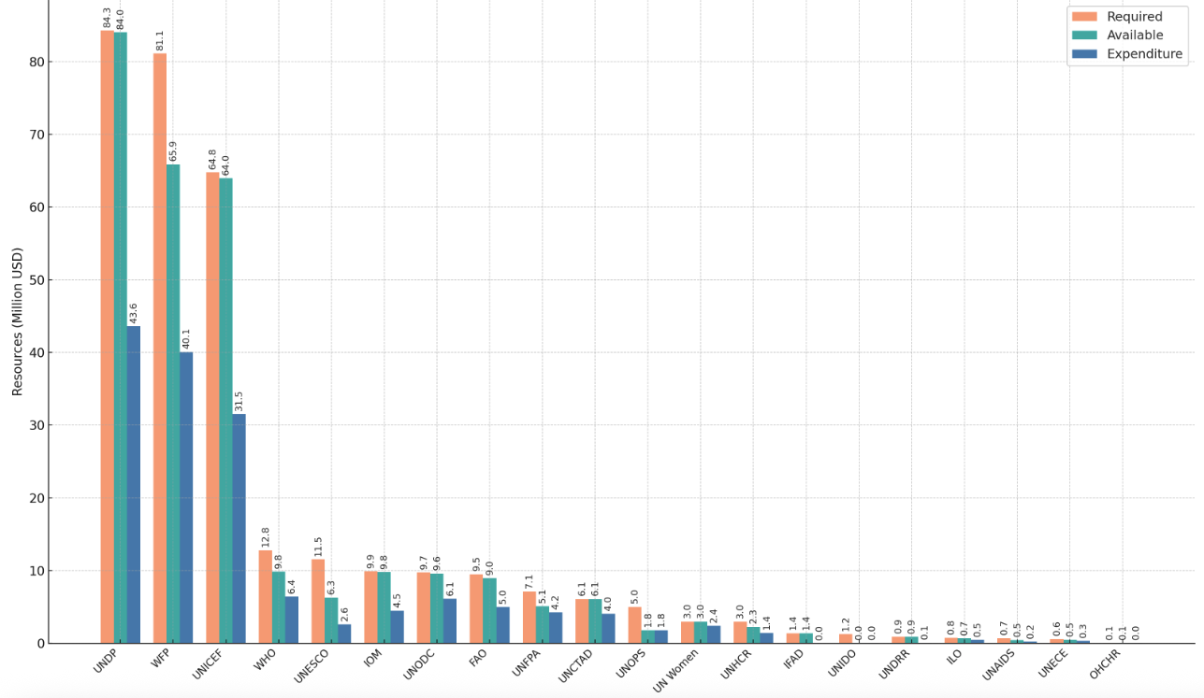
Figure 16 UNSDCF Tajikistan: Required vs Available vs Expenditure (Mid-2025)
Source: UN INFO
UN agencies facing severe underfunding relative to their strategic relevance include UNESCO, with only 54.5% of its $11.5 million requirement mobilized and a delivery rate of just 41.1%; and UNOPS, funded at merely 35.7% but demonstrating complete absorption of available resources. Other specialized agencies like UNIDO (3.1% funded), UNAIDS (64%), and ILO (90.8%) also face considerable resource gaps, negatively impacting thematic outcomes linked to governance, industrial development, health, and labour standards.
Outcome-level analysis reflects these disparities, as most mobilized resources continue to support Outcome 1 (Inclusive Human Development), driven by high-cost interventions from large agencies like UNDP, UNICEF, and WFP. However, critical thematic areas under Outcomes 3 (Climate and Environmental Risk Management) and particularly Outcome 4 (People-Centred Governance and Rule of Law) remain relatively underfunded, limiting advances in crucial areas such as governance reforms, legal system enhancement, human rights, climate adaptation, and disaster risk reduction.
Funding aligned with human rights and gender markers reveals unevenness (as presented in the previous paragraphs), with substantial resources designated as contributing or principally addressing these areas (Markers 2 and 3); however, genuinely transformative investments remain limited, particularly affecting Outcome 4.
In light of these imbalances, the concept of establishing a pooled fund under the UNSDCF has re-emerged as a potential strategic response during the discussion with UN representatives. While still in the early consideration stage and not yet formally designed or operational, the stakeholders and survey participants recognised “pooled fund as a practical mechanism to promote more equitable resource allocation, reduce fragmentation, and support outcomes that currently face systemic underfunding”. Stakeholders across the UN system, including smaller and non-resident agencies, have recognised the potential of pooled financing to enhance joint planning, delineate complementary agency roles, and elevate strategic coherence in line with national priorities. Notably, the survey participants recognised that the idea of a pooled fund has gained traction in the context of tightening global funding, donor earmarking, and fiscal unpredictability. As traditional bilateral funding sources decline and thematic earmarks become more rigid, pooled financing offers an opportunity to safeguard critical yet less commercially attractive components of the Cooperation Framework, particularly those linked to legal reform, human rights, DRR, and climate adaptation.
F25. The “Delivering as One” (DaO) has advanced the institutionalization of integrated UN support, yielding tangible operational efficiencies and fostering inter-agency collaboration. However, these achievements remain uneven, and bottlenecks continue to hinder the full realization of a coherent and unified UN response.
The ET finds that while the adoption of the DaO approach has brought incremental progress toward more integrated and efficient UN system functioning in Tajikistan, persistent structural and behavioural barriers continue to limit its full operationalisation. Based on triangulation of survey data, key informant interviews, and documentary evidence, several interconnected constraints were identified. The ET confirms that the fact that CF is still now a unified programme instrument remains a fundamental bottleneck undermining stronger coherence. As indicated in the previous paragraphs, the UNSDCF serves as the overarching strategic framework; its implementation remains anchored in individual agency Country Programme Documents (CPDs) and projects. The evaluation repeatedly observed that this issue prevents efforts toward unified budgeting (or even planning). This fragmentation was also highlighted in interviews with programme and operations staff, and in survey feedback referencing siloed approaches to design, delivery, and accountability.
This structural incoherence is mirrored in the operational domain. The Business Operations Strategy (BOS) 2019–2024 has generated measurable efficiency gains—USD 267,000 in cost avoidance in 2024 alone, and over USD 1.2 million since 2019 through joint procurement, shared premises, and logistics coordination.
Figure 17 Business Operations Strategy Implementation 2019-2024 | Figure 18 Realized benefits across BOS service lines in 2024
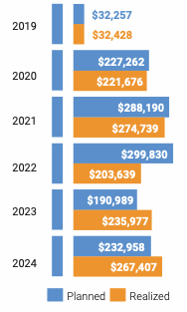 | 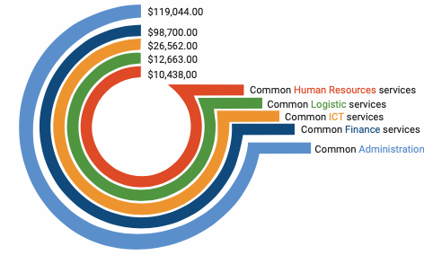
Source: ARR 2024
However, the ET finds that BOS is often misunderstood as a comprehensive coordination instrument, whereas its actual mandate is to streamline transactional services. BOS does not function as a programme or budgetary framework and cannot address fragmentation in planning and financing structures. Several operations staff noted that while BOS institutionalised some standard services, it lacked a country-level cost-benefit model to evaluate shared versus individualised delivery, limiting its transformative potential.
Survey results also reveal uneven perceptions of DaO implementation. Only 14.3% of operations respondents assessed the approach as fully implemented, while 42.9% judged it as only partially realised or insufficient. Interviews reinforced these perceptions, with repeated references to weak interoperability of financial systems, limited mutual recognition of agency-specific rules, and a lack of harmonised operational procedures.
Figure 19 Perception of the DoA implementation among the operations staff
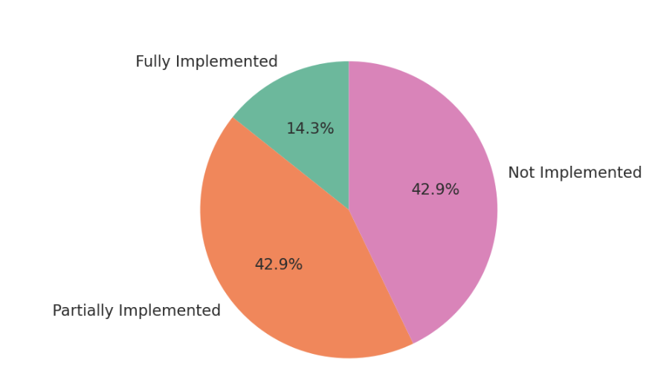
These constraints continue to impede integrated service delivery, despite improvements in specific areas such as shared ICT platforms and co-location arrangements like the EDGE-certified Green UN House.
From a programmatic perspective, 77.8% of surveyed programme staff reported engaging in inter-agency planning or implementation. Notable joint initiatives—such as the Spotlight Initiative, the joint programme on Transforming Food Systems, and local SDG financing—were referenced as cases where collaboration added value. However, only 52.3% of respondents believed joint programming had been sufficiently used to address complex development challenges, while 47.7% disagreed. This divergence reflects the continued variability in Result Group performance and commitment levels. Interviews with Outcome Group co-chairs indicated that while some Results Groups functioned as vehicles for coordination and joint advocacy, others remained under-utilised and weakly institutionalised.
Figure 20 Cooperation with Other UN Agencies (Programming & Implementation)- joint programming | Figure 21 Perceived Use of Joint Programming by Programme Staff
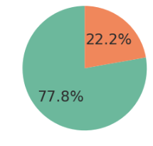  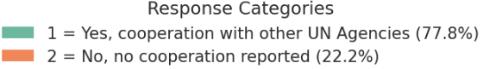 | 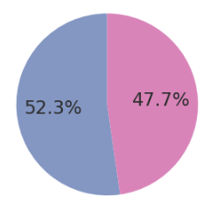  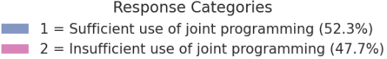
Despite considerable progress in designing the JWPs, the analysis deriving from the document review and key informant interviews confirm that JWPs are often treated as administrative deliverables rather than vehicles for joint planning grounded in shared theories of change. As a result, the interviewed and surveyed UN staff stated that JWP implementation has limited effects on strengthening collective accountability or reinforcing synergies. The issues concerning the RGs have been highlighted, especially national ownership and involvement.
Communication under the “Communicating as One” pillar also remains underdeveloped. While the UN Communications Group (UNCG) Tajikistan has produced joint messaging around UNSDCF milestones, it lacks a fully implemented communications strategy and consistent agency participation. Interviews noted that RCO-managed platforms such as the UNCT website and central social media accounts were underutilised and insufficiently linked to joint programme visibility or stakeholder engagement. The ET finds that the current communication setup does not effectively project the UN’s collective identity or showcase inter-agency cooperation.
The 2023 and 2024 UN Annual Results Reports (ARRs) for Tajikistan provide comprehensive accountability and adaptive planning, systematically structured around the four strategic outcomes. The ET finds that the document explicitly link UN interventions to Tajikistan's national priorities and specific SDGs, enhancing transparency through clear, outcome-by-outcome summaries, data-driven visuals, and illustrative country case studies. Additionally, the reports demonstrate improved alignment of indicators with national SDG targets, reflecting significant advancements in data harmonization, such as establishing a national SDG data platform to monitor progress on a substantial subset of SDG indicators.
Gender equality and women's empowerment (GEWE) are systematically integrated across both ARRs, evidenced by regular gender-disaggregated data reporting and detailed coverage of gender-focused legislative reforms, including significant amendments addressing barriers faced by survivors of sexual and gender-based violence. The reports consistently highlight specific interventions empowering women and vulnerable groups, such as skills training for female entrepreneurs and advocacy campaigns involving journalists and bloggers to promote gender equality. The ARRs also underscore substantial progress in inter-agency coordination, joint programming, and results-based management (RBM). The reporting narratives consistently reflect collaborative achievements, jointly presented by Result Group Co-Chairs from different UN entities, indicating strengthened clarity in inter-agency roles and responsibilities. Moreover, the ARRs reflect reduced fragmentation in monitoring frameworks through consolidated data collection via platforms like UN INFO and clearly linked outcome indicators.
The Partnership and Resource Mobilisation (P&RM) Strategy 2023–2026 presents a strategically robust and well-structured approach to enhance financing for Tajikistan's development priorities and SDGs. It clearly articulates objectives, such as establishing a national pooled fund, achieving 15% government co-financing, and engaging strategically with international financial institutions (IFIs), the private sector, and global funding mechanisms, including the SDG Fund and the Green Climate Fund.
Despite its comprehensive vision, interviews and document analysis highlight key gaps in operationalisation, notably the need for more consistent commitment from UN agencies to collective resource mobilisation efforts, deeper integration of government counterparts, and clearer delineation of roles among stakeholders. Evidence from stakeholder consultations further underscores that achieving the strategy’s ambitious goals will require assertive and coordinated leadership by the UN RCO/ UNCT, especially heads of agencies, as well as enhanced capacities for joint programming, partnership-building, and transparent monitoring of resource mobilisation outcomes. One of the UN staff commented that the full realisation of the DaO approach in Tajikistan requires “a cultural shift toward shared accountability, trust, and incentives for collective delivery”

Progress towards impact
The ET assessed progress toward impact by examining the extent to which UN system activities under the UNSDCF contributed to the Theory of Change (ToC) outcomes and the advancement of the SDGs in Tajikistan. The analysis focused on the alignment between UN interventions and national development goals, as well as the effectiveness of programming in fostering systemic change. In addition, the ET evaluated contributions to cross-cutting impact areas—such as gender equality, human rights, and environmental sustainability—by reviewing programmatic results, policy influence, and institutional changes supported by the UN across sectors.
EQ 5.1. To what extent have UN system activities, as articulated in the CF, driven progress towards, or supported the achievement of sustainable outcomes?
- F26. The UN Agencies under the CF have contributed to advancing progress towards outcomes by supporting the development of sectoral policies and institutional mechanisms that enhance public service delivery, social inclusion, and the realization of rights. Through strategic engagement with national partners, the UNCT played a key role in elevating issues of public interest into actionable policy priorities.
The ET applied a policy cycle model to analyze and validate the causal linkages between UNSDCF-supported results and national policy-level changes.
I) Policy Decisions (Problem Identification and Agenda Setting) and Policy Development
The UNCT has actively shaped national policy agendas through upstream engagement, prioritizing vulnerable groups and aligning advocacy efforts with SDG principles and international human rights norms. Notably, UN-supported multi-agency gap assessments significantly informed the revision of the Civil Registration Law, leading to the introduction of unique ID numbers for newborns—an essential step in improving access to public services and enhancing social protection targeting.
Moreover, the UN has been instrumental in facilitating legislative amendments to the Law on Prevention of Domestic Violence and developing the comprehensive State Programme on Domestic Violence Prevention (2025–2030), redefining gender-based violence as a multisectoral development issue. The UN has also influenced the child protection agenda through advocacy that resulted in significant legal reforms, including prohibitions on corporal punishment and enhanced children's participation in judicial and administrative proceedings. Stakeholders specifically highlighted the catalytic role of the UN in the migration sector, particularly through post-COVID diagnostics and vulnerability assessments that directly informed the national Reintegration Roadmap. Survey respondents corroborated these findings, emphasizing the UN’s essential role in elevating neglected issues—such as civil registration, domestic violence, and child protection—to the level of national policy dialogues, aligning these agendas closely with international normative frameworks and human rights obligations.
II) Policy Drafting, Including Policy Instruments and Implementation Mechanisms
Beyond agenda-setting, UN Agencies actively contributed to the drafting and operationalization of critical policy instruments and implementation mechanisms. For instance, in public administration, including civil registration, the UN supported the design of digital infrastructure plans and inter-agency interoperability protocols, creating a foundation for a fully integrated digital registry system. The UN also supported institutionalization in the prevention of gender-based violence through developing standard operating procedures (SOPs), multisectoral referral mechanisms, and updated care protocols, which were embedded into bylaws and directives at the ministerial and local government levels. Furthermore, the operationalization of the Free Legal Aid Law was significantly supported by the UN through technical assistance that included costed service standards and mobile legal aid clinic protocols, progressively transferring financial and operational ownership to the Ministry of Justice.
Nonetheless, the evaluation identifies ongoing challenges on the side of the Government of Tajikistan- which is not directly correlated to the CF. For example, policy coordination mechanisms—both vertically across national and sub-national levels, and horizontally among ministries and agencies—remain underdeveloped. Inter-agency working groups exist in several sectors, often supported by the UN, but they tend to be informal, project-based, or reliant on personal networks rather than being institutionalized through formal mandates, clear rules, or dedicated budgetary authority. Moreover, the government's prevailing approach to policy and legislative formulation frequently excludes development partners in the early stages, limiting opportunities for meaningful input, strategic alignment, and collaborative ownership from the outset. This practice has implications for policy coherence, institutional buy-in, and effective operationalisation of reforms.
While inter-agency working groups exist, their effectiveness often remains dependent on project-based funding or informal networks rather than sustainable institutionalization. Yet, promising institutional developments, such as the establishment of the Agency for Innovation and Digital Technologies under the President of Tajikistan, indicate progress towards more structured policymaking and improved inter-agency coordination, potentially mitigating earlier fragmentation.
- F27. Across the four CF outcomes, the UN Agencies have addressed and strengthened institutional capacities at multiple governance levels. UN-supported interventions sought to enhance public institutions' capabilities for service delivery, oversight of reforms, and fulfillment of mandates aligned with SDG priorities, particularly in justice, employment, education, health, and environmental governance.
The UNCT has played a catalytic role in strengthening national institutions and public service systems across all four outcomes of the UNSDCF, contributing to policy reform, digital transformation, and inclusive service delivery. These efforts, according to the national partners, have collectively enhanced Tajikistan’s institutional capacity to plan, implement, and monitor reforms aligned with SDG priorities, particularly in areas such as justice, education, health, employment, and environmental governance. For example, the ET finds that in the employment sector, the UN supported institutionalisation of vocational education and labour market analytics, including the launch of kor.tj, a digital job-matching platform. These interventions were designed to address structural barriers to youth employment and strengthen the Ministry of Labour’s data-driven decision-making. Under the National Programme on Productive Employment, entrepreneurship support units were expanded in several regions to improve outreach to women and young people. However, the 2023–2024 CCA update highlighted that institutional readiness to operationalise these reforms fully remains uneven, particularly at the subnational level. Fragmented links between national and local departments, limited digital infrastructure, and human resource gaps undermine scalability and sustainability.
In the health sector, the UNCT supported major improvements in disease surveillance, inclusive immunisation, and data systems through DHIS2. These investments led to greater integration between service delivery and health information systems. Similarly, in education, UN interventions focused on enhancing early childhood education (ECE) standards and promoting inclusive education, including the development of professional standards and training modules. Yet, institutional fragmentation, limited continuous professional development, and inadequate monitoring systems have constrained national roll-out. In the social protection domain, the UNCT provided technical assistance to operationalize the National Social Protection Strategy, develop referral and case management systems, and pilot integrated service delivery approaches. These initiatives have enhanced clarity around institutional roles and expanded models of care for vulnerable groups.
Justice and governance reforms under Outcome 4 represent a cornerstone of the UNCT’s contribution. The institutionalization of the Free Legal Aid (FLA) system, as previously elaborated, is now financed and administered by the Ministry of Justice, demonstrating promising sustainability prospects. Coverage has expanded to 53 centres, with improved outreach to rural and marginalized populations. Civil registration reforms, including the introduction of unique personal identifiers for newborns, digital protocols, and systems integration, have substantially improved legal identity and access to services. Survey results strongly validated these reforms, citing increased citizen satisfaction and reduced administrative barriers.
The UN also supported parliamentary oversight, legal drafting, and national human rights institutions, including the Human Rights Ombudsman and the Inter-Ministerial Commission on Trafficking in Persons. While technical tools and guidance were introduced, implementation is still often donor-dependent, with institutional continuity threatened by weak retention strategies and insufficient integration of reforms into national budgetary frameworks.
UN support in DRR and environmental governance facilitated the development of early warning systems, risk mapping, and resilience strategies, particularly in vulnerable regions. The Committee for Emergency Situations and Civil Defense acknowledged these contributions, and the National Hydrometeorological Service made notable progress in climate data generation.
Systemic Constraints and Cross-Cutting Institutional Challenges
The evaluation finds that despite substantial institutional gains, national institutions continue to face persistent structural bottlenecks that limit the full transition of pilot initiatives into sustainable national systems. Survey responses corroborated these institutional constraints, reflecting broader concerns regarding the government's internal capacity to manage and sustain development changes initiated through UN support effectively. While 45% of programme staff felt the UNCT's contribution to development outcomes was either “complete” or “sufficient,” a significant proportion (36%) considered this contribution insufficient, and another 18% lacked adequate information to make an informed judgment. This feedback points to persistent gaps within national institutions regarding strategic communication, clear attribution, and robust tracking of results in complex reform contexts.
Nevertheless, respondents recognized the important role the UN has played in advancing critical national reforms, including improvements in the civil registration system, gender equality legislation, and child protection frameworks. However, stakeholders consistently emphasized the necessity for national institutions to strengthen their internal data systems, improve inter-agency coordination, and establish mechanisms for institutional learning and continuity to ensure sustainable and resilient outcomes from these reforms.
F30. UN’s support through the UNSDCF has clearly aligned with and contributed to Tajikistan’s SDG priorities, particularly in the areas of institutional reform, climate adaptation, and inclusive human development. However, the realization of full impact and sustainability will depend on continued efforts to strengthen national capacities, expand data systems, and secure consistent political and financial support from domestic stakeholders.
Tajikistan has demonstrated steady yet uneven progress toward the SDGs, with key advancements in poverty reduction, human capital development, governance reform, and environmental management. According to the 2023 Voluntary National Review (VNR), the national poverty rate decreased to 22.5%, with notable improvements in immunisation rates, nutrition outcomes, and digital education infrastructure. Despite these gains, multidimensional poverty continues to affect one in four citizens, substantial gender inequalities persist—with Tajikistan ranked 111 out of 146 globally—and significant systemic vulnerabilities remain, particularly evidenced by high out-of-pocket health spending, accounting for over 65% of total healthcare expenditure.
Against this challenging context, the UN system, through the UNSDCF, strategically contributed to significant national policy reforms and institutional strengthening efforts aligned directly with SDG priorities. These included supporting flagship national initiatives such as the National Programme on Productive Employment (aligned with SDG 8), the Mid-Term Education Action Plan and Digital Education Roadmap (aligned with SDG 4), and the comprehensive Social Protection Strategy and 2024–2026 Action Plan (aligned with SDG 1). These interventions had measurable impacts, benefiting more than 1.5 million vulnerable individuals—including refugees and stateless persons—and extending national social protection coverage to approximately 25% of the population. Additionally, targeted UN support enhanced nutrition and food security, providing school feeding for over 550,000 children, and significantly improved access to clean water and sanitation for more than 300,000 people.
In governance (aligned with SDG 16), UN-supported reforms have substantially strengthened national capacities for protecting human rights and improving access to justice. Landmark achievements include the adoption of Tajikistan’s first National Human Rights Strategy, significant legislative changes enhancing protections against sexual and gender-based violence (SGBV), removal of age restrictions for filing SGBV complaints, bans on corporal punishment, and formal recognition of children’s rights within judicial processes. The UN’s substantial technical assistance facilitated the expansion of free legal aid services, resolution of statelessness for over 8,000 individuals, and digitalization of civil registration, notably through the introduction of unique personal identifiers for newborns, resulting in citizen satisfaction increasing from 35% in 2022 to 86% by 2024.
In climate resilience and environmental management, the UN’s contributions were catalytic and strategic, notably under Outcome 3 (aligned with SDG 13 and SDG 6). This included the development of six sector-specific climate adaptation plans as part of the National Adaptation Plan (NAP) process, the finalisation of the National Water Strategy 2040, and the successful implementation of 14 watershed management action plans. The UN’s efforts significantly strengthened Tajikistan’s international advocacy and leadership in water diplomacy, notably at COP28 and through hosting the International Glaciers’ Forum. Furthermore, the UN supported institutional enhancements in disaster risk management.
The ET finds that specific achievements under the CF demonstrate clear impacts: mainstreaming human rights and gender equality within national legal frameworks, fostering inclusive economic participation and digital innovation, enhancing community resilience to climate impacts, and significantly improving access to critical social services for vulnerable populations. Moreover, the CF process facilitated a more results-oriented culture within national institutions through joint planning and institutionalized annual performance reviews across all four strategic outcomes.
Despite these meaningful accomplishments, the evaluation highlights systemic constraints primarily within national institutions that hinder achieving the full transformational potential and sustainability of reforms. Some of the main challenges among the national institutions that the interviewed stakeholders highlighted included low absorption and implementation capacities within ministries and subnational bodies, high staff turnover exacerbated by limited structured career development paths, fragmented planning processes disconnected from sectoral and budgetary frameworks, and insufficient integration of costing and sustainability strategies into reform agendas. Moreover, weak monitoring and data systems continue to constrain effective measurement of outcomes and attribution of SDG progress, despite establishing an SDG database with UNESCAP.
EQ5.2. To what extent have UN activities stemming from the CF impacted key cross-cutting areas of interventions in the area of gender inequality, human rights, and environmental sustainability?
- F31a. The UNSDCF has made notable advances in promoting gender equality and women's empowerment in Tajikistan through significant normative, institutional, and operational achievements. However, despite substantial progress, achieving sustainable, systemic gender equality outcomes requires more comprehensive, strategic, and coherent efforts to address remaining gaps and structural barriers but the involvement of national institutions is of utmost importance .
At the normative and legislative levels, the UN has played a transformative role, particularly evident through the Spotlight Initiative. This joint intervention significantly improved national institutional responses to gender-based violence (GBV), notably by supporting crucial amendments to Tajikistan's Law on Prevention of Domestic Violence. These amendments established a comprehensive and survivor-centred framework, introducing provisions such as multisectoral coordination mechanisms, free access to health services, specialized shelters, and extended protective orders for survivors. Such institutional improvements have facilitated a notable shift, reframing GBV from a legalistic approach to a multisectoral development issue, thus fostering cross-sectoral engagement involving social, health, and judicial actors
In parallel, considerable strides were made in enhancing women's economic empowerment. Capacity-building initiatives targeting women entrepreneurs—encompassing innovative agricultural practices, greenhouse management, and business development—have not only bolstered women's economic participation but also challenged entrenched socio-cultural barriers. The collaboration with the Ministry of Labour, Migration, and Employment to significantly reduce the list of prohibited professions for women, from 336 to 195, represents an essential structural advancement, indicating strong government buy-in and incremental shifts towards gender-responsive labour market policies. Nevertheless, the slow pace of full-scale gender-responsive labour reforms and the persistence of occupational stereotypes and barriers indicate the need for ongoing, intensified advocacy, technical assistance, and policy dialogue.
Internally within the UN Country Team, gender mainstreaming has seen notable progress, as reflected by the 2024 UNCT-SWAP Gender Equality Scorecard. The UNCT exceeded minimum requirements across core performance indicators on organisational culture, leadership commitment, and capacity-building. High levels of internal confidence (over 80% positive ratings) illustrate the effective internalisation of gender equality commitments among UN personnel in Tajikistan Yet, significant disparities remain regarding the consistency of gender-sensitive implementation at subnational levels, where programmes often remain gender-neutral rather than transformative. Furthermore, only approximately 35% of CF indicators are gender-sensitive or sex-disaggregated, signalling an analytical gap that limits precise tracking of gender-specific progress and undermines the ability to measure transformative impacts accurately.
Survey results provide valuable analytical insights into the effectiveness of gender mainstreaming. While approximately 59.57% of respondents assessed gender integration as "sufficient," a smaller percentage (6.38%) perceived these efforts as comprehensive. Crucially, nearly one-fifth of respondents (19.15%) viewed efforts as insufficient, highlighting persistent, systemic limitations. Respondents critically emphasized fragmented implementation, inconsistent prioritisation of gender equality across UN agencies, and a scarcity of specialized technical expertise within coordination structures. A clear analytical inference here is the need for more centralised strategic guidance, clearer accountability mechanisms, and stronger capacity-building frameworks to ensure gender-responsive programming transcends nominal inclusion towards genuine transformation in Tajikistan.
Furthermore, respondents highlighted systemic constraints that hinder effective integration, including inadequate disaggregated data collection and limited use of comprehensive monitoring frameworks. These constraints were seen as undermining the ability to systematically measure and communicate the impact of interventions related to gender equality, human rights, disability inclusion, and environmental sustainability.
Figure 22 Perception of gender equality within the CF
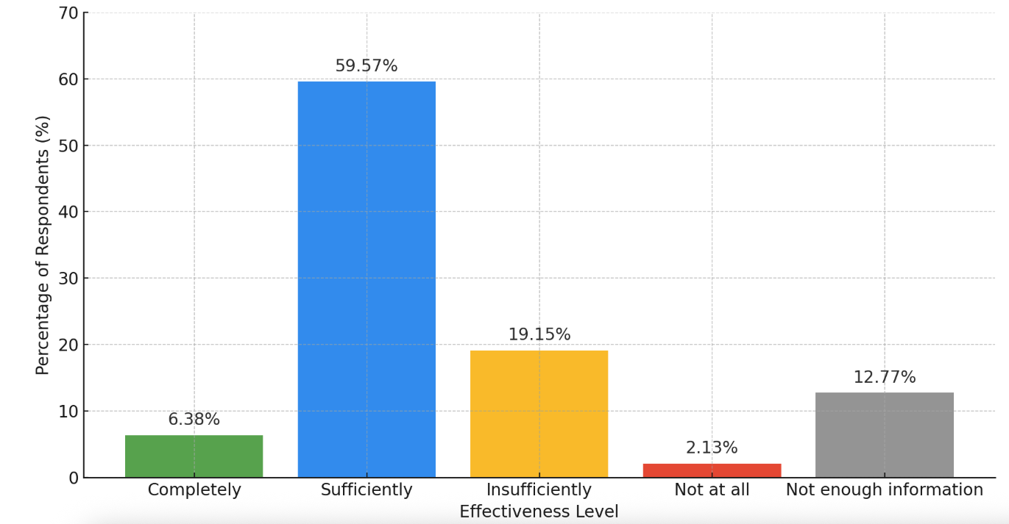
Source: UN Programme and Management Staff Survey
Systemic challenges outside of the CF and related to national institutions, such as inadequate data collection and limited monitoring frameworks, have also hindered the effective integration of gender equality. The existing monitoring systems lack the granularity required to capture the intersectional dimensions of inequality accurately. In particular, there are substantial data gaps in monitoring gender-based discrimination, economic disparities, unpaid care work, and violence against women at subnational levels. The absence of robust, consistent, and intersectional gender data limits strategic decision-making and undermines advocacy efforts, reducing the ability to demonstrate clear evidence of gender-transformative impacts.
The UNCT SWAP analysis further emphasizes critical dimensions for advancing gender equality. While the Common Country Analysis (CCA) and UNSDCF outcomes have integrated gender considerations to a significant extent, additional improvements are necessary, including greater clarity in gender-sensitive outcome indicators, more explicit accountability mechanisms for gender mainstreaming, and stronger linkages between policy advocacy and measurable outcomes for women and girls
Overall, while the UN’s efforts have clearly yielded positive normative, institutional, and operational achievements in gender equality, the analytical perspective highlights critical remaining gaps. Future strategic actions must prioritize enhancing systematic gender mainstreaming across all CF outcomes, strengthening accountability through gender-sensitive indicators and disaggregated data collection, expanding meaningful engagement with women’s organizations and marginalized groups, and bolstering the internal gender architecture and capacities of the UNCT. Only through addressing these interlinked systemic issues can the UNCT ensure a truly transformative, sustainable, and equitable advancement of gender equality in Tajikistan.
- F31b. The UNSDCF has significantly advanced human rights and environmental sustainability in Tajikistan through strategic normative support, institutional capacity-building, and integrated multisectoral programming. However, the reach and consistency of these achievements varied considerably, influenced by fragmented implementation, limited technical capacities, and incomplete mainstreaming across UNCT interventions.
In human rights, the UNSDCF notably supported the enhancement of national policy frameworks and improved access to justice, particularly through substantial legal aid reforms. National institutions recognized significant UN contributions to strengthening their capacities, especially the Ombudsman’s Office and Ministry of Justice. Despite these advances, feedback from surveys and stakeholder interviews highlighted considerable gaps in the practical application of rights-based approaches. Respondents expressed concerns over inadequate dedicated guidance, limited utilization of Human Rights-Based Approach (HRBA) checklists, and a perception that human rights integration often remained compliance-driven rather than inherently embedded within programme design, implementation, and monitoring—especially beyond central urban areas.
The UNSDCF period also saw significant strides in environmental sustainability, reflecting increased visibility and strengthened cross-agency collaboration. Substantial UN contributions supported disaster risk reduction systems, watershed-based climate adaptation initiatives, and low-emission rural energy solutions, effectively raising awareness about climate-related risks and linking environmental actions to social and economic resilience. Staff surveys acknowledged progress, particularly in community-based resilience and energy efficiency initiatives. Nonetheless, systematic mainstreaming of environmental sustainability across sectors remained incomplete, particularly in health, education, and economic programming. Survey respondents identified challenges, including insufficient technical expertise within UN coordination structures and an overreliance on short-term, donor-driven projects that lack robust institutional anchoring and long-term financing mechanisms.
Survey findings further emphasised ongoing systemic challenges in mainstreaming cross-cutting areas. While approximately two-thirds (66%) of respondents considered the integration of gender equality, human rights, disability inclusion, and environmental sustainability as sufficiently compelling, nearly one-third perceived it as insufficient. Identified gaps included the lack of unified operational tools, inadequate use of disaggregated data, and weak monitoring frameworks to measure outcomes linked to cross-cutting themes. Respondents repeatedly highlighted that integration often depends heavily on individual agency priorities and capacities rather than guided by a cohesive, coordinated UN-wide approach. Moreover, the absence of clear accountability frameworks to ensure consistent incorporation of cross-cutting issues into Joint Work Plans, Results Group deliverables, and national partnerships was noted as a critical barrier to achieving sustainable outcomes. To effectively address these issues, sustained investments in technical expertise, comprehensive accountability mechanisms, robust data collection, and strengthened monitoring and evaluation (M&E) practices are necessary to mainstream these cross-cutting dimensions across all interventions fully.

Sustainability
The ET assessed the likelihood that the progress made under the UNSDCF—particularly in priority areas such as human rights and gender equality—will be sustained by national stakeholders over time. This included analysing the level of national ownership, the integration of interventions into national policies and systems, and the commitment of government partners to continue financing and implementing successful models. Additionally, the ET reviewed whether the CF established institutional, policy, and financial mechanisms to ensure long-term results, including structured transition strategies, domestic financing pathways, and systemic capacity development to embed reforms within national frameworks.
EQ 6.1. What is the likelihood that progress towards the SDGs is sustained by national partners and stakeholders over time, including in the areas of human rights, gender equality?
F32. The ET finds that the sustainability of results under CF remains a complex and uneven process; still, the foundations that UN agencies have laid—including institution-building, strategic policy support, and systems-level innovation—offer a credible basis for long-term effects of these achievements and their durability. The analysis showed that this basis could be enhances if UN Agencies and national partners continue efforts to ensure deeper integration of reforms into domestic systems, realistic exit and transition strategies, and a continued focus on enabling “reform champions” to lead, finance, and monitor their development priorities.
The evaluation identifies several pathways that have improved the prospects for sustainability. These include the institutionalization of key services, long-term capacity development, embedding reforms into policy frameworks, and the progressive transfer of implementation responsibilities to national systems. Survey results reveal a cautious outlook among UN programme staff, with only about 15% believing that progress can be fully or sufficiently sustained without continued UN support. Respondents frequently cited limited public financing, insufficient institutional ownership, high staff turnover, and over-reliance on project-based modalities as major risks.
1. Capacity Development at Multiple Levels: UNCT has implemented tailored capacity development across all four outcome areas, targeting frontline service providers, national ministries, and oversight bodies. For example, UN supported competency-based education reform, teacher training, and the expansion of EMIS, which enhanced national education management capacities. In health, capacity-building focused on early childhood development, reproductive and adolescent health, and the roll-out of IMCI guidelines. In parallel, civil servants received training in green entrepreneurship, digital inclusion, and value chain strengthening. Several government officials from various ministries, agencies, and departments were capacitated on social protection, including adaptive and shock-responsive programming as well as humanitarian cash transfers. UNCT also contributed to enhancing national statistical capacity for labour market analysis and SDG monitoring. Despite these investments, sustainability is hampered by high staff turnover, lack of systemic career progression mechanisms, and insufficient human resource strategies. Survey respondents noted the need for more institutionalised capacity retention mechanisms and recommended shifting from ad hoc training to structured workforce development.
2. Institutional Strengthening and Ownership: Institutional development was a central feature of many interventions, as elaborated in the previous paragraphs. However, institutional maturity remains uneven. For example, while DRR strategies and early warning systems were introduced, the institutions responsible for implementing them—especially at the subnational level—face chronic under-resourcing and limited coordination authority. Limited performance-based planning, fragmented mandates, and inconsistent application of standard operating procedures further compound institutional fragility.
3. Policy Advocacy and Systemic Reform: UNCT played a catalytic role in supporting upstream policy reform, including the adoption of some of the critical national and sectoral policies (as elaborated under the previous paragraphs). These policy instruments align with international standards and represent a shift toward integrated and rights-based development planning. Yet, the ET finds that many of these reforms have not yet translated into fully functional delivery systems. Policy costing remains donor-driven and is rarely embedded in Medium-Term Expenditure Frameworks (MTEFs). Moreover, policy implementation is hindered by fragmented coordination mechanisms and insufficient sectoral integration. Similarly, UN staff stated the gap between policy design and implementation, citing insufficient technical planning, lack of fiscal alignment, and weak engagement of subnational authorities in policy operationalization.
4. Partnerships and Multi-Stakeholder Engagement: The UNCT in Tajikistan actively promoted inclusive partnerships as a core element of the UNSDCF implementation strategy. Collaborations were forged with a range of governance actors, aligning technical assistance with national development priorities across critical sectors.
The UNCT also supported engagement with civil society actors, particularly in addressing gender-based violence (GBV), legal empowerment, and community-level service delivery. Despite these positive developments, the evaluation finds that CSO engagement remains limited in scope and depth. Many CSOs—especially those representing women, persons with disabilities, and youth—continue to be engaged in a project-based, transactional manner rather than as strategic development partners. Their involvement in policy design, implementation oversight, or coordination platforms is often inconsistent or absent. UN staff emphasised this gap, noting that CSO inclusion is too often symbolic or peripheral, lacking clear roles, feedback mechanisms, or long-term support. A similar challenge was observed with local governments, as they generally lack the institutional capacities, financial autonomy, and clarity of mandates required to deliver services initiated with UN support in a sustainable manner. This disconnect between national reform efforts and local implementation capacities risks undermining sustainability and accountability.
The ET finds the need for the UNCT to be well-positioned to enhance the quality and effects of its partnerships by institutionalizing multi-stakeholder coordination mechanisms, investing in the capacities of CSOs and local governments, and embedding participatory approaches in planning, budgeting, and monitoring processes. Doing so will help ensure that partnerships are not only inclusive but also empowering, resilient, and aligned with the SDG principle of leaving no one behind.
5. Knowledge Systems, Data, and Learning: Progress was observed in strengthening sectoral data systems and promoting evidence-based decision-making. Still, data disaggregation, particularly by gender, disability, age, location, and migration status, remains insufficient, limiting the ability to track disparities or design targeted interventions.
Also the codification and institutionalization of knowledge remain underdeveloped. The ET finds that various pilot initiatives, assessments, and capacity-building efforts have generated valuable insights, but systematic documentation, dissemination, and integration into national systems are inconsistent. Lessons learned from UN-supported reforms are often retained within project teams or donor reports, rather than translated into national guidelines, training curricula, or operational manuals. Without structured knowledge management systems and dedicated repositories within ministries or sectoral institutions, the potential for institutional memory, peer learning, and replication is weakened. Survey responses echoed this gap, with staff underscoring the need for better archiving, knowledge transfer, and institutional learning practices to support the durability of reforms.
6. Systemic and Structural Challenges to Sustainability: In many areas, sustainability remains constrained by entrenched systemic weaknesses. One of the most persistent issues is institutional fragility, which affects the ability of national counterparts to absorb, maintain, and scale reforms. Furthermore, the ET finds that fragmentation of mandates and duplication of efforts across ministries and agencies remain unresolved. This problem is exacerbated by underdeveloped Inter-ministerial coordination. The evaluation found limited use of inter-sectoral planning tools, despite some efforts by UNCT to align planning cycles.
The absence of costed sustainability strategies is another key limitation. Most initiatives lack a long-term financial plan, and integration into domestic budgets remains the exception rather than the norm. The expectation that external partners will continue to fund services creates risks for ownership and long-term viability.
F33. The national partners have ensured some but limited financial and technical/ human resources to maintain achievements under UNSDCF and the SDGs
The analysis of primary and secondary sources revealed that national ownership of selected UNSDCF results has deepened over the current cycle, and the national stakeholders confirmed institutional commitment to sustaining progress in specific areas, (as mentioned in the previous paragraphs)..
Ministries such as the Ministry of Justice and the Ministry of Health have demonstrated a growing readiness to institutionalise and finance key reforms. Similarly, the Agency of Statistics has made measurable investments in its SDG data architecture, including the SDG Tracker—critical tools for evidence-based policy and monitoring. At the same time, the mentioned negative factors are limited fiscal space, weak inter-institutional coordination, and an overreliance on donor-driven service delivery mechanisms.

Nevertheless, several challenges remain. As already mentioned in the previous part of this report, referring to the CCA, its updates and primary sources- these include the volatility of public budgets, high turnover rates within public institutions, and inadequate local governance capacities. These systemic issues are further exacerbated by the lack of comprehensive human resource development strategies, limited fiscal decentralisation, and the tendency for policy initiatives to be fragmented across different sectors. Survey findings confirm that, although political will is present in certain ministries, sustainability often depends on leadership driven by individual personalities rather than institutional safeguards. Additionally, evaluation participants emphasised that sustainability considerations are seldom incorporated into the design phase of interventions, thereby constraining forward planning and the development of exit strategies.
- The analysis reveals a clear emphasis on SDGs 2, 3, 4, and 16 in both financial and programmatic terms, with gender equality (SDG 5) achieving broad integration through widespread interventions despite moderate funding. However, some SDGs remained underrepresented.
An analysis of UN contributions to the Sustainable Development Goals (SDGs) under the UNSDCF 2023–2026 in Tajikistan reveals a distinct pattern of resource prioritization and programmatic engagement.
Figure 23 How UN contributes to the SDGs (available resources 269 mil USD)
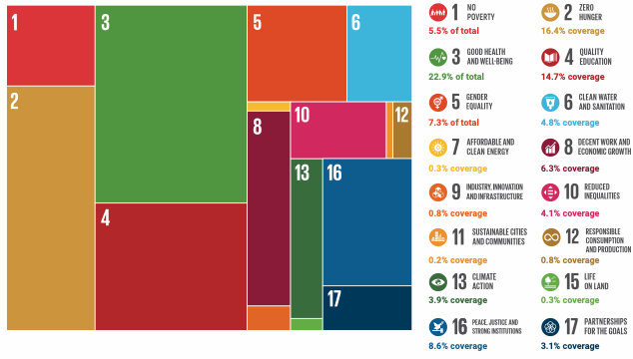
Source: ARR 2024/ UNINFO
Out of the total available funding of $278.6 million, the largest share—22 percent—was allocated to SDG 3 (Good Health and Well-being), underscoring the UN’s continued investment in strengthening health systems, universal health coverage, and pandemic recovery. This financial focus was matched by a high number of programmatic interventions, with SDG 3 ranking among the most operationally active goals. Significant resources were also directed to SDG 2 (Zero Hunger) and SDG 4 (Quality Education), which received 17.6 percent and 14.1 percent of the funding respectively, reflecting the strong alignment of UN support with national priorities around food security, nutrition, and human capital development.
The most striking discrepancy between funding and programmatic engagement emerged under SDG 5 (Gender Equality). While gender equality accounted for only 6.8 percent of total resources, it featured the highest number of interventions—73 in total. This suggests that gender issues have been extensively mainstreamed across sectors and UN agency mandates, and that interventions are frequently embedded within broader programmatic packages rather than financed as stand-alone initiatives. A similar pattern was observed with SDG 16 (Peace, Justice and Strong Institutions), which received 8.3 percent of funding and supported 33 programmatic interventions, confirming the centrality of governance, human rights, and the rule of law in the UN’s cooperation with the Government of Tajikistan.
Moderate alignment was evident in SDG 8 (Decent Work and Economic Growth) and SDG 13 (Climate Action), which accounted for 6.8 and 4.4 percent of funding respectively, and supported 34 and 24 interventions. These areas are increasingly important within the UNSDCF, particularly given the emphasis on inclusive green growth and resilience, but the data suggests that further resource mobilization may be needed to scale up implementation. Conversely, several goals remain underrepresented in both financial and operational terms. SDG 7 (Affordable and Clean Energy), SDG 11 (Sustainable Cities and Communities), SDG 12 (Responsible Consumption and Production), and SDG 15 (Life on Land) each received less than 1 percent of total funding and recorded only 4–5 interventions. This reflects a strategic gap in addressing the environmental sustainability and green economy dimensions of Tajikistan’s development trajectory—an issue that could undermine long-term progress toward the 2030 Agenda if not addressed in future programming cycles.
SDG 17 (Partnerships for the Goals), while receiving just 3.5 percent of the funding, accounted for 27 interventions, highlighting its cross-cutting relevance to coordination, financing, and the enabling functions of the UN system. Despite limited earmarked funding, SDG 17 interventions play a catalytic role in strengthening policy coherence, donor alignment, and pooled resource mechanisms, thereby facilitating broader SDG achievement.
Figure 24 Number of programmatic interventions per SDGs
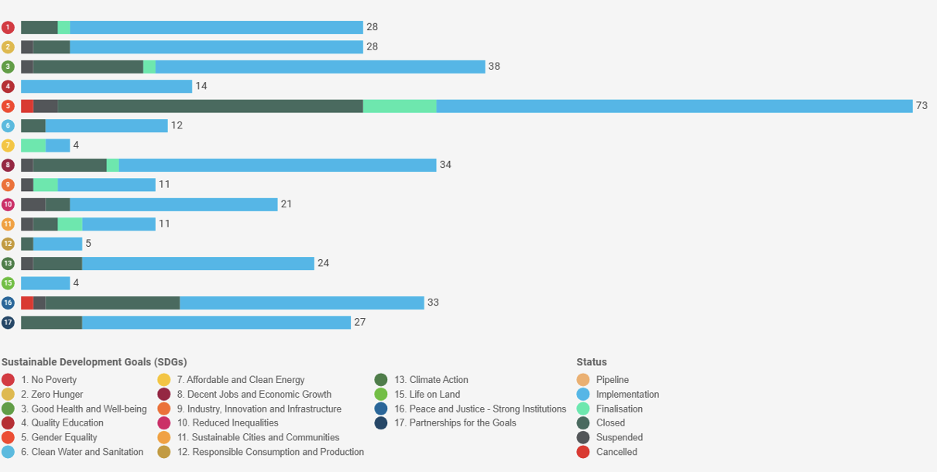
Source: UN INFO
The funding and programmatic landscape indicates a strong focus on the social sectors and governance, with commendable breadth of intervention under gender equality and institutional reform. However, the limited engagement in energy, environment, and sustainable production underscores the need for a more balanced approach in the next UNSDCF cycle—one that fully integrates climate-related priorities and supports Tajikistan’s ambitions for a resilient, low-carbon, and inclusive development pathway.
EQ 6.2. What mechanisms, if any, has the CF established to ensure socio-political, institutional, financial and environmental sustainability?
- F34. The ET finds that while the UNSDCF has contributed to strengthening national systems across all outcome areas, sustainability remains a strategic area of importance that demands deliberate, long-term planning. The CF strived to establish multiple pathways aimed at securing the socio-political, institutional, financial, and environmental sustainability of its results. Still, these are not yet uniformly embedded across all sectors or governance levels. Evidence from interviews, reports, and the staff survey suggests that although the CF has catalysed institutional and policy reforms, the transition to full national ownership is still uneven.
Institutional and Financial Mechanisms
Progress has been most visible where reforms have been institutionalized within core government systems. The example of FLA system and the establishment of integrated child protection units within the Ministry of Health and Social Protection mark shifts toward ownership and sustainability. Similar efforts are evident in the education sector, with early iterations of integrated information systems and the introduction of inclusive education standards. However, the institutional depth of these reforms varies, and the ET notes challenges with long-term staffing, technical expertise, and fragmentation in subnational implementation.
Financially, while there have been moves toward domestic funding, progress in introducing other financial mechanisms such as thematic/green bonds (e.g., school feeding, FLA), many CF-supported initiatives remain reliant on donor resources. Costing exercises have not been consistently translated into multi-year expenditure frameworks, and fiscal space remains constrained, particularly for social and environmental sectors.
Socio-Political Sustainability and LNOB
The CF has made progress in embedding the LNOB principles, gender equality, and human rights into its policy frameworks and service delivery models. Mechanisms for promoting socio-political sustainability include, among others, the integration of gender-transformative approaches in domestic violence legislation, support for inclusive education, and the creation of participatory platforms for children, youth, and persons with disabilities. However, the direct engagement of marginalised populations in decision-making processes (or indirectly, through grassroots and representative civil society organisations) remains inconsistent, and mechanisms for sustained inclusion—such as CSO monitoring or social accountability platforms—are still in their early stages of development.
Evaluation participants highlighted that deeper sustainability in these areas will require the institutionalisation of LNOB and gender equality within national policy, planning, and budgeting processes, not just in project implementation. The focus remains on integration of disaggregated data, participatory approaches, and continuous feedback loops into governance systems.
Environmental Sustainability and Climate Resilience
Environmental sustainability mechanisms were evident under Outcome 3 through support to watershed planning, climate-smart agriculture, and the roll-out of disaster risk reduction (DRR) protocols in vulnerable regions. Yet, national capacities to integrate DRR and climate adaptation into sectoral plans remain limited. While there is growing interest from national institutions in green transition, the enabling legal, financial, and institutional frameworks require further development. The CF has initiated dialogue and technical assistance, but mainstreaming climate resilience into planning and public investment systems is an ongoing need.

Conclusions
The ET prepared conclusions based on an in-depth analysis of findings and facts obtained from desk reviews, surveys, interviews, and direct interactions with final beneficiaries through focus groups.

Conclusions on relevance
C1. The UNSDCF 2023–2026 is a strategically relevant framework that provides a coherent platform for aligning the collective efforts of the UN with Tajikistan’s national development goals, while also responding to global imperatives. Its architecture reflects deliberate alignment with the NDS-2030, and its outcomes are designed around structural levers of transformation: human capital, inclusive economic growth, environmental sustainability, and governance. This alignment is reinforced by evidence-based planning and extensive government ownership, making the CF a legitimate and nationally embedded instrument for SDG delivery. In addition, it has facilitated progress in integrating rights-based, gender-responsive, and equity-focused approaches into national development processes. It facilitated landmark normative shifts—including the institutionalisation of legal aid, adoption of a long-term human rights strategy, and advances in gender-responsive budgeting. Responsiveness to emerging needs—especially those of vulnerable and excluded populations—has been demonstrated through adaptive programming and dynamic use of the Common Country Analysis. However, its reach remains uneven mainly due to weak national governance system in Tajikistan, particularly in rural and underserved areas, and its capacity to translate macro-level priorities into subnational action is hindered by limited fiscal space, institutional fragmentation, and underdeveloped accountability mechanisms. Other structural limitations in national systems include weak disaggregation, fragmented mandates, and inconsistent budgetary integration of equity goals.
C2. While the CF’s problem analysis is broadly sound, the outcome architecture includes ambitions that may exceed what is feasible within the programming cycle. Outputs are often well-formulated to address institutional and policy bottlenecks, but the link between outputs and transformative change is not always clearly articulated. Horizontal integration across outcomes is limited, with cross-cutting themes such as digitalisation, resilience, and gender addressed inconsistently and often without shared indicators or collaborative implementation mechanisms. The absence of a comprehensive country-level Theory of Change further weakens the strategic coherence and evaluability of the CF. In connection with this, the Results Framework includes SDG-aligned indicators. It draws on national data systems, but it suffers from inconsistent baselines, limited geographic and demographic disaggregation, and an overreliance on administrative or perception-based proxies. Critical thematic gaps remain, including the lack of Sendai Framework indicators for DRR, and insufficient tracking of digital transformation, youth inclusion, and institutional performance. These limitations hinder the CF’s ability to capture the full breadth of UNCT contributions or measure the transformative impact of its work.
C3. Strategically, the CF is beginning to reflect the paradigm shifts articulated in the Six Transitions and the Pact for the Future—particularly through initiatives on food systems, green economy, digital transformation, and inclusive governance. Yet these remain fragmented and insufficiently systematized, diluting the CF’s capacity to drive systems transformation. Opportunities to fully operationalize UN 2.0—particularly in the areas of data innovation, foresight, and behavioral science—remain largely untapped. In this context, to enhance its strategic relevance and transformational value, the next iteration of the CF will need to go beyond alignment and compliance. It must focus on enabling systemic change by embedding integrated transition pathways, strengthening vertical and horizontal coherence, investing in inclusive data ecosystems, and hardwiring responsiven ess to complexity and risk into its programming logic.

Conclusions on coherence
C4. The UNSDCF made measurable progress in establishing the foundational architecture for system-wide coherence in Tajikistan. Mechanisms such as Joint Work Plans (JWPs), Results Groups (RGs), Thematic Groups (TGs), and the Joint Steering Committee (JSC) enhanced integrated planning and enabled clearer articulation of shared development priorities (F9, F11, F13). JWPs in particular were instrumental in aligning agency work plans with CF outcomes, thereby improving transparency and planning discipline. However, their potential as transformative instruments for collective delivery was constrained by persistent fragmentation in operational systems, insufficient national ownership, and inconsistent government engagement (F13). The absence of harmonized monitoring systems, joint and strategically diversified funding modalities, and a unified results architecture meant that JWPs and related tools remained underutilized in driving integrated implementation (F9, F11). At the output level, coherence was further undermined by the reliance on agency-specific indicators, inconsistent baselines, and divergent reporting systems, which weakened joint accountability and diluted the visibility of collective impact (F9).
C5. The UNRCO played a central role in anchoring strategic coherence, notably by facilitating high-level government engagement, supporting joint planning, promoting more frequent programming, and providing leadership within the Development Coordination Council (DCC) (F10, F12). While smaller and non-resident agencies benefitted significantly from its convening role, larger agencies with substantial field presence perceived limited value in its support, highlighting the need to clarify the RCO’s technical functions and strengthen its capacity to facilitate integrated programming and serve as a platform for joint resource mobilization (F10, F12). At the same time, the coordination platforms, though structurally adequate, lacked the strategic depth and institutional continuity required for adaptive, results-oriented implementation. RGs have not matured into forums for iterative learning or joint decision-making, while TGs—intended as key vehicles for mainstreaming cross-cutting issues—remained under-resourced and disconnected from strategic planning structures (F13). Weak interlinkages with national SDG governance mechanisms further undermined coherence, as UN planning processes did not systematically inform national SDG monitoring or reporting cycles (F13).
C6. To maximize the value of the coordination architecture, the next phase of the CF must shift from structural adequacy to functional maturity. This entails a strategic transition from compliance-oriented coordination to impact-driven integration. Strengthening institutional anchoring, ensuring consistent government participation, and investing in technical capacity are essential steps, alongside embedding robust data and monitoring systems across all coordination levels (F9, F11, F13). Such measures would unlock the potential of JWPs, RGs, TGs, and the JSC to function not only as procedural mechanisms but as catalysts for transformative, whole-of-system delivery. Ultimately, this approach would allow the UNSDCF to evolve into a platform capable of fostering adaptive, integrated, and results-oriented development cooperation in Tajikistan, fully leveraging the comparative advantages of the UN system and addressing the persistent fragmentation identified during this evaluation (F9–F13).

Conclusions on effectiveness
C7. The UNSDCF enabled the UN Country Team to make meaningful contributions to outcome-level progress by combining service delivery with upstream policy and institutional support. Effectiveness was most pronounced where interventions addressed structural deficits and were embedded in national systems, such as the adoption of the National Human Rights Strategy, education sector reforms, expansion of legal identity coverage, and targeted climate adaptation programmes (F14, F16). These achievements illustrate that the CF functioned not only as a delivery mechanism but also as a platform for governance and policy transformation. Nonetheless, structural constraints—including limited fiscal space, high staff turnover, and uneven subnational capacities—fragmented delivery and hindered institutionalization. While the CF promoted coherence at the strategic level, operational effectiveness was diluted by parallel agency delivery models, weak horizontal integration, and insufficient joint performance tracking (F15, F17). This revealed a strategic disconnect between the CF’s ambition and the operational capacities of both the UN system and government counterparts.
C8. The CF generated important institutional, legislative, and behavioral changes, particularly in digitalization, legal aid, social protection, and the prevention of gender-based violence. Yet consolidation and scaling of these reforms require stronger policy anchoring, harmonized monitoring systems, and sustained domestic financing. Where institutional ownership remained weak or policy coherence fragmented, reforms risked reverting to isolated, donor-dependent initiatives (F16, F17). From an inclusion and equity perspective, the CF facilitated tangible benefits for vulnerable groups through targeted programming—most notably in education, green livelihoods, and access to justice (F18). However, uneven uptake of disaggregated data, lack of standardized vulnerability criteria, and limited cross-agency targeting tools constrained the full realisation of the LNOB principle. Particularly underserved were persons with disabilities, older returnees, and informal workers, who were often overlooked in the design and scaling of economic and digital initiatives (F18, F19).
C9. Digitalization emerged as a transformative accelerator, driving progress in registration systems, public services, and data-driven governance. Yet benefits remained stratified: without stronger investment in rural connectivity, localized content, digital literacy, and cybersecurity, digital transformation risks reinforcing rather than reducing existing inequalities (F17, F19). Looking ahead, greater effectiveness will depend on shifting from demonstration-level successes to systemic implementation strategies. This requires consolidating policy gains, scaling inclusive innovations, and embedding results in whole-of-government systems. Achieving this shift will demand deeper inter-agency synergy, long-term government financing, and robust accountability frameworks to secure equity and sustainability across all outcomes (F14–F19).

Conclusions on efficiency
C10. The CF enabled the UN system in Tajikistan to mobilize substantial resources and maintain strong delivery rates in its initial years, reflecting operational viability and donor confidence (F21, F24). However, this performance masked structural challenges, including the withdrawal of major partners such as USAID and significant fragmentation in resource mobilization and allocation. Funding continues to flow predominantly through agency-specific pipelines, limiting collective flexibility to respond to underfunded outcomes and priorities (F20, F22). While frameworks such as Joint Work Plans (JWPs), the Business Operations Strategy (BOS), and the Integrated National Financing Framework (INFF) represent steps toward coherence, they remain disconnected from a unified programming and budgeting logic. The absence of an operational Integrated Funding Framework and more joint financing mechanisms undermines strategic equity, leaving critical areas such as governance, climate adaptation, and human rights underfunded relative to their importance (F23, F24).
C11. Donor engagement has been strong and financing streams diversified, yet the system does not systematically link funding to outcome-level results. Joint programmes often consist of parallel activities rather than integrated designs with shared financing or risk frameworks (F22). Efficiency gains achieved by some smaller agencies with leaner delivery models have not been generalizable due to uneven resource distribution and a lack of incentives for collective implementation. The “Delivering as One” approach has produced isolated operational gains—such as cost savings from joint procurement, shared premises, and BOS operations—but has not triggered a broader cultural shift across the UNCT (F25). Planning systems remain siloed, marker frameworks inconsistently applied, and interoperability between agency tools weak. The Resident Coordinator’s Office (RCO) has not yet been fully leveraged to drive collective fundraising or joint investment, with agency buy-in for joint approaches still limited.
C12. While human rights and gender markers suggest some integration of normative commitments in resource allocation, performance remains uneven, with GEM scoring below UN-wide benchmarks and a significant share of funds remaining unallocated (F23). This signals both an underperformance in mainstreaming cross-cutting commitments and a missed opportunity to strengthen the CF’s transformative role through financing. Looking forward, efficiency gains will depend on shifting from fragmented, project-based budgeting toward joint and more coherent outcome-driven resources. Establishing a CF-specific pooled fund—currently under discussion—offers a pathway to consolidate pipelines, enhance risk sharing, and better align resources with strategic priorities. To realize this potential, stronger leadership from the UNCT and RCO will be required, alongside a cultural shift toward joint accountability, shared incentives, and integrated delivery. It is noted however that the government is actively seeking support from the development partners and UN System for diversifying its development financing. The ET sees this an opportunity for the UN System to balance its efforts between raising funds for its own operations and assisting the government to increase its resources and allocations to prioritized sectors and focus on the gaps towards inclusive, green socio-economic development.

Conclusions on progress towards impact
C13. The UNSDCF contributed meaningfully to Tajikistan’s progress toward sustainable development outcomes by enabling legal, policy, and institutional transformations aligned with national SDG priorities. Through upstream engagement, the UNCT elevated critical and previously under-addressed issues—such as legal identity, gender-based violence, civil registration, and child protection—into national policy dialogues, aligning them with international norms and human rights standards. The UN played a catalytic role in the adoption and operationalization of laws and strategies, including the Free Legal Aid Law, the State Programme on Domestic Violence Prevention, and child protection reforms. These interventions strengthened legal and regulatory frameworks while expanding access to justice, citizen rights, and essential services for vulnerable populations (F26, F27, F30). Institutional capacity was reinforced in education, health, digital governance, employment, and environmental risk management, with tangible contributions such as the roll-out of unique personal identifiers, digital civil registration platforms, inclusive education standards, and early warning systems. The institutionalization of Free Legal Aid within the Ministry of Justice stands out as a sustainable reform, while the National Programme on Productive Employment and digital job-matching platforms addressed structural labour market gaps for youth and women (F27, F30).
C14. Despite these achievements, the sustainability and scale-up of reforms remain constrained by systemic bottlenecks on the government side. Many strategies are underfunded, donor-dependent, or disconnected from realistic costing frameworks and sectoral budgets. Institutional fragmentation, high staff turnover, and weak absorption capacity—especially at subnational levels—undermine reform implementation (F29, F30). Coordination mechanisms across ministries and government tiers remain weak or ad hoc, often relying on UN project facilitation rather than embedded national systems. Furthermore, the lack of structured feedback loops, underdeveloped monitoring frameworks, and inadequate use of disaggregated data limit accountability and adaptive planning. While the CF enabled visible gains in inclusive human development, governance, and climate resilience, the depth and consistency of these impacts varied. Achievements in human rights protection, digital innovation, and climate adaptation illustrate that when policy support is anchored institutionally and multisectorally, sustainable outcomes are achievable. However, cross-cutting priorities such as gender equality, environmental sustainability, and disability inclusion were unevenly mainstreamed. Although the Spotlight Initiative and gender-related reforms improved legislative frameworks and services for GBV survivors, gender integration across all sectors often depended on agency-specific mandates rather than a cohesive UNCT-wide strategy. Survey data and stakeholder consultations highlighted that the absence of shared accountability frameworks and weak integration of cross-cutting priorities into joint planning, budgeting, and review processes hindered transformative change (F31).
C15. Looking forward, sustaining and expanding UNSDCF achievements requires deliberate systemic shifts. Reforms must be embedded in national financing and planning systems, including through Medium-Term Expenditure Frameworks, to ensure continuity beyond project cycles. Strengthening both vertical and horizontal coordination will be vital to reduce fragmentation and foster integrated implementation across levels of government. Investments in institutional memory and staff retention, supported by structured training and peer-learning pathways, can mitigate turnover and ensure continuity. Successful pilots should be codified into operational standards and scaled through national regulatory frameworks. Enhancing national data systems and disaggregated monitoring tools will be critical for results-based management and inclusive decision-making. Overall, the UNSDCF positioned the UN as a credible strategic partner for policy innovation, joint planning, and institutional reform (F26–F31). To unlock its full transformative potential, the next Cooperation Framework must institutionalize these changes, strengthening national ownership, coherence across UN agencies, and engagement with civil society, subnational authorities, and the private sector. Only through such a systemic and inclusive approach can the UNCT sustain and scale the progress achieved to date.

Conclusions on sustainability
C16. The sustainability of achievements under the UNSDCF in Tajikistan appears promising but remains fragile. UNCT contributions to policy reforms, institutional strengthening, and improved public services have created a credible foundation for long-term sustainability, particularly in justice, civil registration, social protection, health, education, climate resilience, gender equality, and human rights (F32, F34). Notable progress has been achieved in institutionalising certain reforms—such as the free legal aid system and inclusive education policies—yet the integration of UN-supported reforms into national planning, policy, and budgeting frameworks remains limited. The absence of structured exit and transition strategies, combined with fiscal constraints, donor dependency, and weak incorporation of reforms into national Medium-Term Expenditure Frameworks (MTEFs), undermines the likelihood of scaling and sustained national ownership (F32, F33, F34).
C17. Institutional fragility further constrains sustainability, as fragmented mandates, weak coordination across ministries and sub-national levels, and insufficient human resource capacities continue to impede reforms. High staff turnover exacerbates these challenges, making institutional memory and continuity a persistent concern. Strengthening retention mechanisms, including structured career development and peer-learning pathways, is essential to embed reforms within state systems (F32, F33). Although multi-stakeholder engagement has expanded, civil society involvement remains largely transactional, focused on implementation rather than strategic policy oversight. Embedding CSOs, particularly those representing marginalized groups, more systematically in governance and accountability processes is critical for reinforcing transparency, inclusion, and long-term sustainability (F33, F34).
C18. Cross-cutting priorities such as gender equality, human rights, and environmental sustainability have advanced through gender-responsive legislation and climate action plans but remain unevenly integrated into sectoral strategies, budgets, and monitoring systems, limiting their transformative impact (F34). Weak knowledge management and poor documentation of successful pilots also hinder replication and scaling, pointing to the need to codify proven initiatives into national guidelines and operational frameworks. To secure lasting results, greater investment in innovative financing models and domestic resource mobilization is required, including blended finance mechanisms, pooled funding, and stronger private sector engagement, all aligned with national financing strategies (F33, F34). Strengthened national data systems—particularly for generating disaggregated evidence—will be critical for accountability, informed decision-making, and monitoring the sustainability of reforms.

Lessons learned
The ET has identified the following lessons that have been generated during the CF implementation:
- Strategic alignment, adaptability, and emergency responsiveness: the Tajikistan UNSDCF effectively aligned its programming with national development priorities outlined in the NDS and relevant sectoral frameworks. A critical lesson learned from the UN’s response to emergencies—including not only COVID-19 but also regional crises, notably the impacts of the war in Ukraine, the response to the earthquake in GBAO, and flooding events—highlighted the importance of agility and adaptability in crisis contexts. The UN Country Team demonstrated the capacity to rapidly recalibrate programming, such as providing targeted support to returning migrants, addressing emerging food insecurity through expanded school feeding and nutritional programmes, enhancing digital education solutions to counter disruption in schooling, and bolstering disaster risk reduction mechanisms through Early Warning for All (EW4All). These experiences reinforce the critical need for flexible planning frameworks and adaptive budgeting modalities, enabling strategic consistency while swiftly responding to emergent humanitarian and development challenges.
- National ownership and participatory design: A significant determinant of effectiveness and sustainability has been the level of national ownership at both central and subnational governance levels. The evaluation demonstrated that stronger engagement by national and local authorities—particularly evident in sectors such as health, education, employment, and justice—resulted in better institutional uptake, policy integration, and alignment with budget cycles. The participatory design of the UNSDCF and Joint Work Plans (JWPs) has fostered initial buy-in and ownership from national stakeholders; however, depth of local-level implementation remained uneven, reflecting insufficient engagement of regional actors. This underscores the necessity for greater investment in subnational institutional capacities and sustained inclusion of local governments, communities, and civil society organisations in the co-design, implementation, and evaluation of CF-supported initiatives.
- Integration, joint delivery, and financing gaps: While the UNSDCF provided a foundational platform for inter-agency joint planning through JWPs and Results Groups, actual programmatic integration often remained limited to parallel or loosely coordinated agency activities rather than genuinely joint interventions. Many joint programmes were implemented as aggregates of separate agency workplans, budgets, and reporting frameworks, resulting in fragmented impacts and reduced efficiency. This experience highlights the critical need for shifting towards genuinely co-designed, co-resourced, and co-managed programming models. Establishing pooled funding mechanisms and stronger incentives for inter-agency collaboration is essential to enhance collective impact, optimise resource use, and foster accountability for shared outcomes.
- Evidence-Informed Planning, SDG roadmap, and national capacity building: The UNSDCF significantly contributed to enhancing the evidence base for national planning, exemplified by critical support for developing key frameworks such as the National SDG Roadmap, the National Strategy for Development Statistics, and comprehensive LNOB mapping. These interventions strengthened Tajikistan’s statistical capacities and provided a clearer basis for identifying and addressing development disparities. Nonetheless, limitations were observed in the institutionalisation of regular update cycles for these tools, weak inter-ministerial coordination, and insufficient integration of disaggregated data into national planning and budgeting processes. Sustainable development outcomes depend fundamentally on building robust national analytical capacities, enhancing data governance, and systematically embedding evidence-informed decisions into national and subnational planning frameworks.
- Balancing responsiveness with strategic discipline: The UNCT demonstrated strong responsiveness to emerging requests from national counterparts, fostering positive relationships and political buy-in. However, the evaluation found that this responsiveness occasionally led to ad-hoc resource allocations to demands not fully aligned with strategic CF priorities, thereby undermining overall strategic coherence. The critical lesson learned is the necessity of establishing structured prioritisation mechanisms within JWPs, balancing rapid responsiveness with strategic discipline, and ensuring emergency or emerging requests complement rather than detract from long-term, outcome-focused development efforts. Clear criteria and transparent processes should be institutionalised to guide responsive programming without compromising the strategic objectives and outcomes of the CF.
- Communication, innovation, and multi-stakeholder engagement: Effective communication and innovation emerged as crucial enablers of stakeholder engagement, transparency, and programme adaptability. The UNCT demonstrated notable progress in leveraging innovative communication tools, such as redesigned annual results reporting formats, accessible data visualisation dashboards, and inclusive policy dialogue platforms involving government, civil society, and other stakeholders. These approaches built trust, strengthened mutual accountability, and enhanced evidence-based learning across sectors. Nonetheless, continued investment is needed in digital capacities, robust data systems, and multi-stakeholder platforms to sustain and expand these positive trends. Furthermore, strengthened public communication and advocacy strategies are essential to build broader societal understanding, ownership, and sustained commitment to SDG-aligned development priorities.
- Gender mainstreaming and social inclusion: While the UNSDCF and JWPs articulated commitments to including gender, disability, and other vulnerable groups’ interests, implementation often fell short of systematically addressing intersectional disparities. Standalone initiatives such as the Spotlight Initiative demonstrated progress, but mainstreaming across sectors remained inconsistent, with limited use of disaggregated data to track exclusion. Participation in co-design processes skewed toward formal government channels, marginalizing grassroots voices, particularly women, persons with disabilities, and refugees. Financing for inclusion was frequently fragmented, often treated as secondary to "core" outcomes, rather than being integrated into joint programming and budgeting. Key lessons highlight the need for mandatory indicators on vulnerable groups inclusion in planning and funding, institutionalized intersectional data systems, and structured inclusion of underrepresented groups in decision-making to ensure the CF’s pledge to "leave no one behind" translates into measurable action.

Recommendation
The ET has prepared the following recommendations for the UNCT, the Government of Tajikistan and other stakeholders, grounded in the thorough analysis of findings and conclusions:

RELEVANCE
RECOMMENDATION 1: Strengthen subnational integration and embed cross-cutting commitments
To ensure that the next UNSDCF moves beyond formal alignment and delivers more inclusive, transformational change, the UNCT should enhance its operational relevance by embedding subnational realities and normative principles throughout planning, implementation, and monitoring processes. The evaluation confirms that while the CF reflected Tajikistan’s long-term national priorities, its reach remained uneven, particularly in rural and underserved areas, where institutional capacities, fiscal autonomy, and planning infrastructure are limited (C1).
To address this, the RCO, Results Groups (RGs), and Thematic Groups (TGs) should coordinate regular, structured consultations with local governments, civil society organisations, and community stakeholders. These consultations should inform Joint Work Plans and be supported by participatory needs assessments and disaggregated data on vulnerabilities linked to gender, geography, age, disability, and migration status (main: C1, C2). Local-level output and outcome indicators and feedback loops must be embedded in the results framework to enable timely adaptation and ensure programmes are responsive to regional disparities and context-specific risks. This includes strengthening the quality and disaggregation of data—by gender, age, disability, location, and migration status—and improving indicator design to enable clearer attribution of results (main: C2; other: C5, C6). Subnational monitoring and reporting should also be improved.
In parallel, the UNCT should strengthen the mainstreaming of cross-cutting commitments—including gender equality, human rights, disability inclusion, and environmental sustainability—across all CF outcomes. Although these themes were referenced in the design phase, the evaluation finds that they were often insufficiently operationalised, lacking robust indicators or budgetary anchors (main: C2, C3; other: C7, C8). Gender and rights-based analysis should be institutionalised as standard practice for programme formulation, and targets must reflect the ambition of transformative impact—not just service expansion..
Level of Action: Country level

COHERENCE
Recommendation 2: Strengthen coordination and joint programming
To effectively enhance coherence and reduce operational fragmentation, the UN Resident Coordinator’s Office (RCO), Results Groups (RGs), and Joint Steering Committee (JSC) should significantly deepen the application of joint programming. This should include clearly defining complementary roles and responsibilities across UN agencies, introducing common financial mechanisms such as pooled funding, and harmonizing monitoring frameworks across all agencies. The RCO should explicitly support this shift by providing clear technical guidelines, facilitating joint resource mobilisation efforts, and systematically monitoring the coherence and efficiency of joint activities through annual reviews and adaptive management practices (C4, C5).
Strengthening Results Groups with formal representation, clear mandates, and structured annual performance reviews is essential to address fragmentation, optimize synergies, and achieve deeper coherence. This will help shift the CF architecture from structural adequacy to functional maturity, enabling it to function not only as a compliance mechanism but as a catalyst for integrated, results-oriented delivery (C4, C5, C6).
Level of Action: Country level, supported by regional coordination platforms

EFFECTIVENESS
Recommendation 3: Reinforce national institutional capacities and strengthen ownership
To sustain and deepen the effectiveness of the Cooperation Framework, the UNCT and RCO should prioritise embedding key reforms into national legislation, institutional mandates, and budgetary systems. This includes integrating flagship initiatives—such as the Free Legal Aid system, digital civil registration, inclusive education, GBV prevention mechanisms, and climate resilience strategies—into the National Development Strategy, relevant sectoral strategies, and annual budget cycles (main C7, C8, other C16). Strategic engagement with the Ministry of Finance, Agency of Statistics, and sectoral ministries will be essential to cost and institutionalise these reforms, ensuring that they are sustainably financed through Medium-Term Expenditure Frameworks (MTEFs) and not reliant on external funding (main C8, other C16).
To address persistent institutional fragility and subnational disparities, the UNCT should support core public administration reform to the extent possible, with a focus on structured civil service retention frameworks, career development paths, and incentives for local-level deployment. These measures are essential to reduce high staff turnover, strengthen institutional memory, and ensure continuity of service delivery in remote and underserved areas (main C7, other C1, C16, C17). In parallel, strengthening coordination mechanisms is critical: Results Groups and Thematic Groups should be empowered with clearer mandates and accountability processes to avoid fragmented delivery and enable more integrated programming (main C7, other C5, C6).
National institutions should also be supported to scale up digital and data systems that underpin reforms in social protection, education, civil registration, and health. Efforts must focus on interoperability, equity in access, and sustainability, with special attention to rural connectivity, digital literacy, and cybersecurity to prevent widening inequalities (main C8, C9, other C2, C18). To fully operationalise the LNOB principle, the UNCT should help improve the quality and disaggregation of data (gender, age, disability, geography, migration status) and apply common vulnerability criteria across agencies. Without such system-level consolidation and stronger ownership, the CF’s most promising reforms risk reverting to fragmented, project-based delivery models that limit their transformational impact (main C7–C9, other C2, C18).
Level of Action: Country level

Recommendation 4: Support the Government of Tajikistan in diversifying development financing opportunities
To strengthen financial coherence and reduce dependency on narrow donor channels, the UNCT—under the leadership of the RCO and in close coordination with the Ministry of Economic Development and Trade and the Ministry of Finance—should work with the Government of Tajikistan to diversify funding opportunities for development (main: C10, C11; other: C16). This includes expanding engagement with international financial institutions, regional development banks, private sector actors, and innovative financing mechanisms, while also reinforcing government cost-sharing arrangements and mobilizing domestic resources (main: C10, C12; other: C16).
In doing so, the UN should provide technical support to align diversified financing flows with national development strategies and UNSDCF priorities, ensuring that new and emerging sources of finance are directed toward underfunded areas such as governance, climate resilience, and human rights (main: C10, C11). Greater emphasis should also be placed on integrating gender equality and human rights markers into financing decisions, to improve GEM performance and strengthen the equity of resource allocation (main: C12). Strengthening linkages between financing strategies and outcome-level results will be essential to build accountability, enhance efficiency, and maximize the developmental impact of both domestic and international resources (main: C11; other: C2, C16).
Level of Action: Country level, supported by regional and global UN structures

EFFICIENCY
Recommendation 5: Increase operational efficiency in the delivery of programs and projects under the CF
To enhance operational efficiency, the UN Operations Management Team (OMT) and RCO should explore opportunities to further harmonize procurement, financial management, and ICT systems under the Business Operations Strategy (BOS). Clearly defined operational guidelines, benchmarks, and capacity-building initiatives should be introduced to promote unified operations across agencies, while ensuring that efficiencies contribute directly to programmatic delivery (C10, C11).
The next UNSDCF cycle should establish specific targets and responsibilities for operational convergence under BOS, clarifying its mandate and limitations to stakeholders. Additional training and incentives should be provided to agency staff to support the adoption of common operational procedures, reducing overhead costs and strengthening joint service delivery (C11). Regular performance assessments should inform adaptive management, streamline administrative processes, and encourage further cost-efficiencies and resource optimization. Moving in this direction will be essential for overcoming the current fragmentation in operations and linking efficiency gains more closely to outcome-level results (C10, C12).
Level of Action: Country level, with support from regional and HQ offices

SUSTAINABILITY
Recommendation 6: Strengthen national ownership, multi-stakeholder partnerships and sustainability planning:
To ensure the long-term sustainability of CF-supported reforms, the UNCT and RCO—together with national ministries—should institutionalise sustainability planning from the outset of programme design. This entails embedding costed transition strategies within national planning and budgetary cycles, formalising agreements for phased handover of responsibilities to government institutions, and ensuring alignment with Medium-Term Expenditure Frameworks (MTEFs) (main: C16; other: C1, C13). Special emphasis should be placed on consolidating successful pilot interventions—such as legal aid, civil registration, inclusive education, and climate resilience—into national strategies, service delivery models, and regulatory frameworks (main: C16; other: C7, C8).
National ownership must be reinforced through structured capacity development for institutional retention, civil service career development, and inter-ministerial coordination. This is essential to address fragilities related to staff turnover, fragmented mandates, and limited coherence between national and subnational institutions (main: C17; other: C1, C5, C6). The UNCT should also support the development of knowledge management systems to codify and institutionalise lessons learned and best practices within national guidelines and procedures, ensuring reforms are not lost with staff turnover or political change (main: C18; other: C2).
In parallel, the role of civil society organisations (CSOs), local governments, and private sector actors should be elevated beyond service delivery to co-design, oversight, and policy influence. Institutionalised platforms for regular stakeholder engagement—particularly with marginalised groups, women, persons with disabilities, and youth—are needed to promote inclusive governance, transparency, and social accountability (main: C17, C18; other: C3). Targeted capacity development support for these actors will further enhance their contribution to sustainable development outcomes.
Sustainability also depends on strengthened domestic resource mobilisation and diversified financing. The UNCT should work with the Ministry of Finance to broaden funding opportunities—including innovative financing, blended finance, public–private partnerships, and diaspora engagement—aligned with national priorities, while also improving GEM performance and linking financing to outcome-level results (main: C18; other: C10, C11, C12). By embedding reforms in government financing and institutional frameworks, the UNCT can ensure that transformative gains made under the CF are consolidated, scaled, and resilient to future shocks (main: C16; other: C14, C15).
Level of Action: Country level

PROGRESS TOWARDS IMPACT
Recommendation 7: Promote systemic integration and scale-up of reforms:
To consolidate and deepen the impact of reforms supported under the UNSDCF, the UNCT and RCO—working closely with the Ministry of Finance, National SDG Secretariat, and relevant sectoral ministries—should prioritise the institutional integration and nationwide scale-up of successful interventions. This includes embedding reforms such as digital governance, legal aid, inclusive education, social protection, and climate adaptation into national strategies, policy frameworks, and budget cycles, including their integration into Medium-Term Expenditure Frameworks (MTEFs) (main: C13, C14, C15).
Structured mechanisms should be developed to codify and scale successful pilot initiatives—such as free legal aid, GBV referral systems, digital platforms, and inclusive education standards—ensuring their replication, sustainability, and legal anchoring at the national level (main: C15; other: C16, C18). This process must also address barriers of institutional ownership, fiscal absorption, and inter-ministerial coordination, enabling a transition from fragmented donor-driven interventions to nationally owned and financed reforms that deliver sustainable, transformative outcomes (main: C14; other: C7, C8).
Level of Action: Country level, with strategic support from regional UN offices

https://www.tajmedun.tj/en/news/university/the-address-of-president-of-the-republic-of-tajikistan-his-excellency-emomali-rahmon/
Приложение к постановлению Правительства Республики Таджикистан от 30 апреля 2021 года, №168 Программа Среднесрочного Развития Республики Таджикистан на 2021-2025 Годы- available at https://www.fao.org/faolex/results/details/en/c/LEX-FAOC207625/
TAJIKISTAN ECONOMIC UPDATE Focusing on the Footprint of State-Owned Enterprises and Competitive Neutrality, World Bank, summer 2024, available at https://documents1.worldbank.org/curated/en/099072524040013252/pdf/P501023120e06b0f81979612b98e717e4f3.pdf
https://www.worldbank.org/en/country/tajikistan/overview and UN World Population Prospects 2024
http://www.oecd.org/dac/evaluation/daccriteriaforevaluatingdevelopmentassistance.htm
http://www.unevaluation.org/document/download/2787
http://www.uneval.org/document/download/2148
These instruments ensured that all key stakeholder categories were captured and that the evaluation met the criteria for programmatic, geographic, and stakeholder representativeness
???
UN programme and operational staff)
National Programme for Productive Employment (2023–2027) and broader strategies on youth empowerment, SME development, and formalising the informal economy
Tajikistan’s National Adaptation Plan (NAP), the National Environmental Action Plan, and the Strategy for Transition to a Green Economy.
United Nations Country Team in Tajikistan. 2023. UNCT-SWAP Gender Equality Scorecard. Annual Progress Assessment Report and Action Plan.
The absence of such disaggregation limits the utility of the indicators for tracking equity, identifying underserved populations, or designing responsive course corrections.
for instance, the scaling-up of women’s land ownership without corresponding legal or financial measures
uch as incremental improvements in WASH coverage, which may not fully reflect the scope of UN engagement or the transformative ambitions articulated in the outcomes
such as the UN E-Government Development Index, the ITU’s ICT Development Index, or benchmarks from the Digital Public Goods Alliance (to fill this gap in future planning cycles).
Indicators such as “the number of people covered by multi-hazard early warning systems,” “damage to critical infrastructure,” or “direct economic losses attributed to disasters” would more accurately reflect the scope and intended impact of CF-supported DRR efforts under Outcome 3
https://uninfo.org/v2/location/49/efficiency
The divergence in M&E systems reduces efficiency, creates redundancies, and hampers data comparability and complicates results aggregation across the UN system. It also obscures the visibility of collective contributions to shared outcomes, weakening the evaluability of the CF and its function as a unified performance management framework.
It supports a shift from fragmented, agency-driven resource mobilisation toward a more cohesive and coordinated financing approach, anchored in Joint Work Plans, common planning instruments, and shared results. A well-functioning IFF facilitates transparency in resource allocation, improves predictability of funding, and reduces duplication by harmonising agency efforts around shared priorities.
These concerns were substantiated in both programme and operations interviews and echoed in survey comments referencing lack of clarity in coordination roles and weak follow-through in JWP implementation.
This analytical framework enabled a structured examination of UNCT contributions across distinct policy stages, including problem identification, agenda setting, policy formulation, drafting, adoption, and implementation. Using this approach, the evaluation assessed how the UNCT’s technical assistance, convening power, and normative guidance influenced both the substance of national reforms and the enabling environment for their institutionalisation, linking them with the respective outcomes.
Key institutional challenges include low absorption capacity within ministries and subnational entities, high staff turnover exacerbated by the lack of structured career development paths, ad hoc planning practices disconnected from broader sectoral and budget frameworks, and limited integration of costing and sustainability measures within national reform agendas.
Specific institutional achievements aligned with the Leave No One Behind (LNOB) principle were noted, particularly improved access to identity documentation, healthcare services, and climate-resilient infrastructure for vulnerable populations.
Furthermore, staff survey showed that respondents consistently cited data quality, accessibility, and integration across sectors as persistent bottlenecks. Several emphasized that while data collection mechanisms exist, the institutional use of this data in planning and adaptive management remains weak. Strengthening feedback loops, ensuring transparency in reporting, and embedding learning mechanisms within government systems are essential to enhance both policy effectiveness and accountability.
High staff turnover, limited autonomy of public agencies, and a weak tradition of institutional learning prevent many innovations from taking root. Even where strong technical models exist—such as in inclusive education or school meal systems—scale-up is hindered by unclear mandates, inconsistent budget allocations, and over-reliance on project staff.
These areas demonstrate emerging alignment between policy intent, operational infrastructure, and financial planning—indicators critical for long-term sustainability.
The full assumption of Free Legal Aid costs by the Ministry of Justice (in 2024) and the expansion of immunisation and school feeding initiatives under national budgets are notable developments.
Survey responses reinforce concerns about limited absorptive capacity, lack of medium-term planning, and the need for more robust financial sustainability mechanisms such as pooled funding arrangements or innovative financing models.

